BAKING & PASTRY ARTS DEPARTMENT
YOUTH TRAIN IN TRADES BAKING FOUNDATION CERTIFICATE

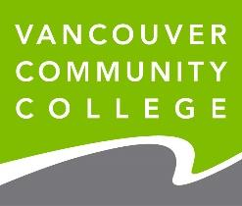

COMPONENTS

This Intake Package consists of two components:
- Portfolio
- Questionnaire

DUE DATE: Sunday, April 7, 2024

Please read all instructions carefully and submit to Laurie Vestergaard, Department Leader, VCC Baking and Pastry (lvestergaard@vcc.ca) AND Kimberly Tada, Instructor (ktada@vcc.ca)
- Use the following examples to name each file:
lvestergaard_YiTBaking_2023_portfolio
lvestergaard_YiTBaking_2023_questinonaire

PORTFOLIO

Create a PowerPoint Presentation with 6-10 slides that illustrate your experience in baking. If you do not have any baking experience, you may include images that reflect your experience in other artistic or physical activities, or your involvement in your community. Each slide should include a written description of the learning you experienced in relation to the image.

QUESTIONNAIRE
Complete the following seven (7) questions to give us a sense of how you like to spend your time and why you are interested in this program.
- . What interests you about baking?

- What are your favourite foods? Explain why they are your favourite foods.

- What are you looking forward to at VCC?

- How comfortable are you about asking questions in class?

- How do you feel about asking for help?

- Do you like to be challenged? Please explain your answer.

- What are your plans after completing the baking program? Please include both your educational and career goals.

