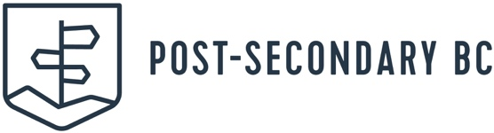

THE FOLLOWING POST-SECONDARY INSTITUTIONS ARE COMING TO VISIT OUR SCHOOL

MONDAY NOVEMER 24TH 9:00 AM – 11:00 AM
GRADES 11 & 12 STUDENTS

BC INSTITUTE OF TECHNOLOGY – Burnaby: One of BC’s largest institutions with more than 48,000 students at five [5] main campuses. Entrance requirements are program specific.
CANADIAN FORCES/RMC – Various Locations: If you qualify for paid university, complete your degree at either the Royal Military College or any accredited program at a Canadian university.
CAPILANO UNIVERSITY – North Vancouver: Offering 101 programs including bachelor’s degrees, diplomas and certificates; best known for jazz, film, animation and performing arts programs.
CORPUS CHRISTI – ST. MARKS @ UBC: Vancouver: Located on the UBC campus, Corpus Christi–St. Mark’s offers the first two years of university in a smaller, more personal environment.
DOUGLAS COLLEGE – New Westminster & Coquitlam: the largest degree-granting college in BC offers 13 bachelor’s degrees, 500-plus university-transfer courses and over 40 career programs.
KWANTLEN POLYTECHNIC UNIVERSITY – Traditional academics and hands-on, applied degree, diploma, certificate and apprenticeship programs, many not found at other BC institutions.
LANGARA COLLEGE – Located in Vancouver, offering 130 university and career bachelor’s degrees, associate degrees, diplomas, certificates, and post-degree diplomas and certificates.
SIMON FRASER UNIVERSITY – The Burnaby Mountain campus includes more than three dozen academic buildings, while SFU Surrey campus is located near the Surrey Central transit station.
TRINITY WESTERN UNIVERSITY - Canada’s premier Christian liberal arts university offering 47 undergraduate and 19 graduate programs on a main campus in Langley and also in Richmond.
UNIVERSITY OF NORTHERN BC – One of Canada’s best small universities with undergraduate and graduate programs in arts and science, professional degrees, medicine and engineering.
UNIVERSITY OF THE FRASER VALLEY – Offers over 100 programs, including 19 bachelor’s degree options in more than 30 subject areas, and more than a dozen trades and technology programs.
UNIVERSITY OF VICTORIA – More than 70% of students from outside the Greater Victoria area, with over 1,000 Indigenous students from across Canada and 3,400 international students.
VANCOUVER COMMUNITY COLLEGE – Located in the heart of Vancouver, offering academic, cultural, and social environments that inspire relevant real-world training.
EMILY CARR UNIVERSITY OF ART AND DESIGN Nationally recognized Art school.

