Track and Field Meet
Time: Thursday, May 21st, 2026 from 7:50 a.m. to 3:00 p.m.
Where: Coquitlam Town Centre

Dear Parents,

Our Track and Field practices have been very successful over the past few weeks and students have had an opportunity to try out for numerous events in preparation for the District Track and Field Meet at Town Centre on Thursday, May 21st. Your child has been chosen as a member of our school track team to participate in the meet on this day. Selection was based on a student’s ability to make the standard and/or the number of spaces available in a particular event. Since numerous students will be participating, there will be many students, coaches and spectators at the stadium. For your child’s safety, please remind him/her to always listen to the coaches and follow the rules. Also, we ask that all students remain in the stands when they are not competing. Students are encouraged to cheer on fellow athletes while they wait for their event(s) or after they have finished for the day.

Students need to arrive at the school by 7:50 for attendance, and much more (e.g., jersey, event labels etc.) Students will then travel with parent drivers to Town Centre. Parent drivers will be leaving Blakeburn by 8:15 sharp! We know this is early and we appreciate parents’ help in getting students here on time. We aim to return to Blakeburn by 3:00 p.m.

Students will need to wear proper clothing (t-shirts, shorts, runners) and bring some extra clothes/ towel in their backpacks in case of inclement weather. There is no “inside” so if students get wet, they will need something to warm them up after their event. Also, students are encouraged to bring a healthy lunch and extra snacks (fruit, juice packs, muffins, etc.) as they will be outdoors all day. Extra water to drink is a must. Please don’t send sugary drinks for the day. A concession stand is usually open; however, the line-ups are typically lengthy and crowded, and we strongly encourage students to avoid consuming sugary snacks/drinks.

This is a very exciting day for all students who participate, and parents are welcome and encouraged to come and cheer us on. All students are expected to stay until the end of the day, even if their events are finished, to cheer on their teammates. Please note that students are not allowed to leave the stadium with anyone but their own parent, or the parent driver they came with unless they have checked in with a teacher and have written permission to do otherwise. If you are able to drive students to the meet, please indicate below. We will need a number of drivers as we have many students competing in events. Please fill out the permission portion of the notice and return it to school by no later than Monday, May 11th.

Practices will continue, as usual, but only for those students who have made the teams. These practices will continue until Wednesday, May 20th.

While school staff will take reasonable steps to prevent injuries to students, some degree of risk is inherent in the nature of activities, and may occur without fault on the part of the student, school board, its employees or agents, or the facility where the activity is taking place. By allowing your child to participate in this activity, you are agreeing that the activity described above is suitable for your child, and that there is a risk of injury associated with the activity.
Comments (please include special concerns which school staff should be aware of surrounding your child’s participation)
____________________________________________________________________________________________________________________________________________________________________________
My child and I understand that the district and school’s Code of Conduct applies during this field trip. I will be responsible for any costs caused by my child’s failure to abide by the Code of Conduct, including any costs to send my child home.

I, _______________________, give permission for my child: Name ______________________________
Division: ______ Grade: ________ to participate in the District Track Meet at Town Centre on Thursday, May 21st, from 8:30-2:00 p.m. I understand that my child may be exposed to a risk of injury while participating in this activity.

Date: __________________ Parent/ Guardian Signature _______________________________________

______Yes/No, I am able to drive to the event. I have ____________ seatbelts.

______Yes, I have completed Volunteer Application and Driver’s form-go to sd43.schoolcashonline.com to complete.

______Yes, I have completed a Police Information Check - waiver form can be accessed from the office.

______Yes, I have completed an ICBC Driver’s Abstract-Driving Record-go to ICBC.com and complete and send a copy to Ms. Sather.

If you have any questions, please contact the office, and they will let you know if all of your forms are up to date.

Should you have any concerns or further questions, please contact Mr. Urquhart at
604-944-9037.

We thank you in advance for your support.

Blakeburn Staff

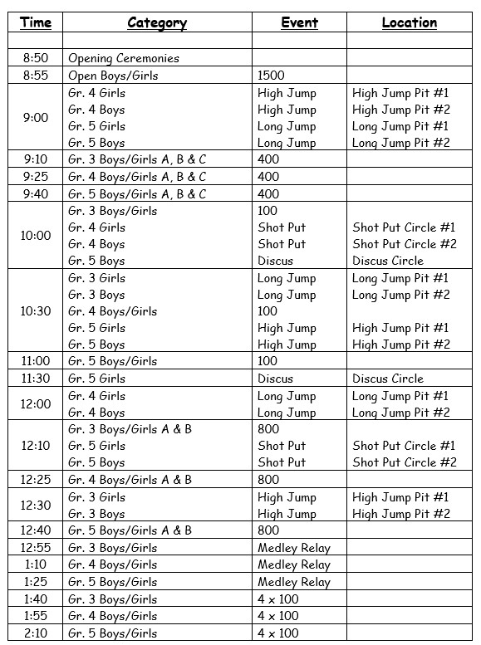
Schedule of Track & Field Events - Grade 3 - 5

