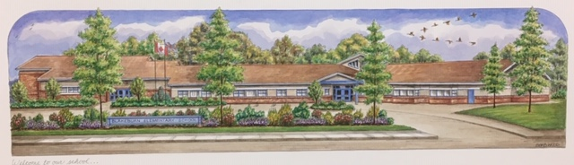
Blakeburn Elementary
Code of Conduct Guidelines: 2021-2022

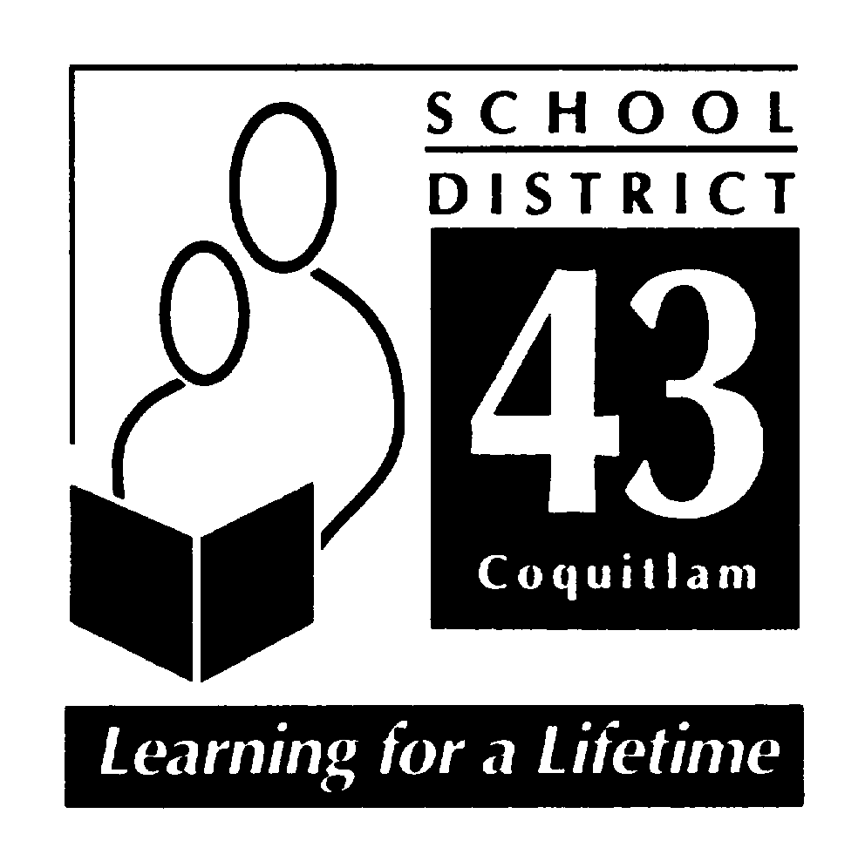

June 2021

- PROCESS

2001: The Blakeburn Code of Conduct was developed and adopted.
2003-2004: Spring Review of the Code of Conduct
2009-2010: Spring Review of the Code of Conduct including the Staff, PAC, SPC
2014-2015: Spring Review of the Code of Conduct including the Staff, PAC, Parents, Students, CDMC committee
2015-2016: Spring Review of the Code of Conduct including the Staff, PAC, and Students
2016-2017: Spring Review of the Code of Conduct including the Staff, PAC, and Students
2017-2018: Spring Review of Code of Conduct including the Staff, PAC, and Students.
2018-2019: Spring Review of Code of Conduct including the Staff and PAC
2019-2020: Spring Review of Code of Conduct including the Staff and PAC
2020-2021: Spring Review of Code of Conduct including the Staff and PAC

- COMMUNICATION

The code of conduct is integrated into our school goals. The school’s foundation is grounded in the social responsibility core competencies and everything we do stems from those philosophies and restorative practices. Therefore, communication occurs through:
- School-wide activities like: Bounce at the Bell, Gatherings, and celebrations.
- Explicit teaching around social responsibility.
- A school-wide opening week program that focuses on incorporating SEL practices and lessons as a means of communicating school wide expectations and our school motto (Take care of yourself, Take care of others, and Take care of this place).
- Communication tools: email, Microsoft TEAMs, planners, Freshgrade, PAC meetings and communicating student learning.
- Personal phone calls, parent/teacher conferences, student-led conferences, and school celebrations.

- IMPLEMENTATION

Social Responsibility and SEL is explicitly taught by staff through:
- Student Leadership: Peace Squad, Bounce Leaders.
- Weekly focus for morning messages based on the Take Care of Self/Others/Place motto for the school
- Buddy Classes
- School Gatherings: Bounce at the Bell, Assemblies, and Celebrations.
- Opening Week program
- Blakeburn Cares Initiatives: Terry Fox Run, SWATZ, Jump Rope for Heart, Cops for Cancer.
- A Restorative Approach to discipline with a focus on strengthening the child.
- Some teachers use circles, Zones of regulation, Mindup and Tribes in their classrooms.
- Modelling of all adults (parents, grandparents, teachers, staff).

As a school and district, we recognize the importance of modeling respectful and responsible processes for managing conflict. Whenever possible, we try to use a restorative approach to resolving conflict and teaching pro-social behaviors.

The fundamental premise of restorative practice is that people are happier, more cooperative, productive, and more likely to make positive changes to their lives, when those in authority do things “with them”, rather than “to them” or “for them”. (International Institute for Restorative Practices http://www.iirp.edu/what-is-restorative-practices.php). As a result, a focus of behavior intervention should be to help an offender recognize and repair any harm done. Furthermore, the purpose is to teach the offender moving forward, and then reinforce positive behaviors, to return the offender to the school community stronger, and more resilient than before the offense.

Every effort will be made to support all students. However, if there are ongoing conduct issues after having implemented restorative interventions, more traditional discipline approaches may be used, separate or in conjunction with restorative interventions. All disciplinary decisions will be made with respect to the individual and context, and responses to conduct issues will take into consideration the student’s age, maturity, and past conduct.

- MONTORING AND REVIEW

- We monitor through report cards student’s social responsibility.
- We sent out the code of conduct to all parents(PAC) and staff in the school community for feedback.
- Regularly review Code of Conduct and school expectations with students in class and at gatherings.
- A working committee, staff and parent volunteers, provided feedback and recommendations.
- The code of conduct is published in planners and can easily be reviewed online.

- ALIGNMENT

- Blakeburn’s Code of Conduct is grounded in the Ministry of Education’s Social Responsibility Core Competencies.
- Our Action Plan for Learning is focusing on using the First People’s Principles of Learning and developing a growth mindset where student take responsibility and ownership of their actions.
- It follows the restorative practices recommended in the Safe and Orderly Schools Manual.
- It is grounded in the values and beliefs of the school community.

- STANDARDS

Blakeburn Elementary School promotes the values expressed in the BC Human Rights Code respecting the rights of all individuals in accordance with the law – As per Section 8 of Human Rights Code of British Columbia, students shall not discriminate against others on the basis of the race, religion, color, ancestry, place of origin, marital status, family status, age, sex, sexual orientation, gender identity or expression, or physical or mental disability. Furthermore, as per Section 7 of the Human Rights Code of British Columbia, no student shall publish or display anything that would indicate an intention to discriminate against another, or expose them to contempt or ridicule, on the aforementioned bases.

Blakeburn Code of Conduct:

At Blakeburn we believe that all members of the Blakeburn School Community are expected to behave in a socially responsible manner. This expectation extends from the classroom, to the hallways, to the washrooms, to school gatherings, to the playground and to the extended learning environment of field trips.

Take care of yourself
Take care of others
Take care of this place

We want to create a safe, caring environment where children build confidence to try their best and know that they are supported. We want to empower our children to develop strategies in solving conflicts and creating solutions.

Conduct Expectations:

Acceptable Conduct is:

- Conveyed through daily conversations.
- Compassionate and kind.
- Using teachable moments to model socially responsible behaviors.
- Valuing diversity.
- Solving problems is peaceful ways.
- Including others.

Unacceptable Conduct is:

- Behavior that interferes with the learning environment.
- Behavior that interferes with an orderly environment.
- Behavior that creates unsafe conditions.
- Any acts of bullying, harassment or intimidation (may include physical, verbal, and cyber bullying on or off the school property) *See District Policy #17
- Being involved in any illegal acts.
- Possessing or using weapons.
- Possession or distribution of illegal substances.
- Theft or vandalism
- Using/naming a physical illness, disability or condition to threaten, harass or intimidate others in the community.

Rising Expectations

- Students are helped to identify or state unacceptable conduct, and coached through a process of making it, “right” with relationships.

- If the behavior continues or is patterned, then we may increase supervision, and communicate with the family.

- If the behavior continues, then we will refer to a larger team to find solutions to support the child (services, supervision, limits, and adaptations).

- All interventions will happen with the aim to strengthen each child and all reasonable steps will be taken to ensure a student who files a complaint or provides information regarding a breach of the code of conduct will not endure retaliation (Ministerial Order 276/07 6(e))

- Parents will be notified of the children involved in an incident based on the severity of the incident. Classroom teachers manage most communication with families. In more serious incidents, the Principal will contact the family.

- If students violate the district or school code of conduct, then due process will be followed according to district mandates. This would include situations involving weapons, harassment and violence. Students may be suspended from attending school for up to five days on an informal suspension. With moderate to severe behavior, a School Based Team Meeting, with parents, would be coordinated.

- A search by school officials of a student under their authority or a search of student property may be undertaken if the school has reasonable grounds to believe a school rule has been or will be violated, and that the evidence of that violation will be found in the location or on the person of the student being searched. Students know that their teachers and other school authorities are responsible for providing a safe learning environment and maintaining order and discipline at school. As a result, they must know that, where reasonable grounds exist, this may require searches of students, their lockers and their personal effects and the seizure of prohibited items.

- Students should also be aware that the schools may collect, use and disclose personal information about students for the purposes of investigating and addressing student misconduct, safety and maintaining order and discipline in school. Such collection and use of student information may include information that is obtained from witnesses or collected from other secondary information sources (e.g. social media). All personal information of students collected by the school will be collected in compliance with and under the authority of the Freedom of Information and Protection of Privacy Act (ss. 26(a),(b), and(c)) and the School Act. Questions about the collection, use or disclosure of student personal information should be directed to the Associate Director of Information and Learning Technologies Stephen Whiffin, at swhiffin@sd43.bc.ca.

Student Voice
On
The Code of Conduct

We need to:
- Focus on learning
- Respect differences
- Follow rules
- Share
- Be good people
Take Care of Yourself
Means:
- Living a happy and good life
- Being responsible for growing healthy and strong
- Behaving yourself
- Being strong so you can help others

To take care of ourselves we:
- Use our mindful moments
- Calm ourselves
- Use deep breathing
- Find a quiet place
- Get a good rest
- Focus on things that make us feel calm
- Eat healthy and drink water
- Remember to dress for the weather

Take Care of Others
Means:
- Being a good friend
- Being nice
- Being kind
- Putting yourself in their shoes
- Including the ideas of others

To take care of others we:
- Stand up for people even if you do not know them well
- Ask if someone is all right if they have hurt feelings
- Treat others with respect
- Include people
- Treat people fairly by sharing and taking turns

Take Care of this Place
Means:
- Being kind to the whole school
- Keeping safe to prevent problems
- Doing charity work

To take care of this place we:
- Pick up garbage even if it is not yours
- Put away the equipment
- Help others clean up messes

