You can find all this information PLUS much more on our www.bakerdrivepac.parentcouncil.net

Here is how you find it:
- Log into your account on the website above.
- Once you are log in, go under “information’ and click on “On-line documents”

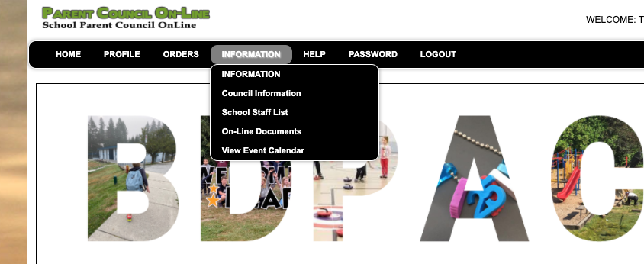

- Here you can find Newsletter for last month (October will be posted shortly) as well as the agenda and notes from each meeting. Now everything is at your finger tips.

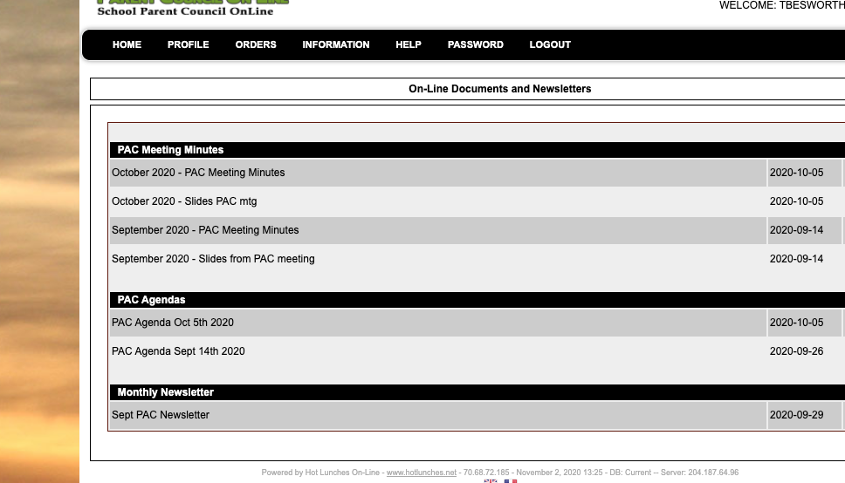

There are still a few who have not registered or haven’t completed adding in each student. Please do the following:
✓ Go to bakerdrive.parentcouncil.net (Formerly known as bakerdrive.hotlunches.net) ✓ Click on "Click Here to Register"
✓ Enter Access Code BDHL
✓ Complete the rest of the registration form - name, phone number, email address, user ID and password. Reminder emails and other notices will be sent to the email address you provide (*) ✓ Click the "Register Now" button at the bottom
EACH student needs to be registered!
✓ If you know your child(ren)’s division, click the “Students” button at the bottom of the home page. Alternatively, go to Profile->Add Students
✓ Enter your child’s name and grade, then use the drop-down menu to select their class. Click “Insert” ✓ To add more students, click “Add New” and repeat the last step

