Action Plan for Learning
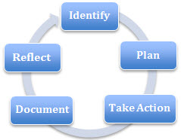 | School Name: Baker Drive
 | School Goal: Social Emotional Learning
 | School Year: 2017 – 2018

Goal / Inquiry  Student learning | To improve student social, academic and personal self-awareness by increasing social-emotional vocabulary, explicit teaching of self-regulation and problem solving skills.

Rationale  1-3 reasons for choosing goal | Last year’s inquiry, assed learners using the five aspects of the Heart-Mind Wellbeing. Parent survey and teacher survey yielded similar results, indicating the following areas as being the most challenging for our learners:  - Secure and Calm – the ability to take part in new activities without being overwhelmed with anxiety and  - Alert and Engaged - the ability to stay calm, focused and alert and be able to slow down and think before acting.

References and sources to support actions | - Fish! Philosophy  - Restorative Practices  - Heart-Mind Wellbeing  - Social Emotional Health  - CASEL (Collaborative for Academic, Social and Emotional Learning)  - The Whole Brain Child & other resources by Siegel and Bryson  - Zones of Regulation  - Second Step  - Kids in the Know
Backup Documentation | Data collected: Teacher assessment in the following five areas: getting along with others, being compassionate and kind, solving problems peacefully, being alert and engaged, and being secure and calm;

Planned Actions  Continuing practices working well (1-3)  - What will we do differently? (1-3)  - How will we provide for staff development and collaboration?  - How will we involve parents?  - How will we involve students?  - How will we monitor progress and adjust actions? | Continue Practices:  - Fish! Philosophy – overarching program that provides common language for students and positive life-long approach to life and interacting with others  - Notice, Name and Nurture – positive interactions, behaviours, efforts etc.  - Feelings Word Curriculum – stories and activities focused on understanding the meaning of feeling words – delivered by Learning Support Teachers.  - Zones of Regulation  - Mood Meter  - Restorative approach when dealing with unexpected behavior  - Levelled Behaviour Support System  New Practices:  - Talking Peace – Restorative problem solving lessons for elementary children  - Student Survey  - Feelings Word Curriculum’s school-home partnership activities  Staff Development and Collaboration:  - Participation in the district’s Restorative Practice cohort (if possible)  - Reflective practitioner exercises during staff meetings and professional development days  - Self-Regulation teacher leader role  Involve Parents:  - Parent education through newsletters & PAC meetings  - Feelings Word Curriculum’s school-home partnership activities  Involve Students:  - Feelings Word Curriculum  - Create/find a self-evaluation tool for the kids to use  - Develop playground agreement for expected behaviours andsolving problems in peaceful ways  Monitor Progress / Adjust Actions:  - Assess learners 3 times a year (October, February & May) in the two following areas: being alert and engaged, and being secure and calm.  - Student self-evaluation  - Attendance data  - Office referrals
Backup Documentation | - Anecdotal evidence (teachers, parents, students)  - student reflection  - Office referrals  - Attendance records

Documentation of learning  Key evidence of change  - How did your actions make a difference?  - Choose 1-3 pieces of evidence to demonstrate the impact your actions have had on student learning to meet your goal.  - Documentation could include video, survey results, performance standard data, anecdotal evidence, work samples, etc. | 2016/2017 APL: Improve student learning through Social Emotional Learning; Develop a common understanding and language amongst teachers, parents and learners for communicating and assessing growth in the areas of self-regulation and peaceful problem solving was a departure from previous academic APL goals. It was the first time the staff was looking at the social emotional learning data and how it was influencing the academic achievement of our learners. We were noticing that there was an increase in anxiety in the student population and we were very curious if different times of year would influence the results in different grade levels. We suspected that the primary learners would improve as the year went on and the increased demands on the intermediate learners would show a need for increased adult support later on in the year. Our findings were that there was improvement in all areas with the least improvement in the areas of being Secure & Calm and Alert & Engaged. The time of year that we were curious about did not seem to influence the children.  Although the goal of the APL was to gather data and to begin to intentionally “Notice, Name and Nurture” the strategies that the learners were currently using, there has been some clear evidence that the efforts have made an impact on the learners. See below.
Backup Documentation | 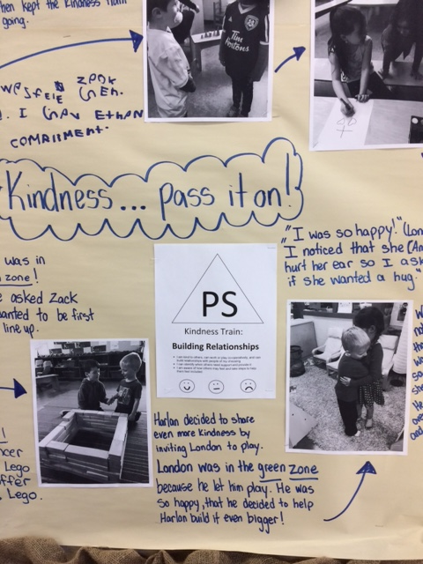  One of the primary classes did a Kindness Project where they intentionally noticed the kindness of others and passed it on.  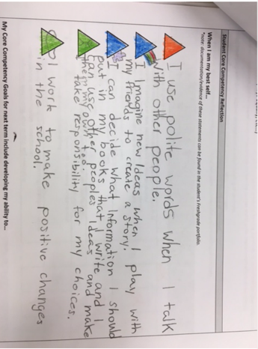  Intermediate classes used the format of reflecting on the Core Competencies.  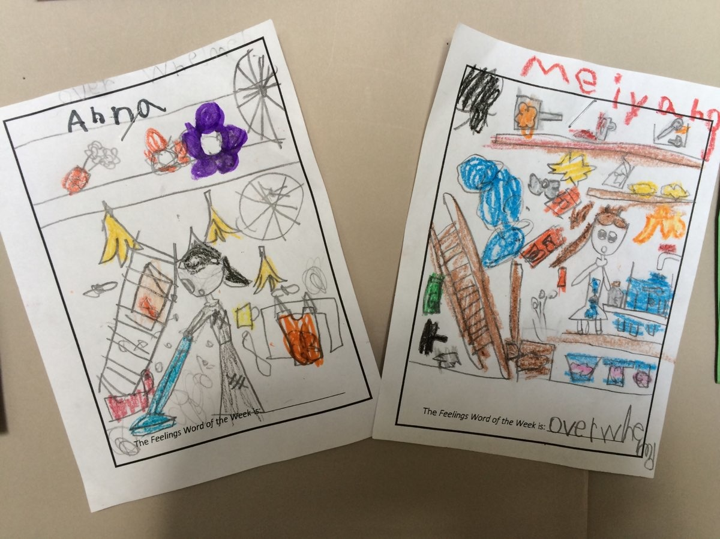  The Feelings Word of the Week focus brought about discussions and clarification of the word’s meaning. (Gr. 1 illustration of overwhelmed)

School Community Engagement Process  - How did you engage parents, teachers, students & support staff in developing your APL?  - How did you share your APL goals with parents, teachers, students & support staff? | The teachers were continuously in discussion throughout the year during staff meetings as well as informal conversations as we were clarifying, refining and defining our focus for the inquiry question. Information was shared with parents though the newsletter and principal’s report at the Parent Advisory Committee meetings.  The teaching staff noted that a portion of the learners were continuing to struggle with anxiety, focusing or being engaged and finding it difficult to focus. Snapshot data was derived through teacher assessment concerning the five areas of heart and mind wellness in October and March. The information was shared with PAC members.  Each week we had a Feelings Word of the Week. Each class was introduced to the word through story and discussion in the library from the beginning of the year. As the year progressed, the word of the week was added to the morning announcements, teachers were encouraged to include the word throughout the week and a bulletin board was created in the front hall.
Backup Documentation | Parent Survey:  https://forms.office.com/Pages/ResponsePage.aspx?id=74xl2ZICUkKZJWRC3iSkSzBr9AK1qpBDjExx7SgcHxVURVNIV1NaTkZMMVc1NUJXWkhWSU9FRkRYRi4u

Reflection Highlights  - Where are we now?  - What are some patterns emerging?  - What surprised you?  - What conclusions / inferences might you draw?  - How does this inform potential next steps? | Where are we now & how does this inform potential next steps?  - We are now moving to a focused plan of action for supporting and improving self-regulation within the school community.  - Literacy is always a focus in schools and will remain so. We are hoping to improve student learning through social emotional learning focusing on the foundational step of self-regulation.  What surprised you?  - We were surprised that the intermediate learners did not show any indication that the stress of academic and social demands affected their self-regulation.  - Data collected indicated the areas of focus and anxiety are areas that influence our learners’ year round.  What conclusions / inferences might you draw?  - There is a direct correlation between the social emotional well-being of the learners and their achievement.  - Most learners improved, however, the learners that struggled in the beginning of the year, continued to struggle in new situations and with others albeit to a lesser degree.
Backup Documentation

Literacy Data  Attach the following:  - Classroom Assessment  - School Assessment  - FSA results | June 2017 - FSA results not available at this time

Signatures
School Name: Baker Drive Elementary | School Goal: Social Emotional Learning | School Year: 2016-2017

Title | Name | Signature
Principal | Margaret Mary Deck
Assistant Superintendent | Gerald Shong

Print this page, have it signed by Principal & Assistant Superintendent, scan it and attach it here

