November 7, 2025
Hi Alderson Families,
November is off to a great start! Please remember that next week includes Remembrance Day. We have our assembly on Monday at 11:00 and schools are closed on Tuesday.

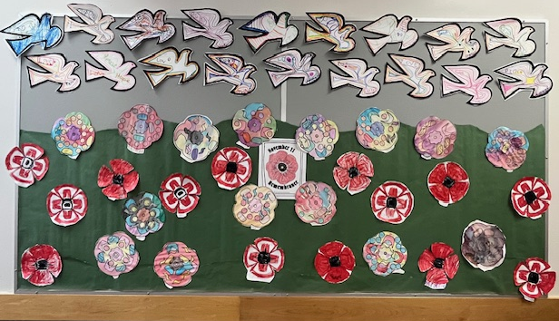

**Still awaiting a few of these forms!! Please complete ASAP if you haven’t yet**

Parent/Caregiver Tasks –
- Pay for or provide school supplies if you haven’t already through SchoolCash Online: https://sd43.schoolcashonline.com/
- Complete School Forms – you can find the forms here: Parent eforms

Upcoming Events


For information about future events please check our online calendar. As information about each event becomes available, it will be added to the calendar item. Click on the item to read more.

Monday, Nov 10th | Remembrance Day Assembly
Parents are always welcome to attend our assemblies.
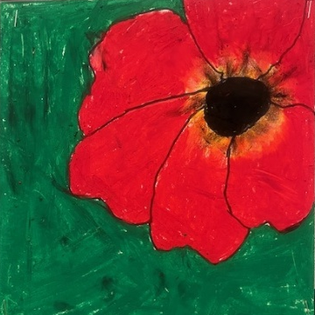
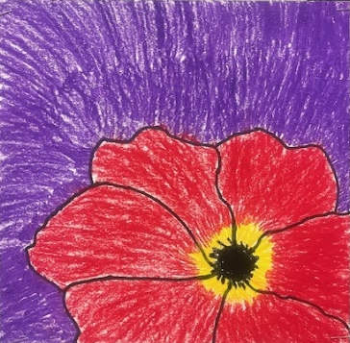
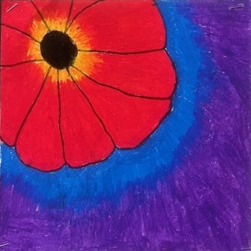

Tuesday, Nov 11th | Remembrance Day
Schools are closed.

Monday, Nov 24 @ 11:20 | November Assembly
Parents are always welcome to attend our assemblies

Thursday, Nov 27th | Volleyball Tournament
Students on the volleyball team and their families are welcome to attend. Unfortunately there is not room for other students or Middle School students to attend as spectators.

Monday, Dec 8th | December Assembly
Parents are always welcome to attend our assemblies

Tuesday, Dec 16 | Winter Concert @ 2:00-2:45
Parents are encouraged to attend.

Wednesday, Dec 17 | Learning Updates (Report Cards) Published to MyEd
Please make sure you can access your MyEd family portal account so that you can view your child’s Learning Update.

Friday, Dec 19 | Last Day Prior to Winter Break

Monday, Jan 5 | First Day back following Winter Break
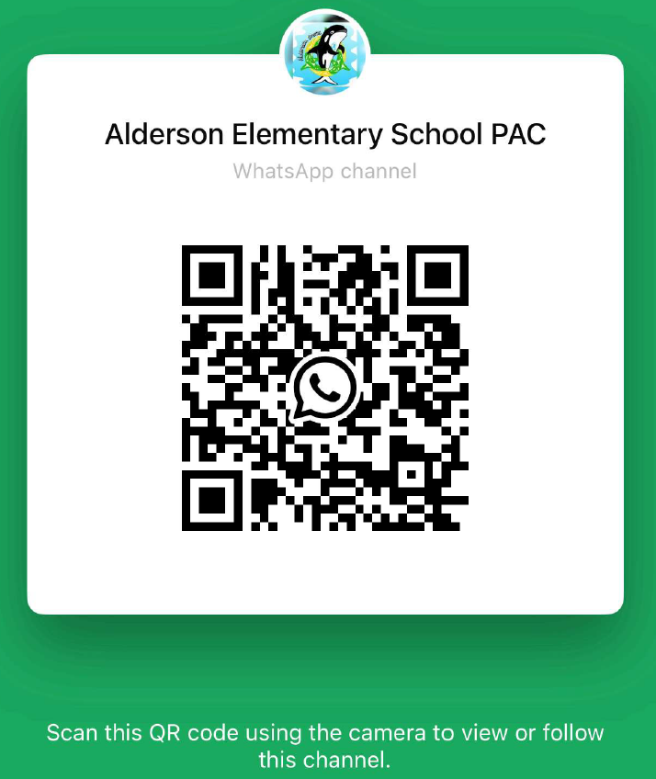 | Alderson PAC  (Parent Advisory Council)  Our PAC works hard for our school to provide some extra special and very valued events to our school year that bring our community together. These events are a lot of work – please do your part. You can send them an email to find out how you can help out. |  | You can visit the Alderson PAC page on our website here:  Alderson PAC  If you have questions about a PAC initiative you can email them at:  AldersonSchoolPac@gmail.com
PAC Fundraisers!!
Spirit Wear
Please see the information below or click on this link to learn more about ordering Spirit Wear for your child.  Spirit Wear |  | Please see the information below to learn more about ordering a Grade 5 Hoodie for your Grade 5 child.  Grade 5 Hoodie
Purdy’s Fundraiser
Please see information below. All proceeds go to funding the Grade 5 Leaving Event.
Click here to order!!

Hot Lunch
Don’t forget to order hot lunch!! Please click on the link below to access the lunch platform.
Munch-A-Lunch!
*** Late orders cannot be accepted due to vendor deadlines.**
