Customized Learning Centre

380 Montgomery Street, Coquitlam, B.C. V3K 5G2
604.936.4285

STAFF DRIVING CONSENT FORM 2023-2024

To Parents and Guardians:

The purpose of this letter is to request your consent for your child to be driven by CLC staff members (teachers, youth worker, counsellor, administrators) for the duration of the school year. All driving arrangements will comply with COVID protocols as determined by the school district. This will be for the following purposes:
- Field trips within the school district i.e., “Tri Cities”, such as:
  - To/from a supermarket as part of our food/cooking program
  - To/from local sites i.e., SPCPA, Four Cats Art Studio, Poirier Rec Centre
  - Please note that you will continue to receive notice of these events in advance
- To/from home or medical appointments as per specific arrangements made with CLC
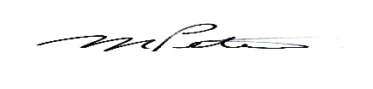

Mr. M. Peters
Principal

Parent/Guardian Field Trip Consent:

Parent/Guardian Permission

I, ________________________, give permission for my child _______________________, to be drive by CLC staff members as described above. I understand that my child may be exposed to a risk of injury due to accident while participating in this activity.

_____________________________ ____________________________
Date Parent/Guardian Signature

