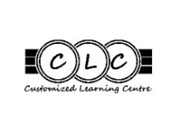
Cell Phones at CLC
At CLC the needs of our students are our top priority. We care about their wellness and their learning. All our CLC classrooms are cell-phone free zones during class time. This policy comes after many conversations among staff about this issue, an issue that all schools are dealing with.
- Cell phones will not be permitted during class time.
- Students will have access to desktop computers and laptops during class as learning tools.
- Cell phones will be placed in classroom cell phone storage slots, off or in silent mode, through the entirety of their classes.
- Cell phones can be used before school, during morning and lunch breaks, and after School District 43 (Coquitlam)

Steps of Consequences for In-Class Cell Phone Use:
- First, Teacher will ask student to put phone away and talk to student if it continues to be an issue.
- Second, If the cell phone issue persists (whether that day or continuously) then parents will be contacted.
- Third, If the cell phone still poses an issue in class, a family meeting will be arranged.
- Finally, Mr. Peters will then speak to student/family if issue persists.

Why?
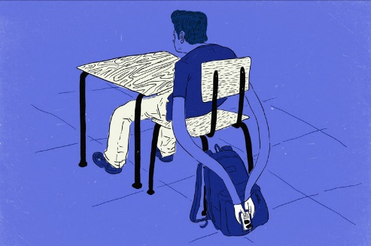
Our staff has agreed that a consistent school-wide policy to bar cell-phone use during class will help students stay more present, engaged, and connected to their learning. Many studies on the internet have shown the negative effects of cell-phone use in classes and lack of productivity and engagement. The intent of having a ban on cell-phone use in the classroom is to support them in their academic success, removing a major temptation and distraction, and promoting face to face social interaction and connection (an important goal for all our students.) Teachers have repeatedly observed that a cellphone on a desk, even when in use as a research tool or music listening device, still provided too tempting a distraction. Phones are not merely distractions for their owners in the classroom, but cellphones can also be a source of distraction for teachers and classmates alike. These devices can adversely affect peers struggling with focus and attention, as studies show, and this is a way that everyone can do their best to support the learning of their fellow peers. We all want to create the very and most welcoming environment for each other that fosters care, growth, and learning.

************************************************************************************************************
I have reviewed the above information and agree to follow the rules for cell phones at CLC.
________________________________________ _______________________________________
Printed Student name Student Signature and date

