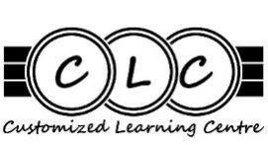
CLC Student Activity Fee – Due Friday September 29, 2023

Dear CLC Parents,

CLC requires an annual Student Activity Fee of $40, payable in September.

School district policy permits schools to charge an activity fee to cover the costs of field trips, guest speakers, and special events. All secondary schools charge such a fee. CLC staff work hard to plan these types of activities and we find they greatly increase the attendance and engagement of our students. This student activity fee will enable our program to cover its costs for these activities.

All CLC students must pay the $40 Student fee by Friday September 29, 2023.

Please pay by:
- Cash
- Cheque (payable to SD43). Please give this to Dannielle Naidu, CLC Youth Worker.
- Debit or credit card at the main office here at Montgomery Centre

If any family has financial difficulty affording these fees, please contact me about the fees being adjusted. This will prevent you from getting future “overdue” notices.

No student will be denied educational opportunities offered at the school due to financial hardship.

Thank you and have a great school year!
Best regards,

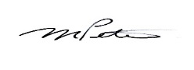
Murray Peters,
Principal

