Community Users Guide to Ebase
School District 43 (Coquitlam) Rentals New Booking Software - eBase

SD43 Rentals Department is excited to announce the launch of our new online booking software and procedure for all 2020-2021 school year bookings onwards. This transition will result in all rental processes going online through our web-based platform for community users.

This new software/process will include user features such as: submitting booking requests online, online space viewing, online account statements and billing history.

ACCESSING eBASE
Community users may access the online booking portal by following the link below:
https://sd43.ebasefm.com/rentals/welcome
All groups will be required to create an account in order to submit their renewals and/or new application requests.
- There will be an optional 8-minute introduction video which will provide an overview of the new system. (We encourage you to watch this video to better understand how to best use the system).
- Sign in
a) New Users – click “get started” to register your account.
* Follow instructions for “registering your account immediately
b) Proceed to “signing in and submitting permit requests.”

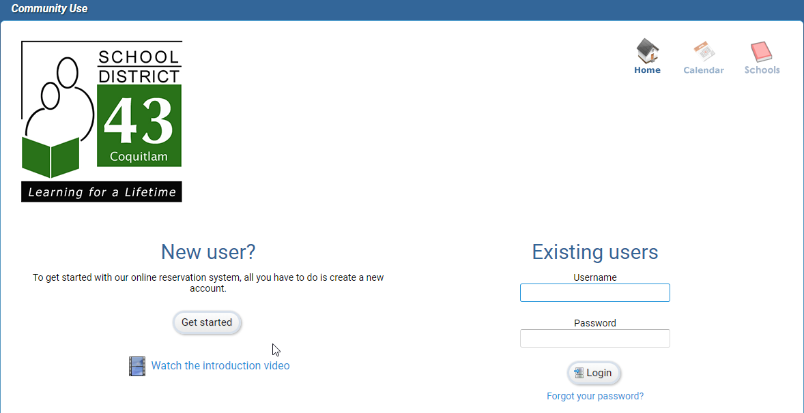

REGISTERING YOUR ACCOUNT
Once you have selected “get started”, you will be redirected to an instruction page. This page will provide a step by step guide to creating your account. Below you will also find FAQs specific to rentals in SD43 (Coquitlam).
Once you have read and understand the steps in which you will follow to register your account, click “register”.

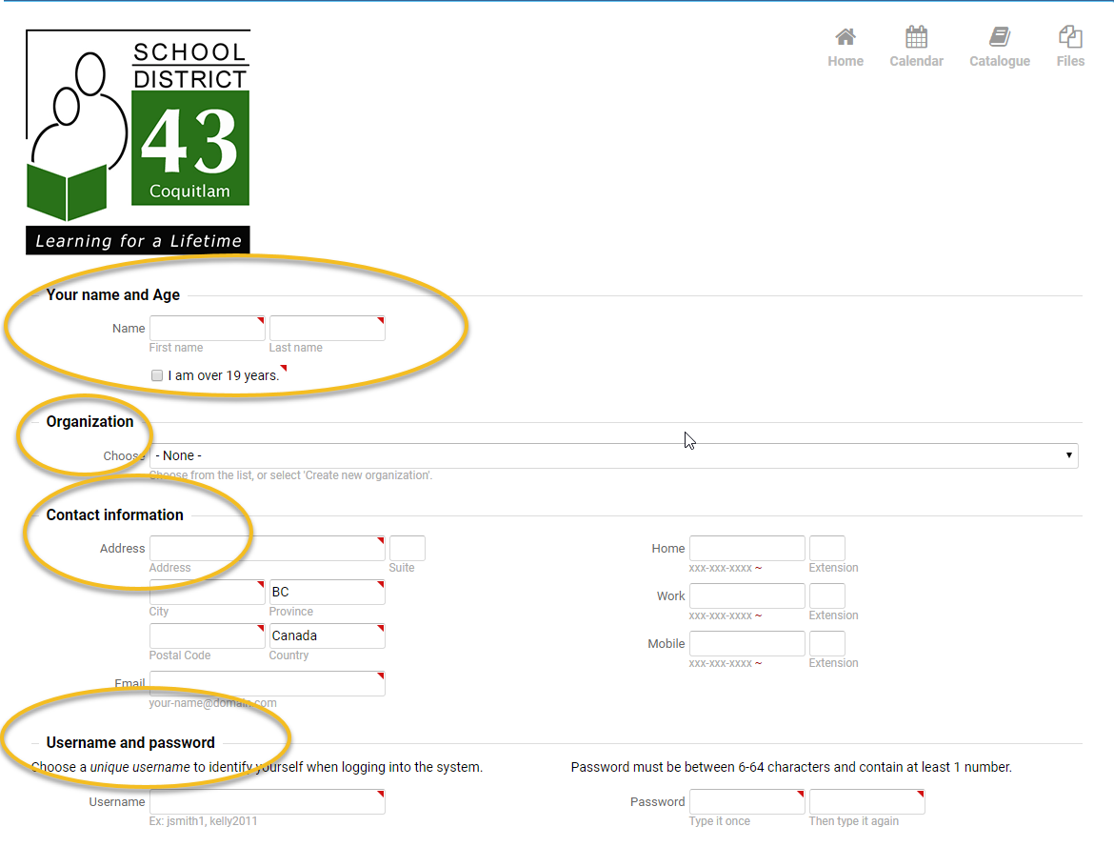

- You will be redirected to a new page in which you will enter the following information.
  - First and last name (as written on government issued ID).
  - Confirming you are over the age of 19. Only those 19 years of age or older are permitted to submit a request to rent space with School District 43 (Coquitlam).
  - Organization
    - If you are booking on behalf of a company or organization, select your organization from the drop-down menu.
      - A request will then be sent to the administrator of the organization who will be required to approve your request to submit requests on behalf of this organization.
    - If your organization does not appear in the drop-down menu, select “create new organization”.
    - If you are a private group of family or friends wanting to book to play recreational sports, register an account under one person’s name.
*Insurance MUST be listed in the exact name of the organization on your rentals account*

  - Contact information – address including postal code, email, phone number.

  - Username and password – each group can create their own username and password to access their account (if one has not already been created for you).
  - Payment information – optional.
    - Online payment – VISA or MasterCard only. VISA Debit or American Express are not accepted online.
    - In person – Cheques or exact cash only.
    - By Mail – Cheques.
*Payment is due immediately upon permit approval*
  - Read through SD43 Terms and conditions. Please note that there have been changes to our terms and conditions. All user groups are responsible to read and understand this document in full. Should there be additional changes throughout the year you will be prompted to re-read and acknowledge that you have read the updated version at that time.
  - Click register.
- You will be sent an email link in which to verify your email address.
Once you have verified your email you have completed the registration process.

SIGNING IN & SUBMITTING PERMIT REQUESTS
- Once you have successfully registered your account, you may sign in as an existing user.
- Use the credentials you created when registering your account. If you have forgotten your username or password, see instructions below for how to reset them.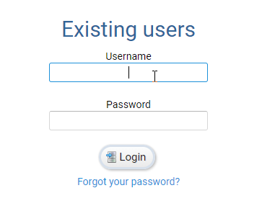

FORGOT USERNAME OR PASSWORD?
Username: if you have forgotten your username, email facilityrentals@sd43.bc.ca for username recovery.
Password: if you have forgotten your password, from the main log in page, select “forgot password”. You will be asked to provide your username and an email will be sent with a link to reset your password.
Upon sign-in, you will be provided with tutorials for how to use the system. These will be available at any time by clicking the “help” button at the top right side of the page.
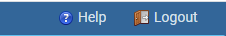
- You will be redirected to your home page which will show your past, current, and future bookings. You may also see the status of any requests you have submitted.
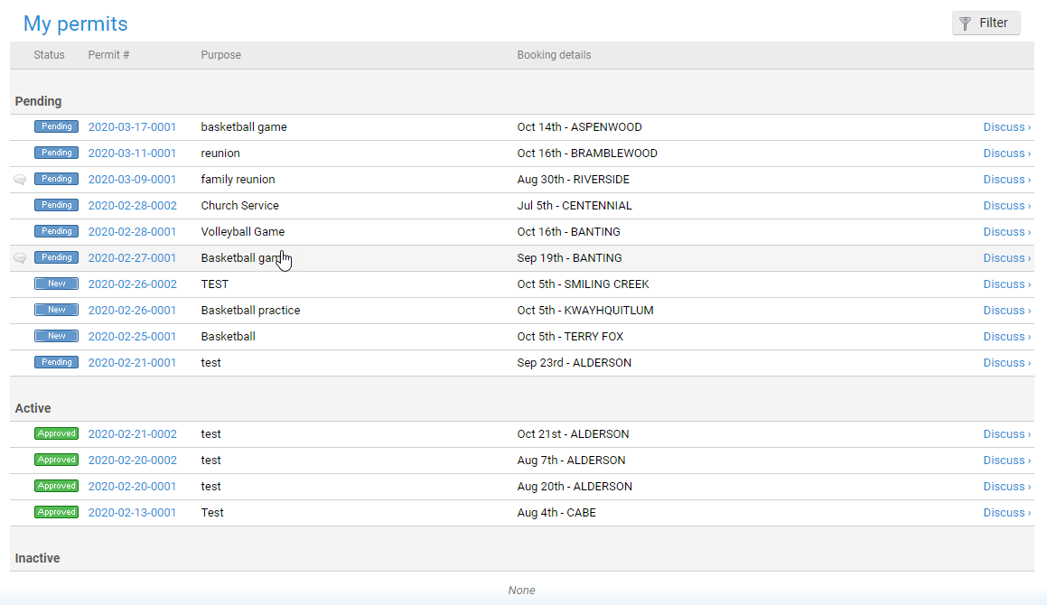
- You will be able to submit requests from this page by selecting “create new permit”
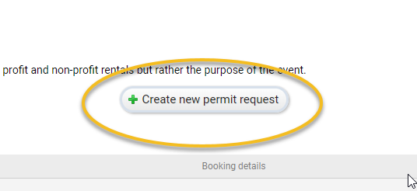
- You will be redirected to enter information regarding your booking (step 1 of 5).
  - Permit Type
    - Childcare – For Daycares/Preschools and /or Before After School Care
    - Social or Sport Organizations (Cat. B) – All users such as youth or adult sports, Scouts/Guides, Cadets; includes youth non-sport activities (ongoing rental i.e. once per week for multiple weeks)
    - Social or Sport Camps (Cat. C) – Short Term Rentals such as Pro-D Days, Winter/Spring/Summer breaks (ie: sports camps, theatre camps, one day personal interest courses).
    - Religious, Educational or Political Meetings (Cat. D) – Language Classes, religious and/or Cultural instruction, Political meetings, Universities & Colleges
    - Theatre Use – Events held in Theatres in Terry Fox, Centennial, Heritage Woods; Musical, Theatrical Productions, Speaking Engagements
    - Commercial Filming/Parking - For all filming in SD43 facilities (Filming permit is required).
Commercial Parking – Use of all weather or paved parking for the purpose of Filming
    - Commercial or private groups (Cat. E) – All uses including weddings, private parties/birthdays, strata council meetings, conventions, and conferences
    - SD43 School/District and City Events (Cat. A) – All school related uses, SD43 Initiatives, CUPE Union meetings, special Community events (ie: Remembrance Day Service), Municipal Elections, All Candidates meetings
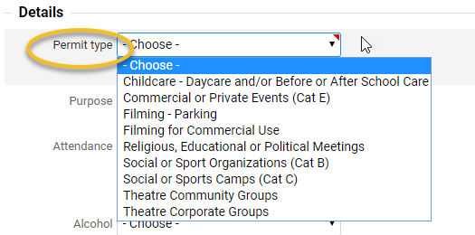
Things to make note of when creating your permit
  - Permit type and purpose.
  - Attendance: maximum number of people attending; including participants and spectators.
  - Participants may be under 19: please confirm if there will be attendees under the age of 19 years old.
  - Alcohol: If alcohol may be served, additional licensing is required.
  - Food and Beverage: food and beverages beyond water may not be consumed in gyms or libraries. On site food or drink may result in additional custodial time required.
  - Insurance: Groups can update their insurance in their account profile
    - Enter Insurance Information: groups can manually enter their insurance information here. A copy of the certificate will be required.
If you purchased Insurance for a full year, add that information here.
    - Will provide later: if you have not yet purchased insurance this option may be selected, and you will be required to show insurance a minimum of 5 business days prior to your start date.
- Equipment: if you would like to rent equipment with your booking click “add”
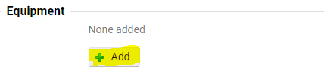
- A pop-up window will appear with options to choose from.
- Equipment will change from year to year at each school. Fees may be applicable.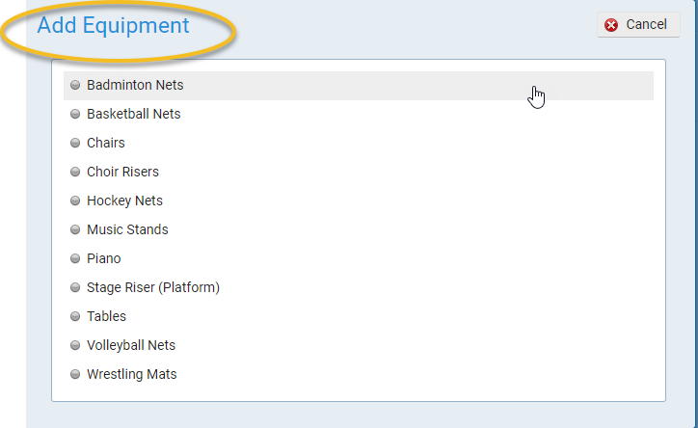

Questions:
    - Check the age of all expected participants.
    - Check the best fit for your type of activity.
Continue to next step

*Terms and Conditions for renting with SD43 (Coquitlam) will be listed at the bottom of the page should you wish to review these at any time*
You will now be redirected to the Bookings page:
You will then be redirected to manage the bookings for your event (step 2 of 5).
- Click “Add Bookings” (Quick select is not applicable until a booking has already been made. It is used to modify times or repeat bookings)
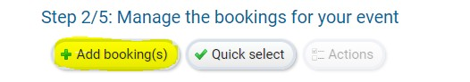
- You will be redirected to a pop-up window which will allow you to either search for space or book a specific facility.
    - Search – will allow you to search for any available space.
    - Build – will allow you to request for a specific space.
- Search for space (single date, or multiple dates)
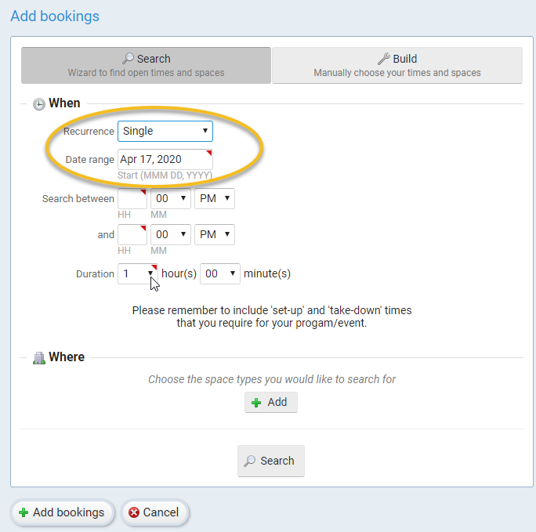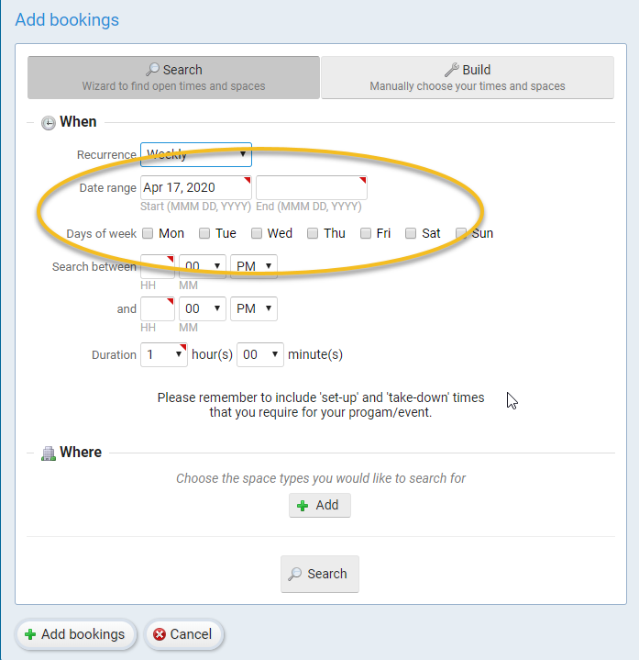
From the drop down, select if you are looking for a single, weekly, bi-weekly, or monthly booking.
  - Select date range you would like to search for.
  - Select the times you wish to book for, this includes your set up and take down time.
    - Bookings are created by the hour (1 hour minimum per booking)
  - Select the number of hours you are looking for.
  - Select what room you are looking for (classroom, gym, cafeteria, etc.) by clicking the “add” button.
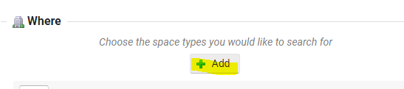
  - Select “search”.
  - You will be redirected to a new screen where you can select which school you would like to book at.
    - There will be a drop-down menu you will be able to see all available schools sorted by municipality, or you may view this in map view by selecting “show map”.
    - Check off “exclude conflicts” to show only schools that are available for the dates/times requested (school availability may change throughout the year).
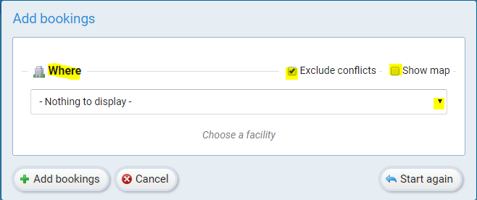
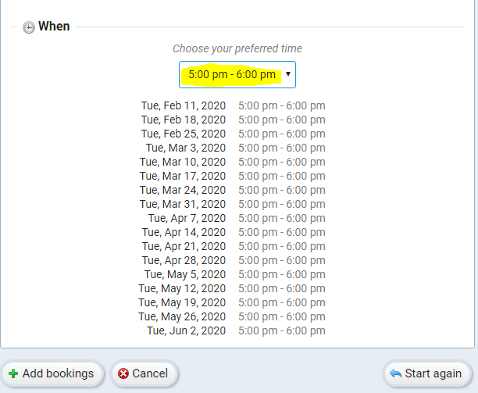
  - Once a school has been selected, a drop-down list will show all the dates in which the space is available.

- You will click “add bookings” to proceed booking the space. If you would like another location, please reselect your school from the drop-down menu or map.
  - You will then be redirected to a full list of all your bookings that you have selected. This list may prompt you with a warning if there is a conflict with the date booked.
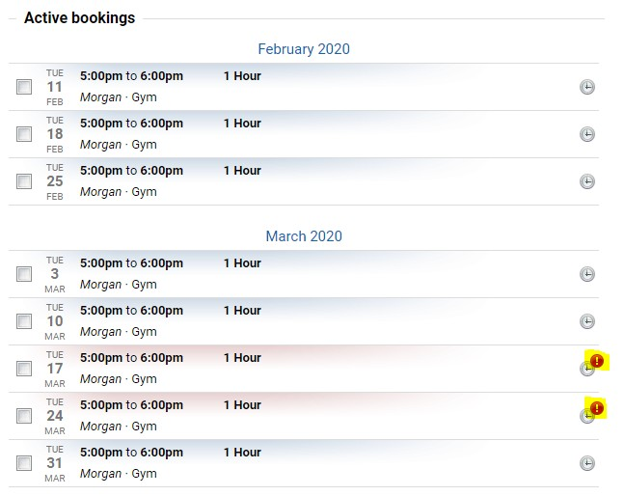
If you hover over this alert you will be able to see what the conflict is.
  - At the top of the page if there are any days you wish to delete from your permit request before submitting to the rentals department for review you can do this by clicking “quick select”.
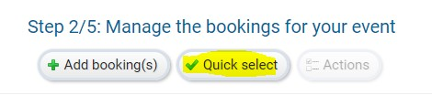
  - You will be redirected to a pop-up box in which you can select a day of the week, specific hours, or any excluded dates. Once you have selected any days you wish to exclude in your request, select “apply”.
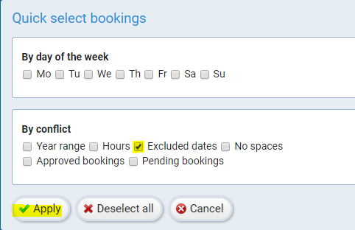

  - Once you have selected any days you wish to cancel or make changes to, select “actions”.
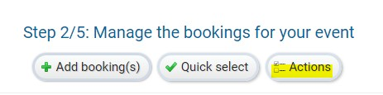

  - You will then be prompted to remove selected bookings, cancel selected bookings, or change the start/end times. Once you have made all changes you require, select “apply”. These changes will be applied, and you will be taken back to review your bookings to see if you would like any additional changes.
  - At the bottom of the page, select “continue to next step”
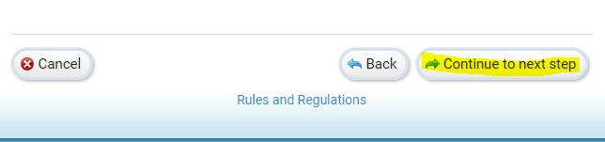

- You will be redirected to step 3/5 Estimated Costs. This will provide you with approximate rental fees for your booking. Additional fees will apply. ($25 processing fee for all new permits, custodial fees, if applicable)
- At the bottom of the page, select “continue to next step”
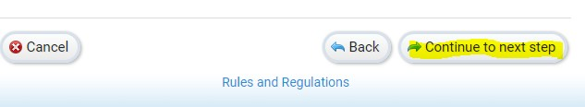

- You will be redirected to step 4 of 5 called Additional Information. In this section you will be able to add any event supervisors who you wish to be notified of approved permits, cancelled days, or changes to the permit. You will also be able to add comments for the District Rentals Department to review when processing your request.
- At the bottom of the page, select “continue to next step”.
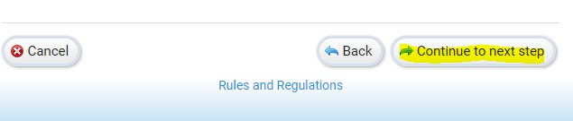

- You will then be redirected to a page where you can review all your request information and submit the request for review from the District Rentals Department.
Once all information is correct, press “submit” at the bottom of the page.
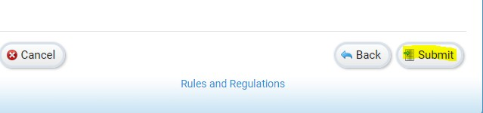
- Your request will then be sent to the District Rentals Department to review. If further information is required, a member of District Rentals will contact you. Once your request has been approved you will be emailed a copy of your permit. Payment is due immediately upon permit approval.

- On your permit screen you will be able to see the status of any requests that have been made. They will show as – pending, active or inactive.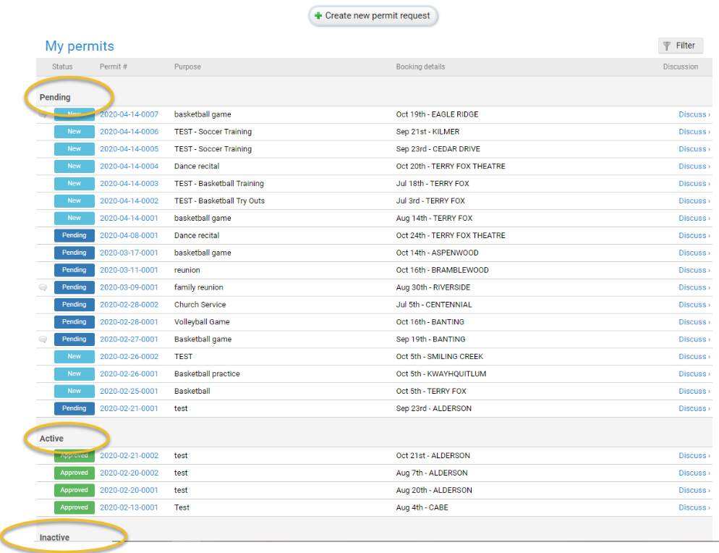

Viewing Upcoming Bookings
To access the calendar select the calendar icon from the main menu bar
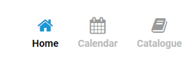

- You will be able to select different views – week, month, or agenda
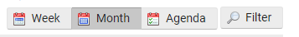
- If you are booking on behalf of an organization or if you have multiple bookings, you will be able to filter between your bookings, bookings for other members of your organization, or bookings by facility/space by using the “filter button”.
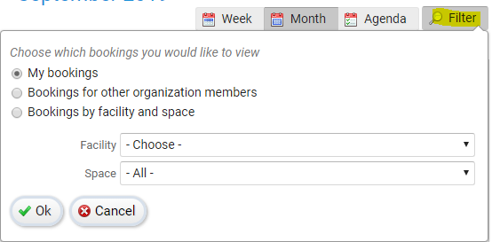

Viewing Site Specific Information
To access information about each site, including size, capacity, photos, and site-specific information, select the “catalogue” icon from the main menu bar.
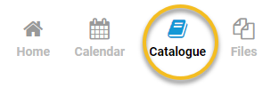

- You will be directed to a list of all rentable SD43 Facilities, categorized by municipality (Coquitlam, Port Coquitlam, and Port Moody)
- Once you find a school that you wish to find out more information about, select “view details” or select the name of the school from the list.
- You will be directed to an overview of the school you have selected. There will be a photo of the front of the school, name of the school, address, and a view of Google Maps which will show the location of the school. Further down on the page you will be able to see all the spaces you may request rental for at the school.
- For more information on a specific room, select the name of the room you are wishing to see, or “view details”
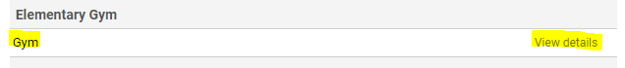
- You will be redirected to more information about this room. This page will provide pictures of the space (if available), information about the size, and available amenities.

Searching for Available Space
Click the “Calendar Icon” on the top right-hand side of the home page screen. The calendar is populated based on approved bookings only. If you hit the “filter” button you can search specific locations to see if they have any time available.

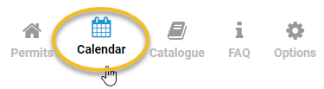

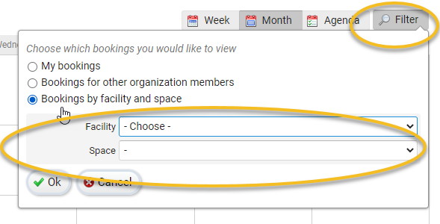
** Please note that this is based off only approved bookings. If there was a request for a time before you initiated your request, that has not yet been approved, you may not receive the requested time slot. New Rental Requests will still be based off a first-come, first-serve basis.

Frequently Asked Questions
1. To access frequently asked questions, select “FAQ” or click here
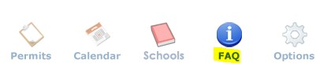

Managing Your Account
1. Select “Options” from the main menu bar.
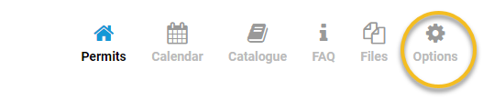

- You will be redirected to update your personal account information.
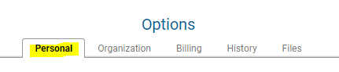
  - Personal
    - Update consent for emails which include communication regarding renewal emails or important information that may be sent to all renters.
    - Address
    - Phone Number
    - Email
    - Update username and/or password
    - Updating insurance information
*if information is updated, ensure this is saved by clicking “save” at the bottom of the page*
  - Organization
    - Name of organization
    - Address
    - Phone Number
  - Updating insurance information
Billing
    - View current account balance.
    - If you would like monthly statement sent to the organization administrator or Licensee, check “send monthly statement email”.
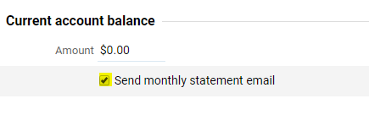
    - Update credit card information.
    - View any upcoming charges due and the dates they will be due.
View statements from previous months – these reports may be exported to both adobe and excel format.
History
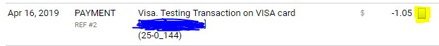
See all charges made to your account including, date, purpose, and amount. Print receipts for transactions made on your credit card by clicking the receipt icon beside the transaction.
Files
You will be able to upload any files you wish to have on your account. A copy of your insurance certificate will need to be uploaded.

For additional assistance please contact the District Rentals Department by email at facilityrentals@sd43.bc.ca or phone at 604-939-9201.

Thank you,
District Rentals Team
550 Poirier Street, Coquitlam, BC
V3J 6A7
T: 604-939-9201
F: 604-939-4492

