What makes a good dog team?

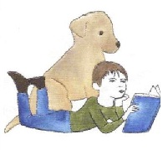
The dog
- calm, quiet manner, and comfortable in an institutional setting; able to tolerate unexpected noises such as school bells and sudden movements, as well as the hands on attention of groups of enthusiastic, adoring children.
- solid, reliable obedience skills.
- able to ignore toys, shoes, leftover lunches, and other doggy temptations.
- tolerant of other dogs who may be on site.
- impeccable grooming, good health, and up to date vaccination status.
The handler
- personality traits similar to those of the dog.
- good knowledge of the dog and solid handling skills.
- enjoy spending time with children and willing to take an interest in their lives and challenges.
- patience and empathy with children who face life and learning challenges, and a willingness to support them.
- flexibility and an ability to ‘go with the flow’.
- a love of books (especially children’s books) and reading! and a willingness to share that love with children.
- neat, well groomed appearance.

