- Global news reports that Canada’s federal budget of about $148 million will be spent over the next five years to promote Canada as the destination for education.

- 2019 marks the 50th anniversary of the Official Languages Act of Canada. Board Chair Barb Hobson has been participating in the public consultation on the modernization of the Official Languages Act of Canada.

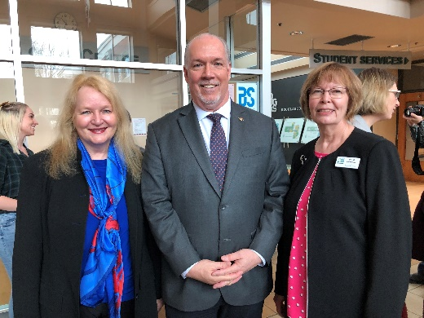
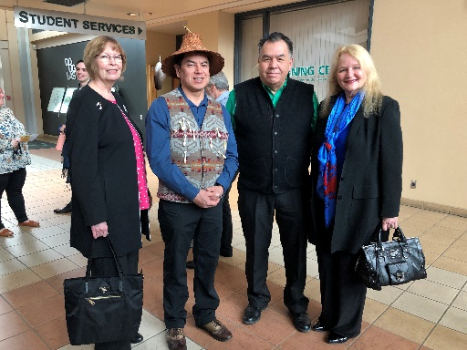
- On April 16, 2019, Superintendent Patricia Gartland and Board Chair Barb Hobson attended B.C. Premier John Horgan’s announcement of the Provincial Tuition Waiver Program for Youth Formerly in Care on April 16, 2019 at Douglas College Coquitlam.

This program allows post-secondary institutions to waive tuition fees for those who were in care. Currently, there are 806 former youth in care that are now accessing the system.

- Superintendent Patricia Gartland will be attending the Tri-Cities Economic Summit, a gathering of world-renowned business leaders hosted by the Tri-Cities Chamber of Commerce on May 8, 2019 at the Executive Plaza Hotel & Conference Centre. This year explores new innovations and technology including AI and automation and their effects on business, marketing, transportation, connectivity and more.

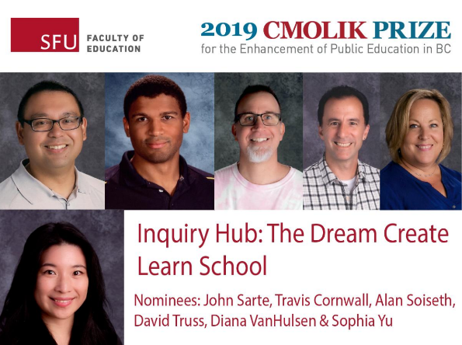
- The School District’s Inquiry Hub: Dream Create Learn School was recognized in the 2019 Cmolik Prize Honour Roll for the Cmolik Prize for the Enhancement of Public Education in BC organized by Simon Fraser University.

The Cmolik Prize recognizes recipients who have developed and implemented an invention, innovation, concept, process or procedure that enhances educational practice in the K-12 public school system in BC.

Photo from the SFU Faculty of Education

- Board Chair Barb Hobson, Vice-Chair Christine Pollock and Trustees Lisa Park, Jennifer Blatherwick and Michael Thomas, Superintendent Patricia Gartland, Secretary Treasurer Chris Nicolls, and Principal of International Education, Geoffrey Johnston, will be attending a dinner with Korean Consul General Chung at his place of residence on May 13th.

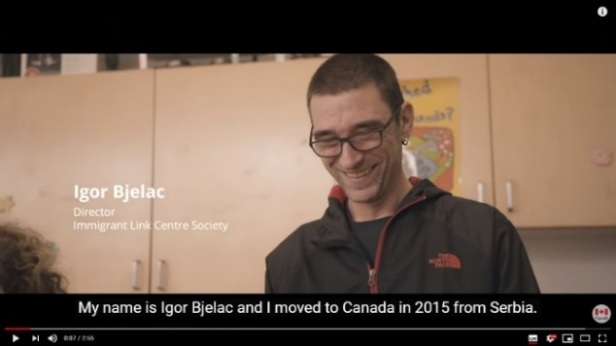
- Igor, an adult SD43 LINC student, is truly making a difference by fighting food waste and helping new immigrants in the community.

He was featured in Citizenship and Immigration Canada, for creating a program that distributes perishable surplus food to underprivileged immigrants in Coquitlam.

He is now the Director of Immigrant Link Centre Society.

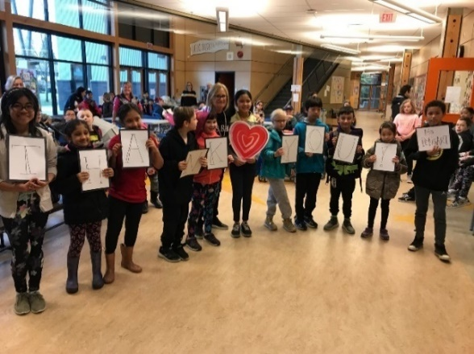
Watch his story here: https://www.youtube.com/watch?v=n1KWLgAXHX4

- Deb Ponsart, Education Assistant from James Park Elementary was nominated by secretary Kathy Wilson and recognized by 104.3 FM The Breeze for her outstanding dedication to serve the community.

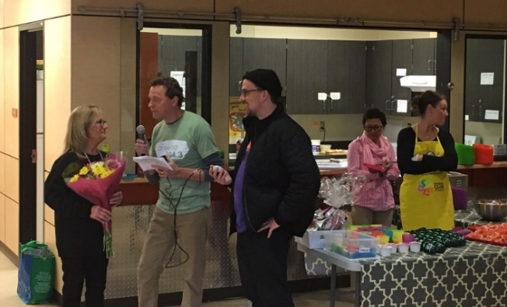
Principal Marco shares, “Deb volunteers so much for our community. Everyday she comes around 7:00 a.m. to set up and cook breakfast for our breakfast program. The average participation is just over 130 students (and some parents) per day. She has also fundraised thousands of dollars for the Heart and Stroke foundation in the past and has raised tons of food donations for SHARE Society.”

- School District 43 theatre productions are being held this April and May. Come and support these students.

- Gleneagle Secondary School students are performing Romeo and Juliet on April 30, May 1 and May 2 at 7:00 pm.
- Terry Fox Secondary School students are performing Rock of Ages on April 11, 12, 13 and April 18, 19 and 20 at 7:30 pm.
- Port Moody Secondary School students are performing The 25th Annual Putnam County Spelling Bee, it’s first spring musical in 13 years starting on May 1 to 3 at 7:00 pm.
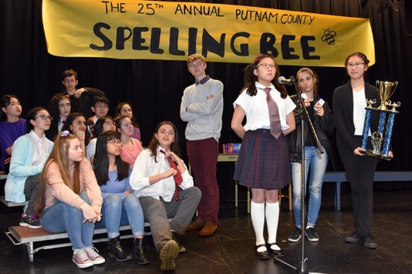
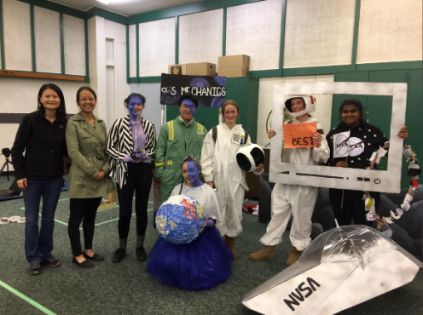
- Terry Fox Secondary students won their first gold at the Odyssey of the Mind Provincial Tournament on April 13, 2019 at Montgomery Middle School and competed at the World Finals at Banting Middle School on April 17, 2019.

Odyssey of the Mind is an international educational program that provides creative problem-solving opportunities for students from kindergarten through college.

- Terry Fox Secondary School is hosting their 3rd Annual Power of Ideas Open House Event on Wednesday, April 24th from 4:00 pm to 8:00 pm.

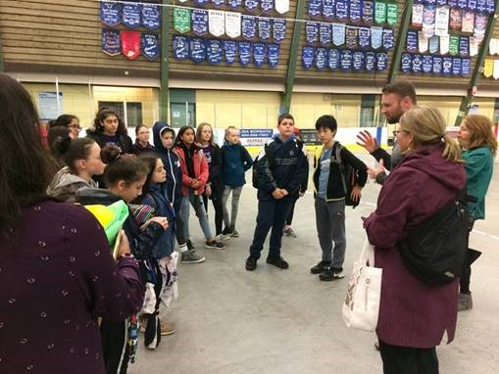
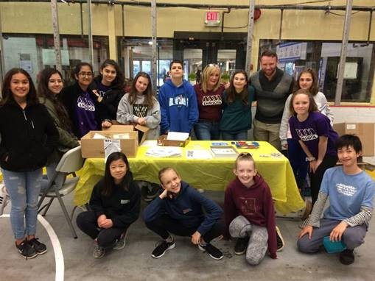
- On Thursday, April 18, 2019, the Port Moody Middle WE Leadership group participated and volunteered at the Tri-Cities Healthy Kids Fair at Port Moody Recreation Center from 9:00 am to 12:30 pm. The students helped set up the event, ran the centers and worked with young children who attended. The event was hosted by community partner organizations and provided resources and information about safety, literacy awareness and health to parents. The Gleneagle Culinary students also attended this event and provided healthy snacks.

Read many more SD43 stories on our website at: www.sd43.bc.ca/Pages/news.aspx

