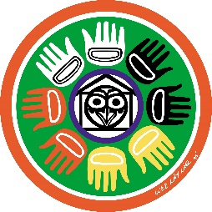
Indigenous Education Department
Coquitlam School District #43
1432 Brunette Ave, Coquitlam, BC V3K 1G5
Phone: (604) 945-7386
abedinfo@sd43.bc.ca
http://www.sd43.bc.ca/AbEd

Indigenous Education Bursaries

Should students without a Status card or without a strong Aboriginal background be eligible for bursaries?
The position of School District No. 43 aligns itself with the Ministry directive. The Ministry is not asking students who self-identify to prove a lineage. That is likely rooted in the basic principle that many Aboriginal families were assimilated. Some individuals have an Aboriginal past, and they are proud of it, but they cannot necessarily come up with a family tree.
School district No. 43 wants to empower young men and women who feel proud of their Aboriginal ancestry, and we will not ask them for proof of lineage either. We are not going to embrace an ambivalent discourse where on one hand we would promote the concept of a positive awareness of one’s identity as prescribed in the new curriculum, and on the other hand we would question a person’s identity if they cannot prove lineage. Besides, these young men and women could possibly “take the torch” tomorrow and fight for Aboriginal rights.
Once a student self identifies, s/he becomes eligible for our bursaries.
There may be situations that come up when it is obvious a person may not have Aboriginal ancestry, but may claim it (for example, a Syrian refugee). If you ever have strong doubts that you can substantiate, please let us know. We will investigate.

