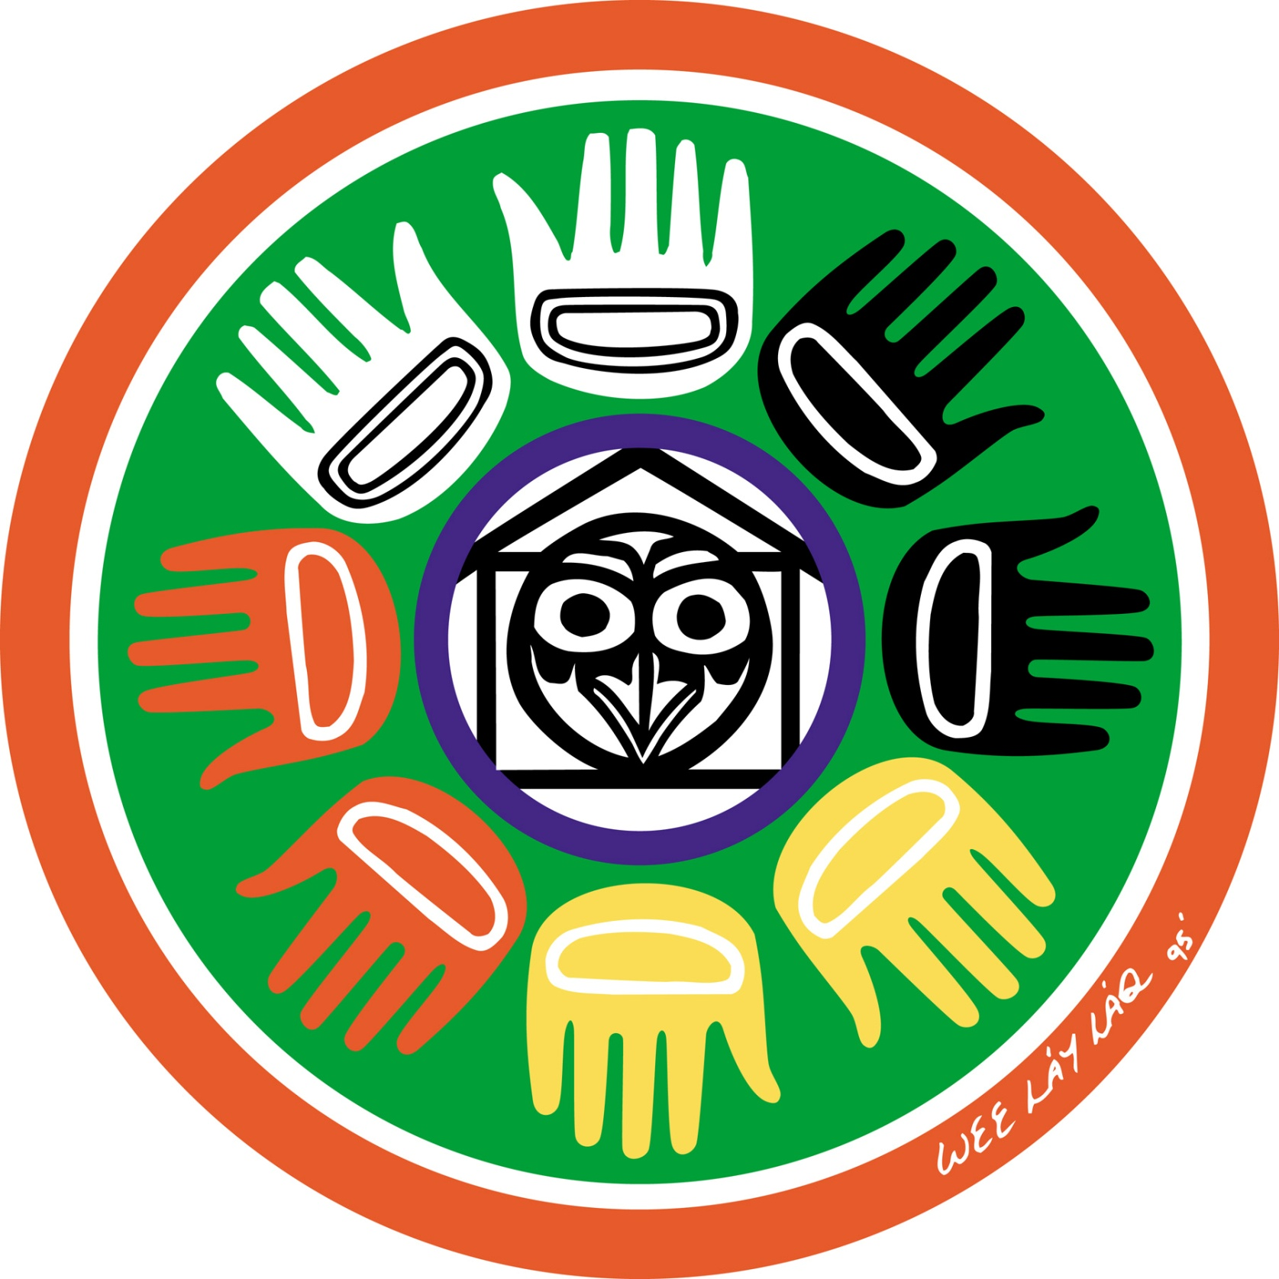
BC Core Competencies and First Nations Principles of Learning: Communication
SD43 Aboriginal Education

First Nations Principals of Learning…. | Communication | Connect and engage with others (to share and develop ideas) | I ask and respond to simple, direct questions | I am an active listener, I support and encourage the person speaking | I recognize that there are different points-of-view and I can disagree respectfully | Acquire, interpret and present information (includes inquiries) | I can understand and share information about a topic that is important to me | I present information clearly and in an organized way | I can present information and ideas to an audience I may not know | Collaborate to plan, carry out and review constructions and activities | I can work with others to achieve a common goal; I can do my share | I can take on roles and responsibilities in a group | I can summarize key ideas and identify the ways we agree | Explain/recount and reflect on experiences and accomplishments | I give, receive and act on feedback | I can recount simple experiences and activities and tell something I learned | I can represent my learning and tell how it connects to my experiences and efforts
ultimately supports the well-being of the self, the community, the land, the spirits, and the ancestors. |  |  | X | X | X |  | X | X | X |  | X | X | X |  | X | X | X
is holistic, reflective, experiential, and relational (focused on connectedness, on reciprocal relationships and a sense of place) |  |  |  | X | X |  | X | X | X |  | X | X | X |  | X | X | X
Involves recognizing the consequences of one’s actions. |  |  |  |  |  |  |  |  |  |  | X | X | X |  | X
Involves generational roles and responsibilities |  |  |  | X | X |  |  |  |  |  | X | X | X
Recognizes the role of indigenous knowledge. |  |  |  |  | X |  | X |  |  |  |  |  | X |  |  | X | X
Is embedded in memory, history, and story. |  |  | X | X | X |  | X |  | X |  |  |  |  |  |  | X | X
Involves patience and time. |  |  |  | X |  |  |  |  |  |  | X |  |  |  | X | X | X
Requires exploration of one’s identity. |  |  |  |  | X |  | X |  |  |  |  | X |  |  |  | X | X
Involves recognizing that some knowledge is sacred and only shared with permission and/or in certain situations. |  |  | X |  | X |  | X

BC Core Competencies and First Nations Principles of Learning: Thinking (Creative)
SD43 Aboriginal Education

First Nations Principals of Learning…. | Thinking (Creative) | Novelty and Value | I get ideas when I play, my ideas are fun and make me happy | I can get new ideas or build on other people’s ideas to create new things with in it constraints on a form, a problem or materials | I generate new ideas as I pursue my interests | I get ideas that are new to my peers | I can develop a body of creative work over time in an area that I am interested in or passionate about | Generating Ideas | I get ideas when I use my sense to explore | I build on others ideas and add new ideas of my own, or continue other peoples ideas in new ways to create new things or solve straightforward problems | I deliberately learn a lot about something (ex. Doing research, talking to others, or practicing) so that I am able to generate new ideas or ideas just pop into my head | I have deliberate strategies for quieting my conscious mind so that I can be creative | I have interest and passions that I pursue over time | Developing Ideas | I make my ideas work or change what I am doing | I can usually make my ideas work within the constraints of a given form, problem and materials if I keep playing with them | I build the skills I need to make my ideas work, and usually succeed, even if it takes a few times | I use my experience with various steps and attempts to direct my future work | I can persevere over years if necessary to develop my ideas. I expect ambiguity, failure and setbacks, and use them to advance my thinking
ultimately supports the well-being of the self, the community, the land, the spirits, and the ancestors. |  |  | X |  | X | X | X |  | X | X | X | X | X |  |  |  |  |  | X
is holistic, reflective, experiential, and relational (focused on connectedness, on reciprocal relationships and a sense of place) |  |  | X | X | X | X | X |  | X | X | X | X | X |  | X | X | X | X | X
Involves recognizing the consequences of one’s actions. |  |  | X | X | X |  |  |  | X | X | X | X |  |  | X | X | X | X | X
Involves generational roles and responsibilities |  |  |  |  |  |  |  |  |  | X |  |  |  |  |  |  |  |  | X
Recognizes the role of indigenous knowledge. |  |  |  |  |  |  | X |  | X | X | X | X | X
Is embedded in memory, history, and story. |  |  | X |  |  |  |  |  | X
Involves patience and time. |  |  |  | X |  |  | X |  |  |  |  |  | X |  |  |  | X | X | X
Requires exploration of one’s identity. |  |  | X | X | X |  | X |  |  |  |  | X | X |  | X | X | X | X | X
Involves recognizing that some knowledge is sacred and only shared with permission and/or in certain situations. |  |  |  |  |  |  |  |  |  |  |  |  |  |  |  | X

BC Core Competencies and First Nations Principles of Learning: Thinking (Critical)
SD43 Aboriginal Education

First Nations Principals of Learning…. | Thinking (Critical) | Analyze and Critique | I can show if I like something or not | I can identify criteria that I can use to analyze evidence | I can analyze evidence from different perspectives | I can reflect on and evaluate my thinking, products and actions | I can analyze my own assumptions and beliefs and consider views that do not fit with them | Question and Investigate | I can explore materials and actions | I can ask open-ended questions and gather information | I can consider more than one way to proceed in an investigation | I can evaluate the credibility of sources of information | I can tell the difference between facts, interpretations, opinions or judgements | Develop and Design | I can experiment with different ways of doing things | I can develop criteria for evaluating design options | I can monitor my progress and adjust my actions to make sure I achieve what I want | I can make choices that will help me create my intended impact on an audience or situation
ultimately supports the well-being of the self, the community, the land, the spirits, and the ancestors. |  |  | X |  |  | X | X |  |  |  | X | X | X |  |  |  | X | X
is holistic, reflective, experiential, and relational (focused on connectedness, on reciprocal relationships and a sense of place) |  |  | X | X | X | X | X |  |  | X |  |  |  |  | X |  |  | X
Involves recognizing the consequences of one’s actions. |  |  |  |  |  | X | X |  |  |  |  |  | X |  | X | X | X | X
Involves generational roles and responsibilities |  |  |  |  | X |  |  |  |  | X |  | X |  |  | X |  |  | X
Recognizes the role of indigenous knowledge. |  |  | X | X | X | X | X |  |  |  | X |  |  |  | X
Is embedded in memory, history, and story. |  |  |  | X | X | X | X |  | X |  |  | X | X |  | X
Involves patience and time. |  |  |  |  |  | X |  |  |  |  | X |  |  |  |  |  | X
Requires exploration of one’s identity. |  |  | X |  |  | X | X |  | X | X | X |  |  |  | X |  | X | X
Involves recognizing that some knowledge is sacred and only shared with permission and/or in certain situations. |  |  |  | X |  | X |  |  |  |  | X |  | X |  |  |  | X | X

BC Core Competencies and First Nations Principles of Learning: Personal (Awareness & Responsibility)
SD43Aboriginal Education

First Nations Principals of Learning…. | Personal  (Awareness & Responsibility) | Self Determination | I can show a sense of accomplishment and joy | I can celebrate my efforts and accomplishments | I can advocate for myself and my ideas | I can imagine and work toward change in myself and the world | I take the initiative to inform myself about controversial issues | Self-Regulation | I can recognize emotions | I can use strategies that help me manage my feelings and emotions | I can persevere with challenging tasks | I can implement, monitor and adjust a plan and assess the results | I take ownership of my goals, learning and behaviour | Well-Being | I can participate in activities that support my well-being and tell/show how they help me | I can take some responsibility for my physical and emotional well-being | I can make decisions that benefit my well-being and keep me safe in my community, including my online interactions | I can use strategies to find peace in stressful times | I can sustain a healthy and balanced lifestyle
Ultimately supports the well-being of the self, the community, the land, the spirits, and the ancestors. |  |  | X | X | X | X | X |  | X | X | X | X | X |  | X | X | X | X | X
Is holistic, reflective, experiential, and relational (focused on connectedness, on reciprocal relationships and a sense of place) |  |  |  | X |  |  |  |  | X | X |  |  | X |  | X |  | X | X
Involves recognizing the consequences of one’s actions. |  |  | X | X | X | X | X |  | X | X | X | X | X |  | X | X | X | X | X
Involves generational roles and responsibilities |  |  | X | X | X | X | X |  |  |  |  |  |  |  |  |  | X
Recognizes the role of indigenous knowledge. |  |  |  |  |  |  |  |  |  |  |  |  |  |  | X | X | X | X | X
Is embedded in memory, history, and story. |  |  | X | X | X | X | X |  | X | X | X
Involves patience and time. |  |  |  | X | X | X | X |  |  | X | X | X | X |  | X | X | X | X | X
Requires exploration of one’s identity. |  |  | X | X | X | X | X |  | X | X | X | X | X |  | X | X | X | X | X
Involves recognizing that some knowledge is sacred and only shared with permission and/or in certain situations. |  |  |  |  |  |  | X |  |  |  |  | X |  |  |  |  | X

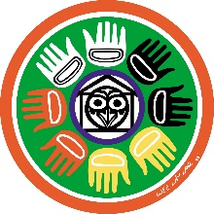
BC Core Competencies and First Nations Principles of Learning: Personal (Positive Personal Identity & Culture)
SD43 Aboriginal Education

First Nations Principals of Learning…. | Personal  (Positive Personal Identity & Culture) | Relationships and Cultural Contexts | I can describe my family and community | I am able to identify the different groups that I belong to | I understand that my identity is made up of many interconnected aspects including life experiences, family, history, heritage, peer groups | I understand that learning is continuous, and my concept of self and identity will continue to evolve | Personal Values and Choices | I can tell what is important to me | I can explain what my values are and how they affect choices I make | I can tell how some important aspects of my life have influenced my values | I understand how my values shape my choices | Personal Strengths and Abilities | I can identify my individual characteristics | I can describe/express my attributes, characteristics and skills | I can reflect on my strengths and identify my potential as a leader in my community | I understand that I will continue to develop new abilities and strength to help me meet new challenges
Ultimately supports the well-being of the self, the community, the land, the spirits, and the ancestors. |  |  | X | X | X | X |  | X | X | X | X |  | X | X | X | X
Is holistic, reflective, experiential, and relational (focused on connectedness, on reciprocal relationships and a sense of place) |  |  | X | X | X | X |  | X | X | X | X
Involves recognizing the consequences of one’s actions. |  |  |  | X |  |  |  | X | X | X | X |  |  |  | X
Involves generational roles and responsibilities |  |  | X | X | X |  |  |  |  |  | X |  |  |  | X
Recognizes the role of indigenous knowledge. |  |  | X | X | X | X |  | X | X | X | X |  |  |  | X | X
Is embedded in memory, history, and story. |  |  | X | X | X | X |  | X | X | X | X
Involves patience and time. |  |  |  |  |  | X |  |  |  | X | X |  |  |  | X | X
Requires exploration of one’s identity. |  |  | X | X | X | X |  | X | X | X | X |  | X | X | X | X
Involves recognizing that some knowledge is sacred and only shared with permission and/or in certain situations. |  |  |  |  | X |  |  |  |  | X

BC Core Competencies and First Nations Principles of Learning: Personal (Social Responsibility)
SD43 Aboriginal Education

First Nations Principals of Learning…. | Personal  (Social Responsibility) | Contributing to community and caring for the environment | With some support I can be part of a group | I can participate in classroom and group activities to improve the classroom, school, community and the world | Contribute to group activities that make my classroom, school, community and world a better place | I can identify how my actions and the actions of others affect my community and the natural environment and can make positive change | I can analyze complex social or environmental issues from multiple perspectives | I can take thoughtful action to influence positive, sustainable change | Solving Problems in Peaceful Ways | I can solve some problems myself and can identify when to ask for help | I can identify problems and compare potential problem-solving strategies | I can clarify problems, consider alternatives and evaluate strategies | I can clarify problems or issues, generate multiple strategies, weigh consequences, compromise to meet the needs of others and evaluate actions | Valuing Diversity | With some direction, I can demonstrate respectful and inclusive behaviour | I can explain when something is unfair | I can advocate for others | I can take action to support diversity and defend human rights, and can identify how diversity is beneficial for my community, including online | Building Relationships | With support, I can be a part of a group | I am kind to others, can work or play co-operatively and can build relationships with people of my choosing | I can identify when others need support and provide it | I am aware of how others may feel and take steps to help them feel included | I build and sustain positive relationships with diverse people from different generations
Ultimately supports the well-being of the self, the community, the land, the spirits, and the ancestors. |  |  | X | X | X | X | X | X |  | X |  |  | X |  | X | X | X | X |  | X | X | X | X | X
Is holistic, reflective, experiential, and relational (focused on connectedness, on reciprocal relationships and a sense of place) |  |  | X | X | X | X | X | X |  | X | X | X | X |  |  | X | X | X |  | X | X | X | X | X
Involves recognizing the consequences of one’s actions. |  |  |  |  |  | X |  | X |  | X | X | X | X |  |  |  |  | X |  |  |  |  |  | X
Involves generational roles and responsibilities |  |  | X | X | X | X | X | X |  |  |  |  |  |  | X |  | X | X |  |  |  |  |  | X
Recognizes the role of indigenous knowledge. |  |  |  |  |  | X | X
Is embedded in memory, history, and story. |  |  |  |  | X | X |  |  |  |  |  |  |  |  |  |  |  | X |  |  |  |  | X
Involves patience and time. |  |  | X |  |  |  |  |  |  |  |  |  |  |  | X |  |  |  |  | X
Requires exploration of one’s identity. |  |  |  |  |  | X |  | X |  | X | X | X | X |  |  |  |  |  |  |  | X
Involves recognizing that some knowledge is sacred and only shared with permission and/or in certain situations. |  |  |  |  |  |  |  |  |  |  | X | X | X |  |  |  |  |  |  |  |  |  | X

