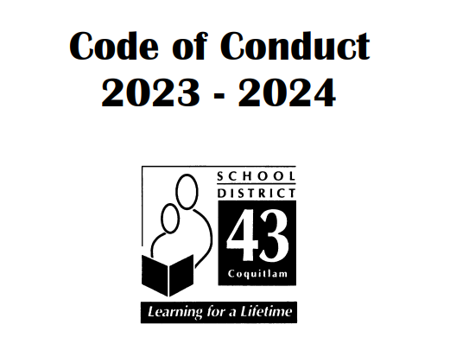
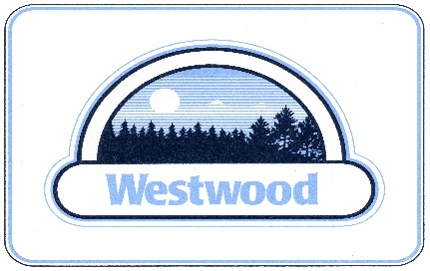

June 30th, 2023
École Westwood Elementary

ÉCOLE WESTWOOD ELEMENTARY SCHOOL CODE OF CONDUCT 2023-2024

I. INTRODUCTION

At École Westwood Elementary School we are committed to providing educational opportunities in a safe, caring, orderly, and respectful environment that encourages students to become responsible lifelong learners academically, socially, individually, and cooperatively. We have a shared goal to encourage socially responsible behaviours that contribute to the school community, solve problems in peaceful ways, value diversity and defend human rights.

Our Code of Conduct outlines the school expectations and acceptable student behaviour as directed by the School Act (85)(2)(C). It applies to behaviour in the classroom, in the hallways, on the school grounds, at assemblies, and in the community (to and from school, on field trips and at sporting events, etc.). We believe that we must take care of ourselves, each other, and this place to ensure that Westwood is a safe and nurturing educational environment.

École Westwood Elementary School promotes the values expressed in the BC Human Rights Code respecting the rights of all individuals in accordance with the law – prohibiting discrimination against a person or class of persons regarding any accommodation, service or facility customarily available to the public because of the Indigenous identity, race, colour, ancestry, place of origin, religion, marital status, family status, physical or mental disability, sex, sexual orientation, gender identity or expression, or age of that person or class of persons. – in respect of discriminatory publication and discrimination accommodation, service and facility in the school environment.

II. CODE OF CONDUCT: KEY ELEMENTS

- Process- The Westwood Code of Conduct has been developed in response to the Safe, Caring and Orderly Schools guide. Parents and Staff are given the opportunity to review the Code of Conduct each year and provide input for revisions.
- Communication- The School’s Code of Conduct is published in the Student Planner (which all students receive annually), is available on the school website, is posted in a prominent location in the school and is taught explicitly to students. Behaviour expectations as outlined in the Code are reviewed with each new employee (including temporary staff and Noon Hour Supervisors) when they join the staff.
The home is contacted to discuss any major issues around student conduct. Meetings are held when appropriate with the School Based Team members, parents, and students, and affected members of the community.
- Implementation - The staff use Morning Meetings, Circle Time or Class Meetings, and school-wide assemblies to discuss and implement the behavioural expectations outlined in the school’s Code of Conduct. In addition, Social Responsibility resources are widely used throughout the grade levels. Social Awareness and Responsibility Core Competencies are used as a baseline to gage expectations for students’ behaviours. Parents are asked to support the school behaviour expectations at home with their children. The modeling of socially responsible behaviour is expected of all adults in the school, both employees and volunteers. Our Code of Conduct reinforces the Core Competencies in all aspects of the learning at school.
- Monitoring and Review - The Code of Conduct is reviewed by staff annually. The school utilizes SNAP Learning Log with children when there is an office referral. Office referrals are reviewed

by the Principal, school-based Counsellor and School-Based Team, as appropriate. Individual positive behaviour plans are also developed, as needed, to support student learning and behaviour.

- Alignment – The Westwood Code of Conduct is aligned with District policies, administrative procedures, and the BC Human Right Code.

6. Standards
a. Statements of Purpose:
1. To establish and maintain a safe, caring, and orderly environment for the purpose of learning for all students
2. To ensure that all members of the school community understand and share the same expectations
• Behaviour is a matter of choice, not chance.
• Helping students recognize their choices and make wise ones is crucial to their social and emotional development.
• Clear expectations and consequences help cultivate a fair, safe, and positive school climate.
• Rights and responsibilities go hand in hand.
• Accepting personal responsibility for our actions is a crucial step towards becoming a thoughtful, independent, and cooperative person.
• Self-control and effective interpersonal communications are life skills that will benefit students in all aspects of their lives.

b. Conduct Expectations
These expectations apply to behaviour at school, while going to and from school, and during school-organized or sponsored activities, including behaviour beyond these times (up to and including on-line behaviour) that negatively impacts the safe, caring, or orderly environment of the school, and/or student learning.

Acceptable Conduct
Students should always be respectful to others and themselves, show imagination when working together and individually, give their best effort, show empathy to others, and take responsibility for themselves (both academically and socially).

Unacceptable Conduct
Behaviour that is deemed unacceptable include poor decision making that results in behaviour that:
• Interferes with the learning of self or others
• Creates unsafe conditions
• Results in bullying, harassment, intimidation, violence, discrimination, or possession of weapons
• Inappropriate use of technology such as computers, the internet, e-mail, text messaging, cellular telephones, or chat rooms
• Students shall not discriminate against a person or class of persons regarding any accommodation, service or facility customarily available to the public because of the Indigenous identity, race, colour, ancestry, place of origin, religion, marital status, family status, physical or mental disability, sex, sexual orientation, gender identity or expression, or age of that person or class of persons, or for any other reason set out in the Human Rights Code of British Columbia (Section 7 and 8), nor shall a student publish or display anything that would indicate an intention to discriminate against another, or expose them to contempt or ridicule, on the basis of any such grounds

• Students may be subject to discipline under the school and/or District Code of Conduct for any conduct which has the effect of negatively impacting the school environment, whether that conduct occurs on or off School District property, at a school sponsored function or activity, or otherwise.
• A search by school officials of a student under their authority or a search of student property may be undertaken if the school has reasonable grounds to believe a school rule has been or will be violated, and that the evidence of that violation will be found in the location or on the person of the student being searched. Students know that their teachers and other school authorities are responsible for providing a safe learning environment and maintaining order and discipline at school. As a result, they must know that, where reasonable grounds exist, this may require searches of students, their lockers and their personal effects and the seizure of prohibited items.
• Students should also be aware that the schools may collect, use, and disclose personal information about students for the purposes of investigating and addressing student misconduct, safety and maintaining order and discipline in school. Such collection and use of student information may include information that is obtained from witnesses or collected from other secondary information sources (e.g., social media). All personal information of students collected by the school will be collected in compliance with and under the authority of the Freedom of Information and Protection of Privacy Act (ss. 26(a), (b), and(c)) and the School Act. Questions about the collection, use or disclosure of student personal information should be directed to the Director of Information and Learning Technologies Stephen Whiffin, at swhiffin@sd43.bc.ca.
• Using/naming a physical illness, disability, or condition to threaten, harass or intimidate others in the community is unacceptable
Rising expectations
All students at Westwood are expected to try to do their personal best; respect others, themselves, and property; treat others in a safe and caring way. The display of these behaviours will vary in accordance with the age and maturity of the students as they progress through the grades. Consequences are progressive and dependent on the type of behaviour and in some instances, the age of the students; but consistent, natural consequences are the norm for all Westwood students when misbehaviours occur.

c. Consequences
Consequences for unacceptable behaviour consider the age and maturity of students as well as the severity, circumstances, and frequency of the offense. Consequences are restorative, rather than punitive, whenever possible and appropriate. Consequences are also consistent, fair, and meaningful to help students learn to make better choices for themselves in the future.

Special considerations may apply to students with special needs if these students are unable to comply with the code of conduct due to having a disability of an intellectual, physical, sensory, emotional, or behavioural nature.

d. Notification
If students breach any area of the Westwood’s Code of Conduct, their parents are informed in a number of ways, dependent on the time, circumstance and nature of the incident.

e. Additional Definitions:

Cyberspace Misconduct
Cyberspace misconduct is not permitted at Westwood Elementary. It may take the form of misuse of technology to harass, insult or intimidate others via the internet, e-mail, text messaging, phone calls, chat rooms or the like. Offences will be dealt with in accordance with the Code of Conduct consequences.
Vandalism/Misuse of School Property
Vandalism is not condoned at Westwood Elementary. Students or Community members caught in the act of vandalizing, destroying, or misusing school property will be subject to school, District, and municipal discipline dependent on the nature of the offence and the age of the individual.

Public Announcements
All students, staff, and parents are expected to stop what they are doing, be still, and listen to the announcements without talking.

S.N.A.P.

