All work and no play ...

... Is not good for the developing brain, says psychologist Dr. Gordon Neufeld

By Joanne Laucius, Ottawa Citizen February 4, 2012

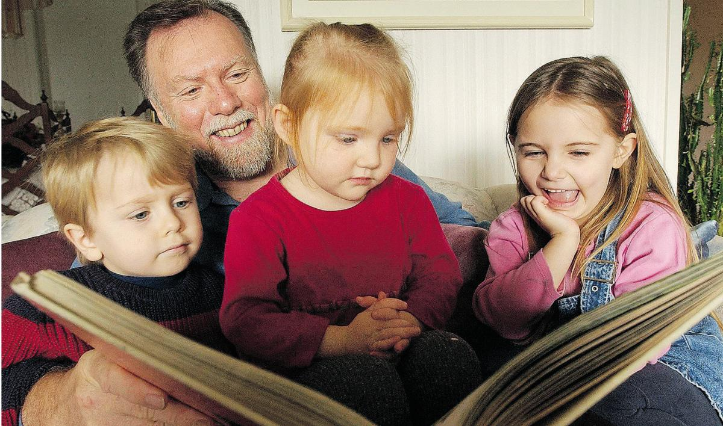

Psychologist Gordon Neufeld, above, opposes kindergarten for four-and five-year-olds unless the emphasis is entirely on play, not results.

Photograph by: Ian Smith, Postmedia News, Ottawa Citizen
Developmental psychologist and best-selling author Dr. Gordon Neufeld has thoughts about early childhood education that may come as an unwelcome surprise to parents of preschoolers and education policy-makers.
Neufeld is against four-year-old kindergarten. He's also against five year-old kindergarten. And possibly even six-year-old kindergarten. Unless, of course, kindergarten is all about play and not at all about results.
Neufeld is co-author of the 2004 book Hold on to Your Kids: Why Parents Matter, which argued that parents who relinquish the parental role too soon prompt children to turn to peers for their attachment needs, sometimes with disastrous results.
"It takes six years of ideal conditions where a child gives his heart to his parents," says the Vancouver based Neufeld, who will be in Ottawa, Renfrew and Gatineau in the next week for lectures and workshops.
Neufeld knows he's slogging into a political mire. Ontario is implementing all-day four-year kindergarten. Last October Charles Pascal, Premier Dalton McGuinty's special adviser on early learning, acknowledged that implementation might have challenges, but things would work out "if people keep a focus on what's best for kids and families."
On the other hand, critics have pointed out that in Finland, one of the countries whose students are among the highest-ranking performers in international comparisons, students don't start formal education until they're seven.
In Canada, Neufeld finds it worrisome that even though children are going to school younger and being educated more intensively, children are less curious in Grade 12 than they were in kindergarten.
"Society is increasing expectations. Parents need to be the buffer," says Neufeld, who has addressed the parliaments of European nations on early education and is scheduled to go to Brussels next fall to talk to the European Parliament.
What's the answer? Play, says Neufeld. And extended families.
Preschoolers have fundamentally different brain wiring and need to be free of consequences and "attachment hunger," says Neufeld. Germany, where the word "kindergarten" was coined more than 150 years ago, mandated play-based preschool education about a decade ago.
Play helps children build problemsolving networks. At four, five, even six, children are not ready to learn by working because the prefrontal cortex, the part of the brain where a child is capable of mixed feelings, is still under construction. "It only gets wired at between five and seven years of age," says Neufeld.
Developmentally, preschoolers have to be secure in the love and attention of their families, says Neufeld. Too often, children are pushed into performing. "You can get incredible things out of them if you detach them from marks and rewards."
What is play? Neufeld defines it as "not work." Play is expressive and it's not "for real." There are no consequences to messing up, and the child is playing for the joy of the activity, not because of an outcome. It's like playing marbles, Neufeld says. You can play for fun and take your marbles home when you're done, or you can play for keeps, where the winner takes all. Only playing for fun is really playing.
Toilet training can be work, and it can be play. If a child is told that they will sit on the toilet until they produce results, then it's work. If there's food dye in the toilet and the child is eager to find out what colour the water turns after a tinkle, then it's play. Learning to play the piano can be work for a preschool child, or it could be play. If it's coming out of a child's passion, then it's play.
"Even monkeys and elephants can be trained to perform. But there are movements to stop that," says Neufeld, who points out that even the Internet search powerhouse Google asks its employees to spend 10 per cent of their activity doing work that is consequence-free - in other words, playing with ideas with no fear of the big smackdown if they don't produce a marketable concept.
Neufeld has five children, all with different passions: One is doing advanced research in neuroscience, another in engineering. One is a vocalist and musician, another is a therapist and another teaches theatre. "I never asked them to do their homework once," he says.
The difference between children who become curious, engaged learners and those who become performers is that the curious and engaged children had parents who acted as buffers between them and society and the educational system. North American mobility and materialism have torn apart the fabric and traditions that tie families together, says Neufeld.
He has lived in France, where nursery schools or "maternelles" accommodate children as young as three. In North America, the French maternelle system is often cited as a good example of the success of early learning. But Neufeld says there are two major differences between the maternelles and North American kindergartens: in France, maternelles are based on attachment and play. The French children are still part of the "village of attachment," as Neufeld puts it.
There are benefits to early childhood education for some kids - those who are living in poverty or neglect, for example - but it's not necessary to impose performancebased education on well-functioning families, says Neufeld. The longterm effects haven't been studied. There is a well-documented headstart effect for children who enter school earlier, but that has not been studied much past Grade 4, he says.
This doesn't mean that Neufeld advocates that mothers stay at home with their children. In fact, he notes that as families become smaller and more geographically dispersed, there is far too much pressure on the nuclear family. "In North America, we have a dangerously small nuclear family," says Neufeld.
Nor was there a golden age when mothers - and only mothers - were responsible for creating a culture of attachment, he says. "Society wasn't mother-centric. It was grandmother-centric."
That doesn't mean there's no recourse for small nuclear families, single-parent families or dysfunctional families.
"If we don't have a functional family, we need to develop surrogate families," says Neufeld, who recalls a senior couple who acted as surrogate grandparents to children living on his block in urban Vancouver. Getting attached to the surrogate grandparents prevented children from getting too attached to peers.
Neufeld is now 65. His own parents created an extended circle of surrogate aunts and uncles for their children. He believes government agencies should help develop these villages of attachment instead of insisting that the state does a better job of raising children.
Neufeld says when he lectures on this topic, educators and childcare workers feel a sense of relief.
"The only resistance I get is from policy-makers."
Read more: http://www.ottawacitizen.com/life/work+play/6101021/story.html#ixzz1lp3ij6Sx

