PINETREE WAY ELEMENTARY SCHOOL
1420 Pinetree Way, Coquitlam, B.C. V3E 6A3
Tel: (604) 945-7011
Email: pinetreeway@sd43.bc.ca
Website: www.sd43.bc.ca/school/pinetreeway

Pinetree Way Newsletter – February 2018

Hello Pinetree Way Families,

When I was in Elementary school, I often felt like my learning was a series of surprises. I would complete a test and await the results not really knowing how I had done. Most of my classmates, so it seemed, had developed the capacity to understand the requisite steps to successfully jump through academic hoops, but I felt like my shoelaces were perpetually tied together! Recently, we have been talking a lot about student self-assessment of competencies. Having students learn about how they learn and putting them at the centre of assessment is one of the most powerful aspects of student achievement. I recently read some research on assessment; students’ ability to report thoughtfully on their own performance was stated as THE MOST influential part of student learning. Self-assessment was found to be even more important than self-regulation and timely feedback (wish I had known that on those many late nights spent marking Humanities 8 essays).

If I was to apply self-assessment to competitive skiing, it would be like having athletes gauge their success on what they noticed about their performance on video after completing their run. Before the run, the skier would have determined a specific part of their skiing on which to focus. Reviewing their performance through an evaluative lens that the athlete created would, in my view, produce some powerful learning. I broke my thumb while downhill skiing when I was 15. Unfortunately, my video footage would have lasted only 10 seconds. Argh! Perhaps with a bigger voice in my assessment of my skiing, I might have experienced more success. The Olympics will provide us with many great examples of athletes who engage in deep and thorough assessment. Go Canada Go!!!!

Sean Della Vedova
Principal

Calendar Dates To Remember:
February 14 Valentines Day
February 16 Chinese New Year 2018 – Year of the Dog
February 20 Backwards Day yaD sdrawkcaB
February 21 PAC Meeting – 1:30 in Computer Room – RM #104
February 22 Ache Brasil – Performing Arts – 11:00 12:00 GYM for Students
February 23 Professional Development Day – School not in session
March 2 After School MOVIE – PAC – 2:45 pm – 4:15 pm
March 16 Green Day –Term 2 Report Cards go home
March 16 - Last Day in Session – school closes for Spring Break
March 19-Apr 1 SPRING BREAK – School not in Session
March 30 Good Friday – STAT holiday – school not in session
April 2 EASTER Monday - STAT holiday school not in session
April 3 School Reopens
April 19 Crazy Hair Day
April 19 Como Lake Relays Grade 4 & 5 -– 3:00 – 5:00 pm
April 20 Professional Development Day – school not in session
May 3 Class and Panorama – Grade 5 – Photo Day
May 4 Musical Multicultural Event – 6:00 pm – 7:00 pm

Please check on the school website calendar for dates and times of events happening at
Website: www.sd43.bc.ca/school/pinetreeway. You can also find these important dates on your school magnet or in your child’s student planner.

School Spirit Wear

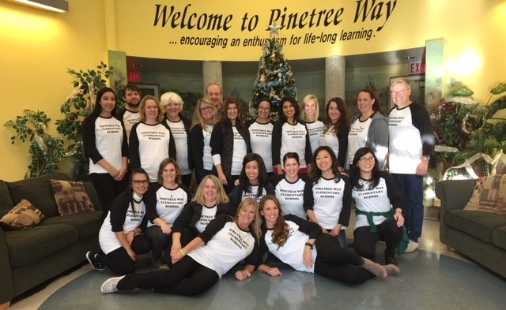

The staff are definitely in the Pinetree Way Spirit wearing their PTW T-Shirts! Thanks to all those who purchased T-Shirts and Beanies. We still have beanies (toques) available in Charcoal and Blue and a few sizes of T-shirts available. You can go to school cash-online to purchase. For T-Shirt purchases, please check first at the office with Mrs. Cowieson re availability of T-shirt sizes.

Report Cards

Take note that Term 2 Report Cards will be sent home on Friday March 16. Reminder this is the last day in session before the Spring Break.

SPRING BREAK
The last day in session will be Friday, March 16 and school will not reopen until Tuesday, April 3, 2018. Happy Easter everyone!

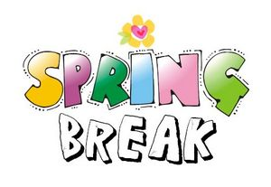

Kindergarten Registration – for the 2018-2019 School Year

Our kindergarten registration dates were February 5 – 7, 2018. Children who are five years old on or before December 31, 2018 may enter school in September 2018. You may defer your child’s enrolment until September 2019. If you have a child or a neighbor who’s child was born in 2013, please direct them to our office. To determine catchment area school, use the school locator on website www.sd43.bc.ca where you can find out complete information regarding registration and documents required.

Message from the PAC

Hello parents and guardians,

We would like to thank you for all your support and help with our very successful Scholastics Book Fair. As you know all the money we make from such events are going back to support our school and children.

For the upcoming events in our school look out for the notice coming soon for the Movie Night on Friday, March 2nd. We’ll be showing a new movie called Coco.

Also we’ll be organizing a fundraiser, along with the Epicure, selling a delicious Trio Kits containing three dip mixes. The notice will be distributed soon.

Our always popular Multicultural Evening, with different cultural performances showing the diversity in our community, is coming on Friday, May 4th.

Again, THANK YOU for all your support!
Happy Valentine’s Day from PTW PAC!

SCHOOL CASH ONLINE
As you may know, las year we have introduced a new online payment system that will allow parents to view and pay for your child’s school fees and field trips safely and conveniently online. Most schools are completely online and do not allow for cash payments. We encourage parents to register your account online now!

Here’s how to get started:
1. Go to https://sd43.schoolcashonline.com
2. Click on “Get Started Today”
3. Create your account
i. Enter your first and last name; click continue
ii. Enter fields: address, phone number, e-mail address; click continue
iii. Choose a password and security question
iv. Make sure to OPT IN to receiving e-mail notifications for updated school information

For further inquiries call the School Cash Online Support Line #1-866-961-1803

FRIENDLY REMINDERS

LOST AND FOUND

When picking or dropping your child off make sure to check our lost and found for clothes, empty lunch containers etc. in the lobby of our school
.

School start and pick up time
A reminder to parents that the first school bell rings at 8:40 am each school day and that school starts promptly at 8:45 am. Please ensure your child is at school on time each day as this greatly helps their learning and transition to school each day. School dismissal time is 2:45 pm each day. At the beginning of each school day and at the end of each school day we request that parents drop off and pick up their children from exterior classroom doors. Doing so will keep our hallways clear and will facilitate critical conversations and important information being shared between teachers and students at these times of the day. Thank for your cooperation with this.

Attendance – Absent/Late
If your child will be late or absent, whether for illness, appointment, vacation, please call the school at 604-945-7011 and you can leave a message on the answering machine. You can also send a message to pinetreeway@sd43.bc.ca and advise of your child’s absence. If your child is late, please send them to the office to obtain a late slip as the student has been marked absent. That way we can mark the student present. We appreciate your assistance in this matter.

Parking
Parking is always quite busy on and around our school property. Parents please follow these helpful tips in regards to parking at our school so that our students and families can stay safe.
- Please only park your vehicle on the street, or in the lower parking lot.
- Please DO NOT park in the staff parking lot as this space is reserved for school staff and for those families with students who have physical disabilities.
- When dropping off or picking up your child in our drop off loop, please stay in your car and pull forward so we can keep the flow of traffic moving. Please DO NOT park in the drop off loop as this causes congestion and backs traffic onto the street.
- Use caution, drive slow and adhere to traffic rules
- Walk your child to school instead. (This can be a great opportunity to connect with your child and share your day with each other)

Community News

See pages below for community events and SPRING BREAK Classes

Please contact the programs directly

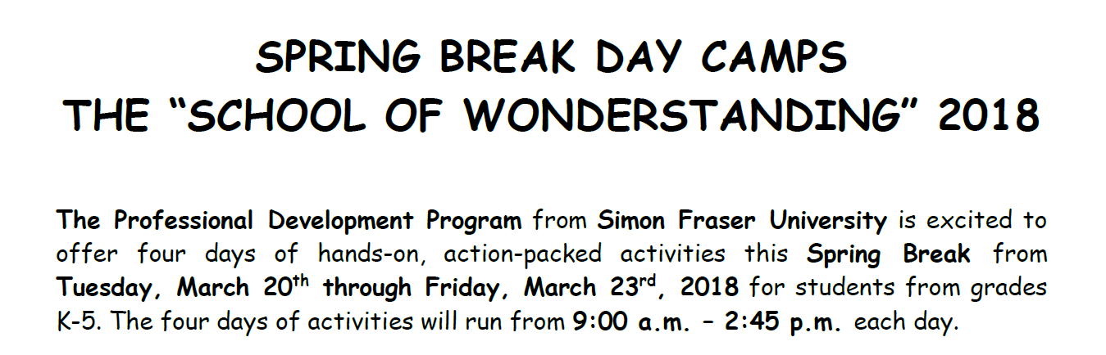
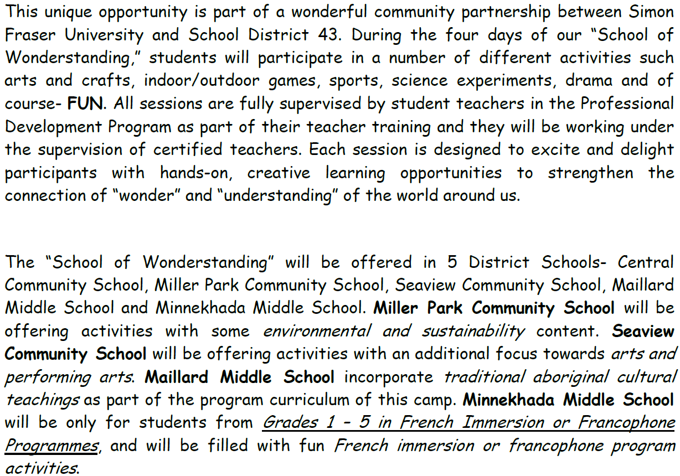

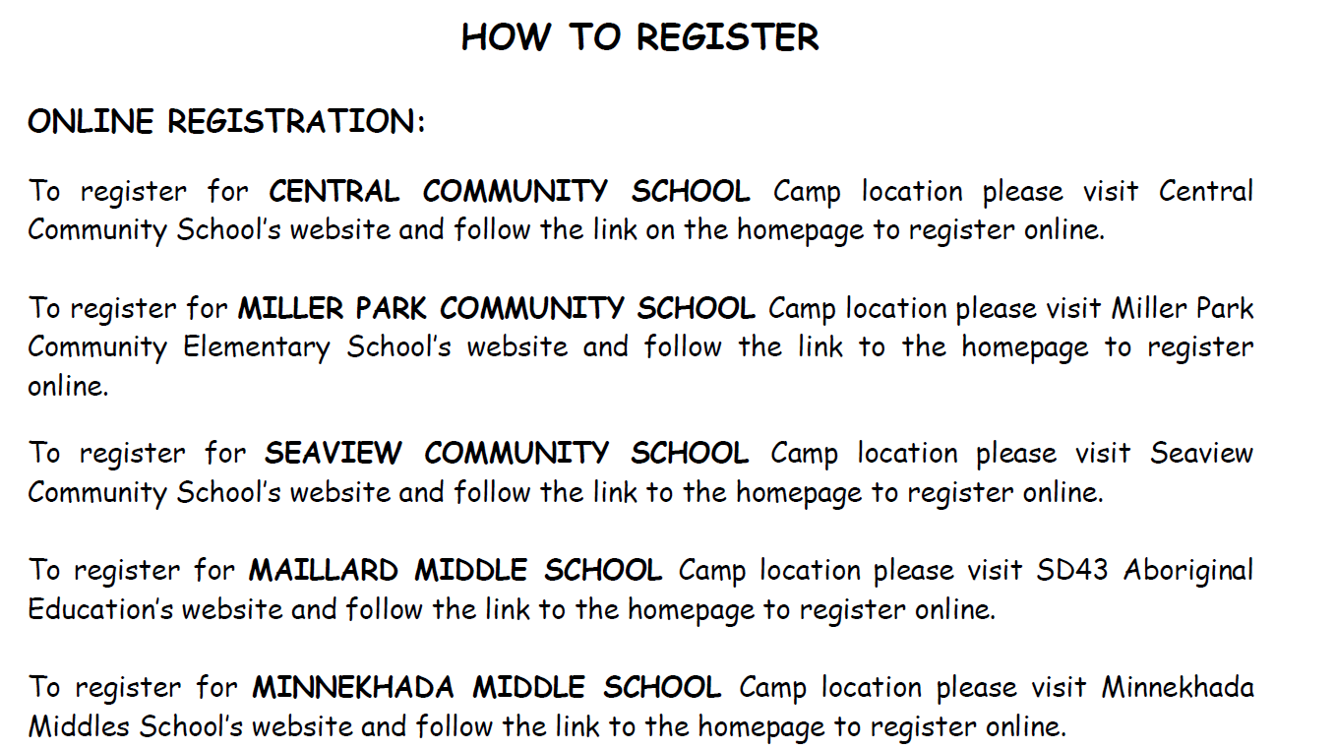

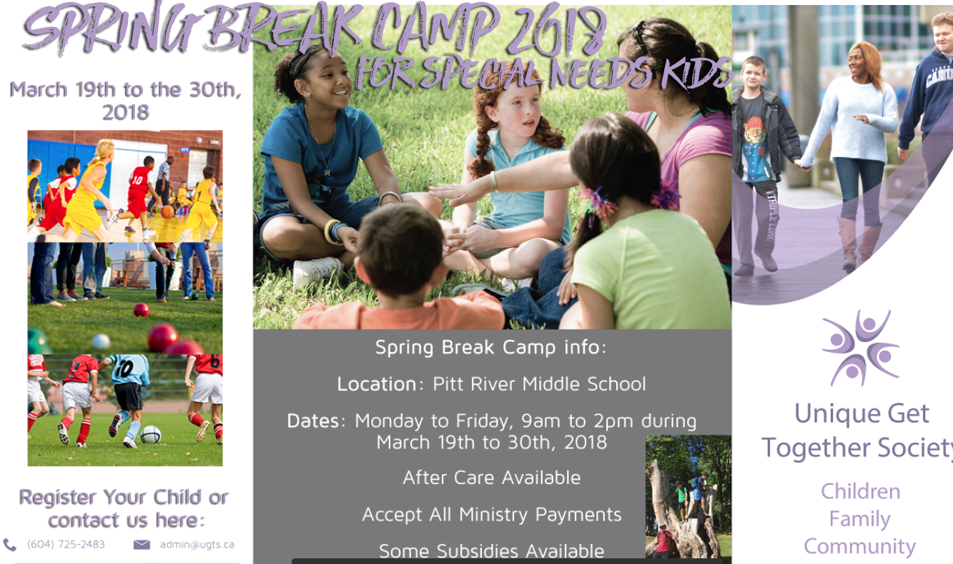

Thank you for taking the time to read this very important newsletter.

Pinetree Way

