Newsletter- September 4th, 2018
I am so excited to start working with the students at Mountain View. My name is Jody Moss and I am the new Principal. I have an open-door policy so please always feel welcome to bring your ideas to my attention. I have two kids of my own and a dog name Jake. I have worked as a Vice Principal the last four years at the high school level but I couldn’t be more excited to make my way back to elementary.
Jody Moss
School Supplies
Our classes use a bulk order system as it is more economical. Parents have the option of purchasing items on their own. The cost for the school supplies is $40. You can pay by cash or online at https://schoolcashonline.com. A list of supplies can be found on our web page at www.mountainview@sd43.bc.ca

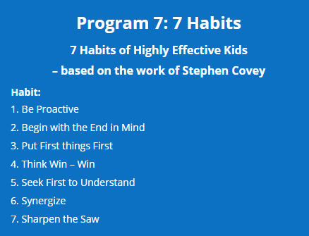
On the Calendar
September 6th- Motivational Magic Guest Speaker (parents welcome)
September 10th- Students move into their classes.
September 12th- Parent Advisory Council Meeting at 6:30pm
September 19th- Open House at 6:30pm
September 20th- Terry Fox Run at 2pm
September 21st-Professional Day for Teachers (no school)
September 27th- Hot Lunch

Parking is a limited resource at Mtn.View. Please do not park in our staff parking lots. We encourage families to plan ahead, park on the street and walk to school.
Attendance
Every morning and after lunch, the classroom teacher takes attendance. If your child is going to be away or late, please submit your child’s absence online or call.
(604) 936-7288
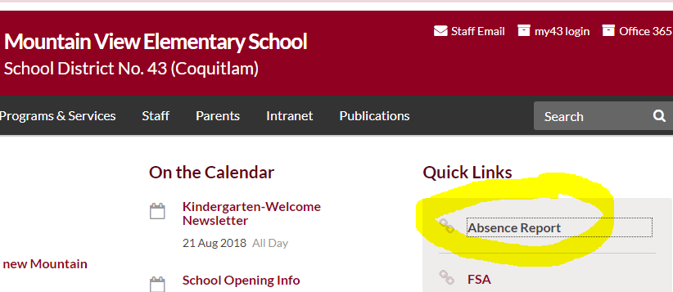
If your child is not in class and we haven’t heard from you, our secretary, Mrs. Kerr will call home to check on the whereabouts of your child. School starts at 8:50am and students are dismissed at 2:50pm. Getting places on time is an important life lesson.

Please ensure your information is up to date…especially your phone numbers and email addresses.
Follow us on Twitter at twitter@mtn.viewsd43

