École Moody Middle School of the Arts
PAC GENERAL MEETING AGENDA
Wednesday, January 12 at 6:30pm by ZOOM

________________________________________________________________________________________
2021-2022 PAC Executive Members:

Co-Chairs – Kerry LeCorre, Kimiko McDonnell
Vice-Chair – currently vacant
Co-Treasurers – Alicia Purvis / Danny Raposo
Secretary – Michelle Blackwell
DPAC – Samantha Kuypers
Hot Lunch Lead – Carla Pasqua
Volunteer Coordinator – Kimberley Thompson-Suzuki
Communications Lead – Sonya Burdett
________________________________________________________________________________________

HAPPY NEW YEAR !!
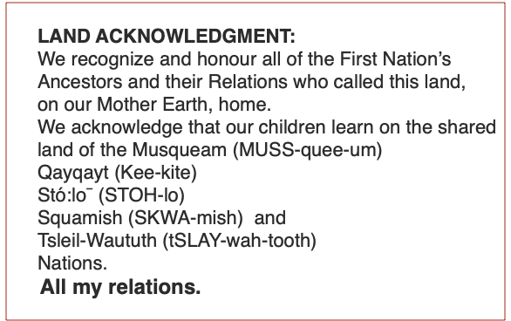
1. Land Acknowledgement (Kimiko)
2. Welcome and Introductions of PAC members (All)
3. Approvals – 2 mins
a. Tonight’s Agenda
b. Minutes of the December 14 General Meeting

4. Principal & Vice Principal’s Report – 35 mins (Mark/Kathryn)
5. Executive Reports -- 15-20 mins
a. Co-Chairs (Kerry and Kimiko)
- Parent Feedback Survey rollout (Kimiko)
b. Treasurer (Alicia and Danny)
c. DPAC (Sam)

6. Current and Upcoming Fundraising Program Updates – 10 mins
- Hot Lunch/PAC Parent Portal (Carla and Terri)
- Raise the Funds (Kerry)
- Global Coffee (Kerry)
- Year-round fundraisers (Port Moody Liquor, Cobs, etc.) (Alicia)

7. New Business – 10 mins

8. Dates for remaining PAC Meetings:
February - March -
April - May –
June -

9. Adjournment

