Action Plan for Learning
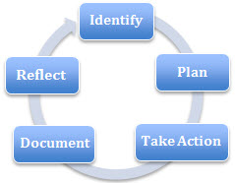 | School Name: Meadowbrook
 | School Goal: Social Emotional Learning
 | School Year: 2018- 2019

Goal / Inquiry  Student learning | How can we strengthen our learner’s position on the concentric rings of care?  1. increase the understanding and use of the model of the concentric rings of care as a way of strengthening learners’ capacity to regulate in different learning environments.  2. increase opportunities for learners to discuss and reflect on the aspects of the concentric rings of care so as to move our learners to a maturing view of what it means to care in each domain.

Rationale  1-3 reasons for choosing goal | We believe we have found a theory and construct that is helping our learners develop their capacity to regulate which indicates social emotional wellness. We believe that it is vital to continue this journey to facilitate our learners continued development of self and others. Data indicates that learners are beginning to internalize what it means to care and we feel having this as our focus for another year will further imbed the concept in our practice and our daily life.  Teachers have indicated that they have a desire to learn how best to support learners with trauma and we believe the APL goal will support this.

References and sources to support actions | Nel Noddings – Educating Moral People  Downey, L. (2007). Calmer classrooms: A guide to working with traumatised children.  Office of the Child Safety Commissioner, Melbourne, Victoria, Australia.  www.ocsc.vic.gov.au.  Barr, D. (2018). Childhood trauma: When trauma hinders learning. Phi Delta Kappan International, March (4), kappanonline.org.  Watson, M. (2003). Learning to trust. San Francisco, CA: Jossey-Bass.
Backup Documentation | 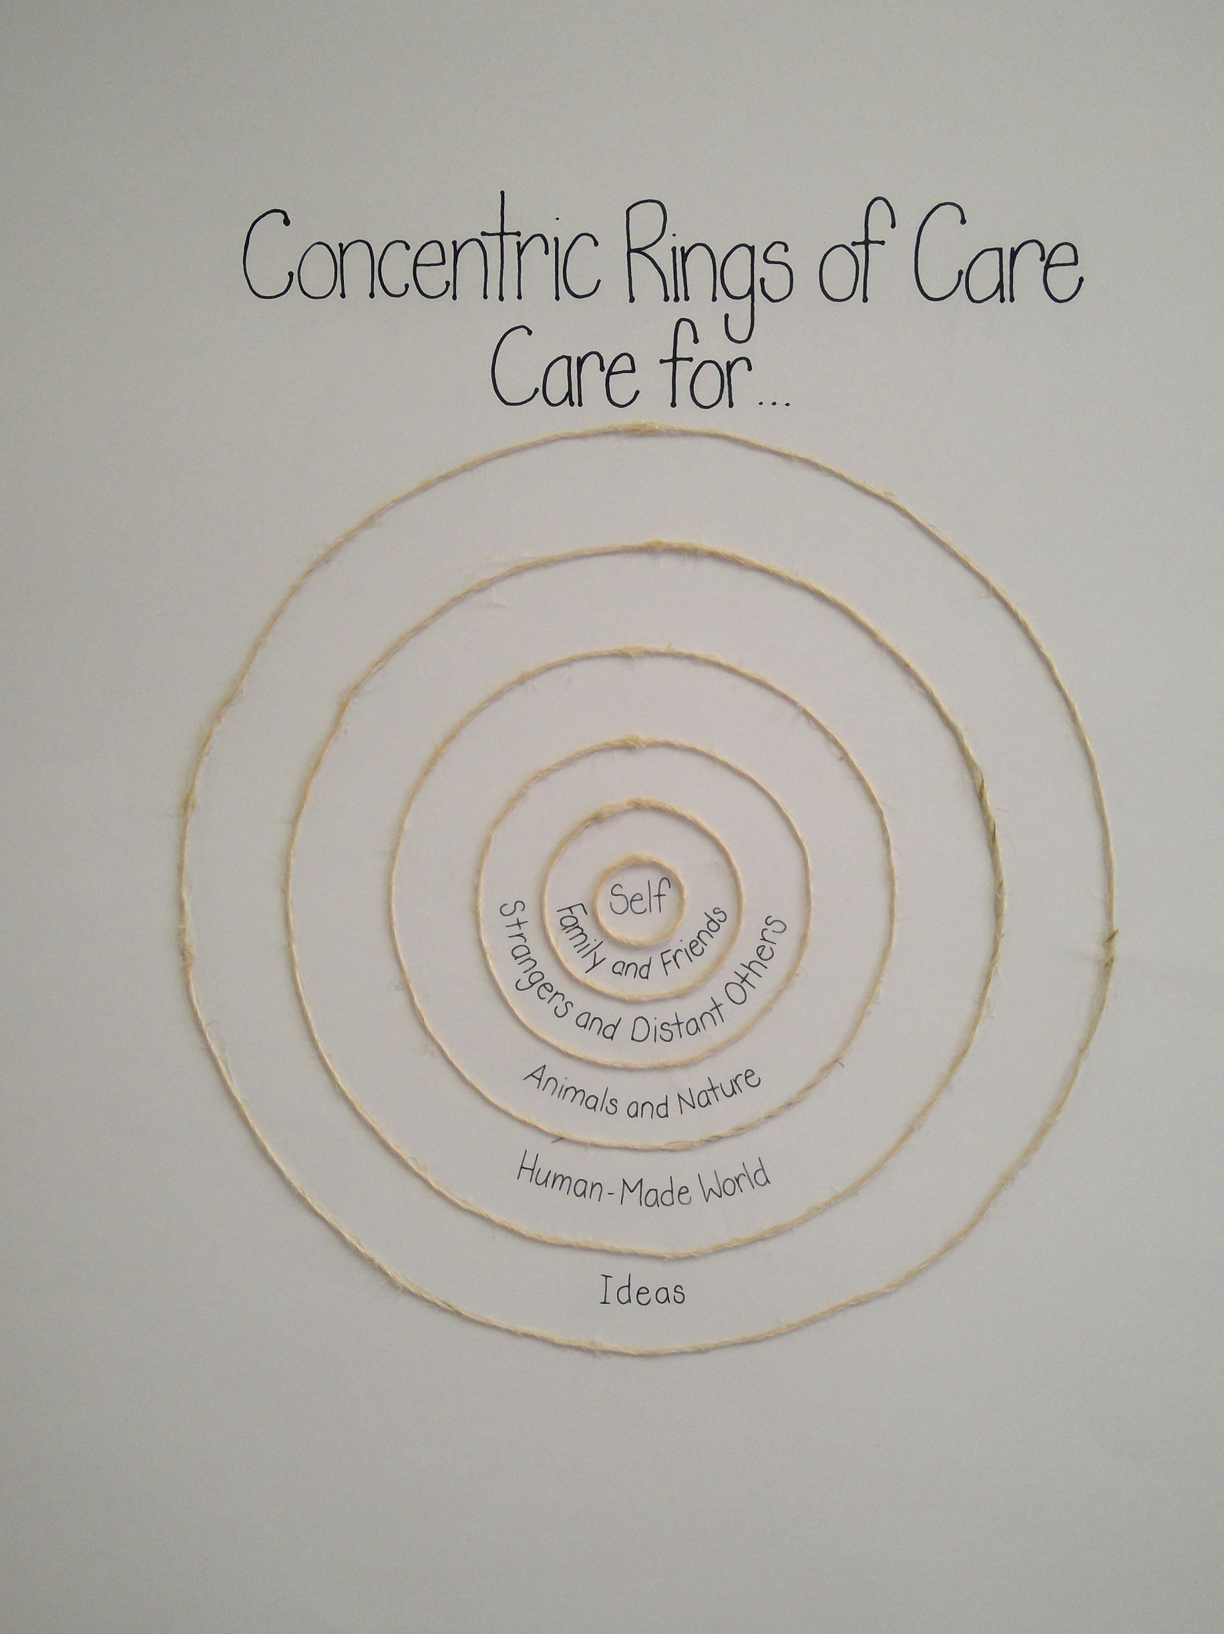

Planned Actions  Continuing practices working well (1-3)  - What will we do differently? (1-3)  - How will we provide for staff development and collaboration?  - How will we involve parents?  - How will we involve students?  - How will we monitor progress and adjust actions? | Continuing Practices  - Continuing to use the office reflection sheet that was adapted this year. Restorative practices approach to discipline  - Continuing to facilitate the use of calming tools (circles, places and objects)  - Taking advantage of school wide opportunities when they present themselves to explicitly attend to the concentric rings  What we will do differently?  - Ensure whole staff is together when discussing the APL (beginning, middle and end of year)  - Invite AbEd teachers in to support teacher and student  - Library books will be available for each of the rings.  Staff development and Collaboration  - Staff meetings will explicitly focus on an element of care modelling, dialogue, practice or confirmation) so teachers can see what we are doing interfaces with the APL in a tangible way and supports their classroom practice. Deconstruct concept  Parent Community  - We will share our model of care with the PAC at a fall PAC meeting and communicate updates in newsletters and student led conferences. We look at infusing the language into our student led conferences  Monitoring  - We will use a portion of every staff meeting to reflect and discuss our goal and how we can further imbed it into our daily practice  - We will develop protocol to be used by classroom teachers and learners to gauge the impact of our practices on learners and the community as a whole.
Backup Documentation

Documentation of learning  Key evidence of change  - How did your actions make a difference?  - Choose 1-3 pieces of evidence to demonstrate the impact your actions have had on student learning to meet your goal.  - Documentation could include video, survey results, performance standard data, anecdotal evidence, work samples, etc. | - Teachers who were able to deepen their understanding of the concentric rings and infused their daily practice with the language of the concentric rings did influence their children in taking a stronger position in these areas. ( based on the year end data collected – there was evidence of a more mature view of what it means to care in each domain) ( See examples from learners attached)  - Office documentation – became a true opportunity to dialogue. In previous years learners would fill out a reflection sheet and have parents sign with occasional follow up by admin or counsellor. This year the documentation reflected the rings of care. See attached. Now when a learner is struggling to show their best self we start a dialogue with the learner using the format attached. The dialogue included a chance to reflect on the areas of harm based on the concentric rings and how to repair harm and move forward. Usually the parent was part of the dialogue for the purpose of learning. Admin or counsellor supported the learner and parent in the conversation and how to move forward so that the learner could show their best self. Often this took happened over the course of several days or weeks, so it became a more fluid and thoughtful process that truly attended to promoting social emotional well being.  - School Wide Practices – DC group (SPCA) / Kindergarten volcano fundraiser/ Gardening day – we explicitly infused the language of care. Stream of Dreams – implicate application but explicate .
Backup Documentation | 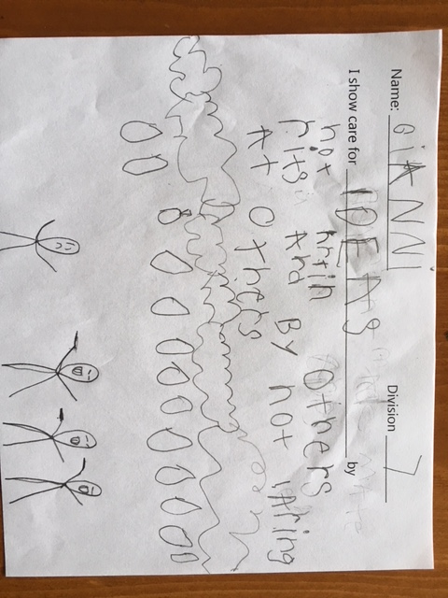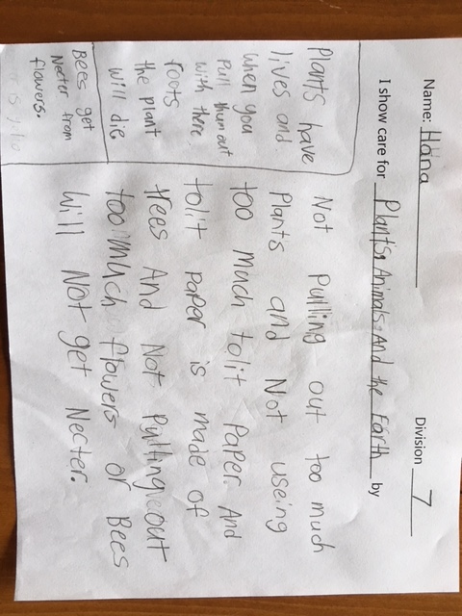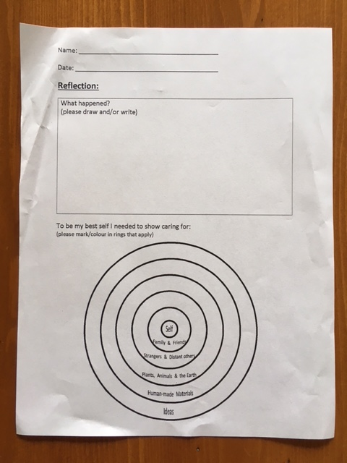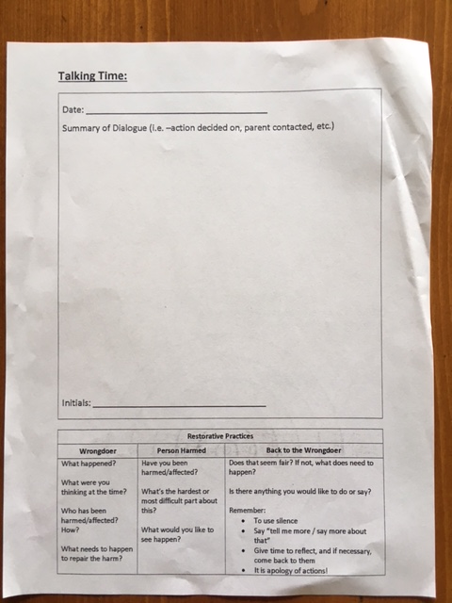

School Community Engagement Process  - How did you engage parents, teachers, students & support staff in developing your APL?  - How did you share your APL goals with parents, teachers, students & support staff? | - PAC meeting – Jocelyn shared the theory and practice of concentric rings  - Movie night – see attached. We worked with our parent volunteer to make movie night more reflective of the APL so that learners and adults alike are showing their best self and showing care. Admin and counsellor went into each class to talk about movie night and the changes so that going forward learners knew what to expect.  - Staff meeting – staff mobile (including EA/ noon hours)  - 2 by 20 – focus on one learner for 2 minutes a day for 20 days  - Wishing rocks- every class completed a wishing rock collage facilitated by our counsellor
Backup Documentation | 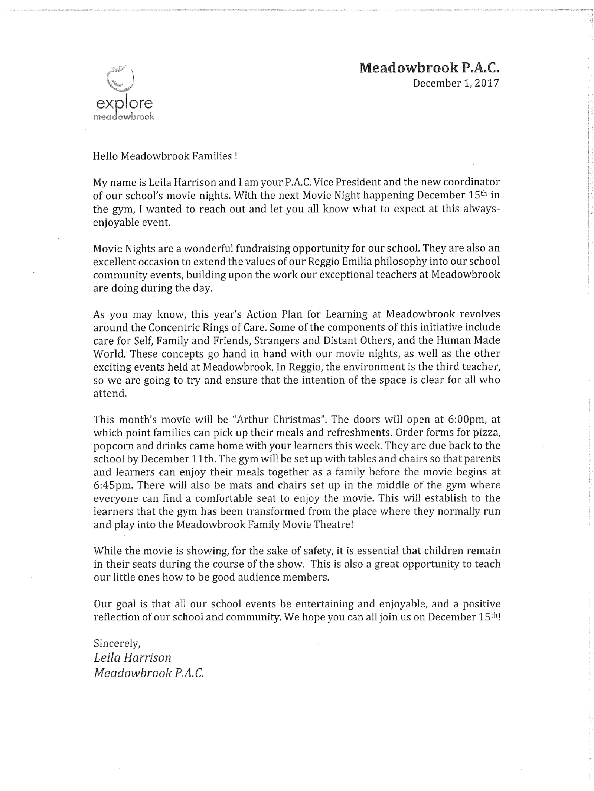

Reflection Highlights  - Where are we now?  - What are some patterns emerging?  - What surprised you?  - What conclusions / inferences might you draw?  - How does this inform potential next steps? | To be updated in April as we work our way through the planned actions  - We have teachers who are curious and would like to deepen their understanding for next year  - People are connecting their daily practice with the concentric rings. It is becoming organic with opportunities to explicitly use the language emerging.  - Report card comments used by a few teachers infused the language of the rings ( this was organic as we didn’t discuss this as a class  - When initial info is presented the whole staff needs to be there ( some teachers attended a district wide pro d on that day)  - Autonomy, Belonging and Competence – needed to feel well by all (adults and children) – this is what we focused on. – Didn’t resonate  Next year – way you apply care theory is modeling, dialogue, practice and confirmation. Focusing on that in an explicit way rather than using the language of ABC. It is all about believing that there is a best -self sitting inside ourselves. Focusing on teachers understanding that confirmation is important for learners to feel. This maintains a sense of hopefulness for teachers, students and parents.  - School based pro d days – need to be thoughtful about the pro d days so we utilize them for best practice.  - Library books for care theory – offering teachers material so they can apply the theory.
Backup Documentation | - Report card comments

(Delete this section if Literacy is your main goal)
Literacy Data
Attach the following:
- Classroom Assessment
- School Assessment
- FSA results

Signatures
School Name: Meadowbrook | School Goal: Social Emotional Learning | School Year: 2017-2018

Title | Name | Signature
Principal | Dawn Holden
Assistant Superintendent | Reno Cioffi

Print this page, have it signed by Principal & Assistant Superintendent, scan it and attach it here

