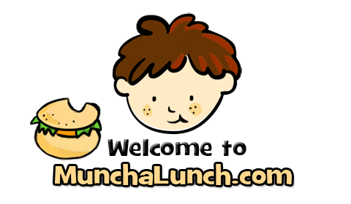

Welcome to the PAC’s main ordering system!!! Every family must have a MunchaLunch account in order to participate in Hot Lunch, Treat Days, and most Fundraisers.
**Please note: If you already have an account from last year, you DO NOT need to create a new one. Just log in and update your child’s grade/division**
To create a new account / to access MunchaLunch, please go to:
https://munchalunch.com/login
You can either pay with a Credit Card right on the MunchaLunch website, or you can pay by Cash or Cheque. If you are paying by cash or cheque please make sure to include your order # or the child’ first and last name when handing it in.
*Order cut offs will be the Friday before hot lunch delivery day.
*For those of you who do not own a computer or would like help with setting up your account or ordering from MunchaLunch, please contact our Munchalunch Coordinator
Cynthia Johnson

