Action Plan for Learning
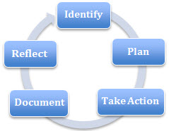 | School Name: James Park Elementary
 | School Goal: Social Emotional Learning
 | School Year: 2017-18

Goal / Inquiry  Student learning | To improve our community’s social emotional abilities and skills.  To focus on our school wide values and beliefs – Safety, Respect, Kindness, Trust and Learning.

Rationale  1-3 reasons for choosing goal | - Self-Regulation skills (Zones of Regulation) have been a focus for the last three years.  - Staff continues to notice that emotional dysregulation is a significant barrier to learning, affecting not just dysregulated students, but all the students whose sense of calm and safety are disrupted by the behavior(s).

References and sources to support actions | - BC Performance Standards for SEL, conflict resolution  - Zones of Regulation book  - Children with Trauma and Trauma Informed Behaviour Plans - Kim Viljoen presentation to staff at October 2015 staff meeting  - Building School Culture – John Goheen presentation at May 2016 pro-d day  - Staff pro-d: Presentations by Anna Lenarczyk (IST) and Lynda Swain (District OT) on self-regulation, FASD and sensory needs of students at multiple staff meetings in the 2016 – 2017 school year  - Establishment of school wide values and beliefs – involving students, parents and staff
Backup Documentation | - http://www.zonesofregulation.com/index.html (book was purchased for all classrooms)  - https://curriculum.gov.bc.ca/competencies/personal-awareness-responsibility

Planned Actions  Continuing practices working well (1-3)  - What will we do differently? (1-3)  - How will we provide for staff development and collaboration?  - How will we involve parents?  - How will we involve students?  - How will we monitor progress and adjust actions? | Continuing Practices:  - Use of Zones of Regulation  - Respectful interactions with students to model self-regulation  - Use of the newly established sensory room  - Full time position for behaviour support teacher  - Engaged school community in identifying school-wide beliefs: Safety, Kindness, Respect, Trust and Learning  - Use staff meeting time to report on progress and discuss further action  - Keep parents updated through school newsletters  - Involving students, parents and staff in ‘doing’ our school-wide beliefs  - Purchase sensory equipment for student use in all classrooms  What will we do differently?  - Collect data on office referrals  - Collect anecdotal reports from staff and parents  NEW  - Since April 2018, we have received support from the Breakfast Club of Canada, allowing us to serve a healthy, nutritious breakfast every school day of the week. At this point, we are unable to comment on the effect a healthy start to the day may have on our student population and their social-emotional skills, but the participation in this program has been astounding (see attached document – an average over 96 participants per day!). It has also been noted by staff and parents that the breakfast program has made an amazing impact on our community in terms of providing a strong sense of community right from the start. According to several parents, their children are looking forward to coming to school now ever since the breakfast program has started.
Backup Documentation | Anecdotal (teacher, student, parent) evidence  Office referral documentation

Documentation of learning  Key evidence of change  - How did your actions make a difference?  - Choose 1-3 pieces of evidence to demonstrate the impact your actions have had on student learning to meet your goal.  - Documentation could include video, survey results, performance standard data, anecdotal evidence, work samples, etc. | - The need for social emotional learning at James Park is evident on a daily basis. Over the last three years, we:  - chose to focus on the Zones of Regulation and establish a common language  - went through a number of pro-d sessions, focusing on self-regulation  - identified common values and beliefs, involving students, parents and  Staff  - the principal restructured James Park’s student services model, creating  a full time behaviour support, a full time skill development and a full  time (reading) resource position at the school  - we made efforts to keep our school wide values and beliefs at the  Forefront; it is clear that our students know these values  Staff and parents alike have mentioned on numerous occasions how different the school feels this year. The number of behaviour incidents and office referrals have gone down significantly. We increased the number of Student Services classrooms from two in 2015-16 to four locations in the 2016-17 year, in that we added a sensory room and a designated skill development room to the school. Doubling the locations where students can be supported throughout the day have given us more options to work with students with special needs. Creating the role of a behaviour support teacher (and staffing it with a teacher who is highly gifted in this area) allowed us to use reverse integration for students with behavioural needs throughout the year, especially at the beginning when rules and routines are re-established with returning students and established with Kindergarten and new students. Further, classroom teachers and student services teachers communicated effectively around scheduling of subject areas, leading to a more efficient use of staff resources, including EAs. Student services teachers have worked extremely well together and were able to clearly define areas of responsibilities.  Last but not least, this year we began a journey identifying our school culture, values and beliefs involving students, parents and staff. Now, at the end of the 2017-18 school year, all students are able to recite our 5 identified values and beliefs: Safety, Kindness, Respect, Trust and Learning. Our new school logo also reflects these school-wide beliefs and values. We feel that this year marks the beginning of our journey, and our vision is that these values will not only become second nature to all who work and play at James Park, but are also acted out on a daily basis.  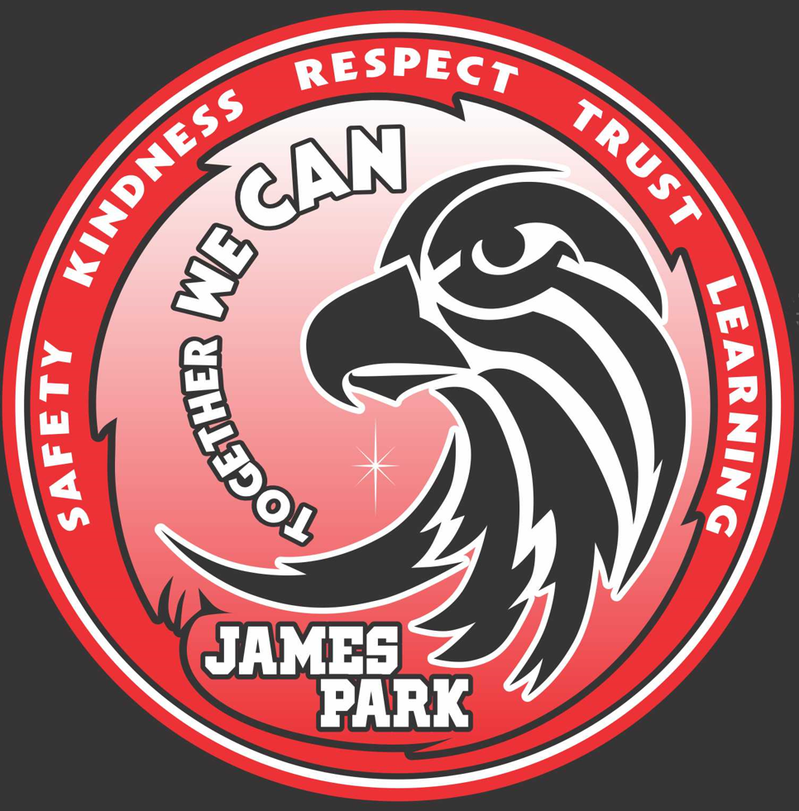

Reflection Highlights  - Where are we now?  - What are some patterns emerging?  - What surprised you?  - What conclusions / inferences might you draw?  - How does this inform potential next steps? | Is James Park a perfect place? Have we been able to eliminate all misbehaviours? Not quite! In fact, we still have ways to go, but there is a definite ‘We are on the right track’ feeling in the building. Similar to my last two years at the school, we are expecting a number of students with significant social and emotional needs joining us for Kindergarten in September 2018.  We are not sure what is causing this phenomenon but more often talk about how different it is being a small child today, and how those experiences affect the child’s ability to regulate. We notice the media is also reporting on this.  We will continue to work with staff, parents and students. And, even though we have experienced cuts in the area of student services for next year, the principal was able to maintain full time positions for our behaviour support and skill development positions next year. Since we are on the right track, we will continue in this direction.  In addition, due to retirements and four maternity leaves on staff, the principal has requested pro-d support from our IST department and the district OT, especially at the beginning of the school year.  A positive outcome of the daily use of our sensory room was that enrolling staff has become curious about and requested sensory equipment for students in their classrooms. Funds were made available to purchase these items and teachers will be able to sign these items out on a monthly basis for their students.

Signatures
School Name: | School Goal: Numeracy | School Year:

Submitted by School Planning Council:
Title | Name | Signature
Principal | Mr. M. Jankowiak
Parent | Ms S. Hanan
Parent | Ms T. Bradshaw
Parent | Ms D. Kroeker
Recommended by Assistant Superintendent:
Assistant Superintendent | Mr. G. Shong
Board and Superintendent Approval:
Board Chair | Kerri Palmer Isaak
Superintendent | Patricia Gartland

Print this page, have it signed by School Planning Council, scan it and attach it here

