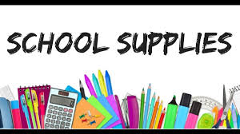
All necessary school supplies will be ordered by bulk this year and will be put onto your account on School cash online to be paid.
Pricing info will come out as soon as it is available.
Please contact office for any questions.

