Code of Conduct
2010 – 2011

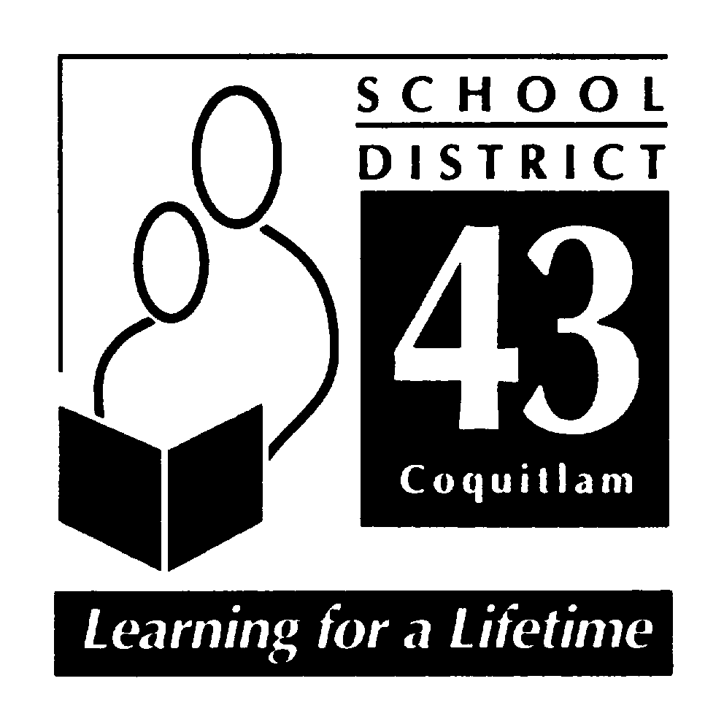

June 2010

“Hampton Park Elementary School”

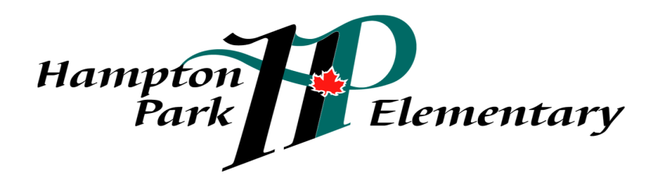

School Mission:
Hampton Park: working together, encouraging and supporting
Safety, Pride, Achievement, Respect and Kindness
“Hampton Park Elementary” Code of Conduct

I. INTRODUCTION
As described on p. 9 of ‘Safe, Caring and Orderly Schools’, BC Ministry of Education, March 2004:
Hampton Park strives to develop positive and welcoming school culture, and is committed to fostering optimal environments for learning. Members of our school community share a commitment to maintaining a safe, caring and orderly school. We focus upon prevention of problems and use school-wide efforts to build “community,” fostering respect, inclusion, fairness and equity. We set, communicate and consistently reinforce clear expectations of acceptable conduct. We teach, model and encourage socially responsible behaviours that contribute to the school community, solve problems in peaceful ways that value diversity and defend human rights.
Hampton Park has a ‘zero tolerance’ policy for any kind of bullying activities, aggressive behaviour or foul language. For purposes of discussion, bullying is to be defined as any of the following behaviours:
- Physical violence and attacks
- Verbal taunts, name-calling and put downs
- Threats and intimidation
- Extortion or stealing of money/possessions
- Exclusion from peer group
- Racial verbal abuse
- Cyber bullying

II. CODE OF CONDUCT: KEY ELEMENTS

- Process
Hampton Park developed a school-wide policy for social responsibility using the EBS (Effective Behavioural Support) framework. A matrix, referred to as ‘Hampton Park SPARK’ was developed and describes expectations for appropriate behaviours in a variety of settings. The matrix was presented to students and parents. Revisions were made based upon input gathered from these two groups. This matrix is reviewed annually and revised as necessary. Policies in respect to progressive consequences are posted in student planners for annual review by parents and students. Hampton Park’s Code of Conduct was reviewed and written as follows:
History:
- Principal and Department Heads reviewed Hampton Park Code of Conduct
- Taking key elements from this document; from responses from Department Heads; from parent survey responses and gathering elements from previously published materials, the principal consolidated a DRAFT Code of Conduct including the Hampton Park SPARK matrix
- Principal brought this draft Code of Conduct to the Department Heads and then school staff for review and comment
- Principal introduced this draft Code of Conduct and SPARK Matrix to October 2006 PAC Meeting for comment
- Principal brought this draft Code of Conduct to parent members of the SPC (School Planning Council) for discussion and comment
- Revisions were made based upon feedback and input from these groups
- Revised draft was taken to a meeting of principals from schools in close proximity to Hampton Park seeking alignment
- Revisions were made based upon suggestions arising from this meeting
- Draft Code of Conduct was brought to Staff Meeting for final review and comment
- Revisions were made based upon suggestions arising from this meeting
- Student representatives were brought together to examine and provide feedback on aspects of the Code of Conduct including: the Hampton Park SPARK matrix; acceptable and unacceptable conduct; rising expectations; consequences; notification; and follow-up
- Revisions were made both to Hampton Park’s Code of Conduct and matrix based upon suggestions arising from this meeting
- Final draft of Hampton Park’s Code of Conduct presented to staff and to PAC Chair
- Code of Conduct is revised annually and brought to the SPC, Classroom Meetings, Student body at SPARK 40 Minutes, Department Head Meeting, and Staff Meeting
- Revised Code of Conduct was reviewed by parent members of the School Planning Council and then presented annually at the October PAC Meeting
- Code of Conduct is updated on the school’s website
- The Code of Conduct is reviewed twice per year, most recently, May 2010

- Communication
Hampton Park’s ‘School-Wide Policy for Progressive Consequences’ is published in our students’ planners. The matrix, ‘Hampton Park ‘SPARK’ is published on the back cover of student planners; on the school website; and on the PAC bulletin board. As well, the same are presented to kindergarten parents at a Kindergarten Orientation Meeting in May of each year. The matrix for school-wide expectations is prominently displayed in each classroom. During daily morning announcements a goal for socially responsible behaviour is set for each week and reviewed with students by classroom teachers. Monthly Recognition Assemblies highlight student successes, linked to academic success and to positive socially responsible behaviours. In addition, each student composed a “commitment statement” outlining a goal for the school year, which could have an academic or social focus.
3. Implementation
Hampton Park Elementary begins each new school year with ‘Week 1 Activities’ based around teaching, modeling, role-playing and practicing elements of socially responsible behaviour as described in our ‘Hampton Park SPARK’ matrix. During the year, teachers continue to teach and actively promote socially responsible behaviour using a variety of strategies and programs that include but are not limited to:
- Class Meetings
- Virtues Project
- Historica Program
- Roots of Empathy
- Various classroom incentive programs
- Friendship Groups
- Reduce/Reuse/Recycle – a school wide initiative introduced in 2010 with aims to dramatically reduce the amount of garbage produced and increase the amount of recycling
- SPARKle Tickets – Incentive program rewarding socially responsible behaviour
- Social Responsibility Assembly – monthly student gatherings where current issues are explored and where student have a venue for expressing their views and making decisions and plans related to Social Responsibility and other topics (eg.: planning theme days that develop community) Student commitment statements are read aloud.
- Monitoring and Review
- Once a year staff reviews Hampton Park matrix and revisions are made as necessary
- Once a year staff reviews Hampton Park matrix with students inviting suggestions and revisions are made as appropriate
- Once a year PAC reviews Hampton Park matrix and revisions are made as necessary
- Daily the principal records incidents of inappropriate behaviour on an excel spreadsheet
- The principal submits a report of ‘Office Referrals’ to staff for review, discussion and action at staff meetings
- Monthly and ad-hoc meetings with noon-hour supervisors to review issues and procedures and to identify patterns
- Regular meetings with the counselor to review caseload of students requiring behaviour support
- Meetings with School Based / Case Management Team as required over issues arising from breaches of the Code of Conduct
- Meetings with students in classrooms or at class meetings as required over issues arising from breaches of the Code of Conduct
- SPARK 40 time where issues arising from breaches of the Code of Conduct are raised and explored in small discussion groups of 12-14 students in each group

- Alignment
Efforts to align our ‘Code of Conduct’ with those in our community and across elementary, middle and secondary include:
- Sharing our policies and procedures with that of neighbouring elementary schools during a meeting
- Sharing our policies and procedures with that of neighbouring schools during ‘Community of Schools’ meetings
- Ongoing discussion and sharing of information amongst principals when issues arise
- Our code is aligned with District policies, administrative procedures and the BC Human Rights Code.

Standards
Hampton Park Elementary School promotes the values expressed in the BC Human Rights Code respecting the rights of all individuals in accordance with the law – prohibiting discrimination based on race, colour, ancestry, place of origin, religion, marital status, physical or mental disability, sex or sexual orientation – in respect of discriminatory publication and discrimination in accommodation, service and facility in the school environment.
  - Statement of Purpose
- To establish and maintain a safe, caring and orderly environment for purposeful learning
- To ensure an environment where bully behaviour is not tolerated and is dealt with promptly
- To ensure a code of conduct where the victim feels safe in reporting bully behaviour and where the victim feels confident that such behaviour will not be tolerated
- To establish and maintain appropriate balances among individual and collective rights, freedoms and responsibilities
- To clarify and publish expectations for student behaviour while at school, while going to and from school, and while attending any school function or activity at any location
- to define expectations for all parties (students, staff and parents)

Conduct Expectations
Acceptable conduct
- Engaging in behaviours consistent with Safety, Pride, Achievement Respect and Kindness, known to students as SPARK
- Respecting self, others, the school, and the environment
- Helping to make the school a safe, caring and orderly place
- Using W.I.T.S. strategy to solve a problem
- Reporting to a ‘tellable’ adult, in a timely manner (in advance, if possible) of incidents of bullying, harassment or intimidation
- Engaging in a purposeful learning activities in a timely manner
- Acting in a manner that brings credit to the school

Unacceptable conduct
- Students shall not discriminate against others on the basis of the race, religion, sex or sexual orientation, or disability, or for any other reason set out in the Human Rights Code of British Columbia, nor shall a student publish or display anything that would indicate an intention to discriminate against another, or expose them to contempt or ridicule, on the basis of any such grounds
- Students may be subject to discipline under the school and/or District Code of Conduct for any conduct which has the effect of negatively impacting the school environment, whether that conduct occurs on or off School District property, at a school sponsored function or activity, or otherwise
- Behaviours that:
- Interfere with the learning of self and of others
- Interfere with a safe environment
- Interfere with an orderly environment
- Acts of:
- Bullying, harassment or intimidation. Bullying includes but is not limited physical or verbal intimidation, verbal harassment and cyber bullying, occurring on or off school property. (policy 17)
- Inappropriate use of the Internet in contravention of the ‘Internet Appropriate Use Policy’
- Inappropriate use of the Internet to bully, harass, intimidate or to promote hate
- Physical violence against another
- Retribution against a person who has reported incidents
- Foul or inappropriate language
- Disrespect towards teachers or other adults
- Illegal acts, such as:
- Possession, use or distribution of illegal or restricted substances
- Possession or use of weapons or items that can inflict harm
- Theft of property
- Damage to property (eg.: graffiti)
Rising expectations
- Expectations for personal responsibility and for self-discipline increases as students rise up through the grades
- Consequences for inappropriate behaviour will vary according to the age of the student

  - Consequences
- Responses to unacceptable conduct are based upon an established plan; are consistent and fair
- Disciplinary action, wherever possible, is preventive and restorative, rather than merely punitive
- Students, wherever possible, are encouraged to participate in the development of meaningful consequences for violations of the established code of conduct
- Students, wherever possible are expected to provide restitution to the injured party
- Parents are involved where possible in providing background and in supporting restitution and consequences and follow-up as appropriate
- Meaningful consequences may vary determined upon the age and maturity of the student(s) involve. These may include but are not limited to:
- Loss of privileges (incremental with the frequency of violations and variable considering the level of intensity or the age of the student)
An example of Loss of Privileges may include but are not exclusive to:
- 1st violation – loss of privileges for one Recess and Lunch;
- 2nd violation - loss of privileges for two Recesses and Lunches;
- 3rd violation – loss of privileges for three Recesses and Lunches;
- 4th violation – Informal In School Suspension for half a day;
- 5th violation – Informal In School Suspension for one day;
- 6th violation – Informal Home Suspension for one day;
- 7th violation – Informal Home Suspension period of time determined by the school principal or Formal suspension for a period of time determined by the school principal and the District Principal of Student Services
NOTE: The age of the student and/or the level of seriousness or intensity may determine a leap over one or more of these levels of consequences.
- Special considerations may apply to the imposition of consequences on a student with special needs if the student is unable to comply with this Code of Conduct, due to a disability of an intellectual, physical, sensory, emotional or behavioural nature.
- Where appropriate, student asked to give input into what would be an fitting consequence
- Requirement to complete a ‘problem solver’ that will be sent home for the parent follow-up and for parent’s signature
- Requirement to be confronted by the victim, to apologize and to make restitution
- Consequences are progressive and can lead to suspension
- Follow-up with the victim by the principal to ensure bully behaviour has ceased

  - Notification:
School officials will notify parent(s) of all serious breaches of the code of conduct as follows:
- Parent of student offender(s) – in every instance
- Parents of student victim(s) – in every instance
- School district officials – as required by school district policy
- Police and/or other agencies – as required by law
- All parents – when deemed to be important and to reassure member of the school community that school officials are aware of a serious situation or incident and are taking appropriate action to address it
  - Follow-up
Follow-up of all serious breaches of the code of conduct may include but is not limited to:
- Meeting with the parent before re-entry after any formal suspension
- Meeting with the parent before re-entry after any informal suspension
- Meeting with the student violator before return to class
- Where appropriate, follow-up with the victim/s in not more than 2 weeks and again in not more than 6 weeks to substantiate that bully behaviours have ceased

SPARK at Hampton Park

Settings and School-Wide Expectations for Social Responsibility

 |  |  | SETTING
 |  |  | PLAYGROUND | ASSEMBLIES | HALLWAYS, STAIRS AND WASHROOMS | LUNCH TIME | OFF SCHOOL GROUNDS | ALL CLASS SETTINGS
 |  | Kindness | count everyone in  include others  share equipment  - help a friend solve a problem  - defend human rights  - report problems to a supervisor | make room for others  sit appropriately (not blocking the view for others)  be patient & considerate with others (ie., allowing for mistakes) | make room for others on stairs and in hallways  share the space without budging | help others keep the classroom clean | pick up belongings of others  take care of the environment | include others  use encouraging language (put-ups)  show patience with others
EXPECTATIONS |  | Respect | follow directions from supervisor  practise good sportsmanship  use appropriate language  be warm and welcoming to visitors  respect the environment; leave wildlife alone; leave nature on the ground  wait your turn on equipment | keep personal space while sitting  eyes on the speaker, keep quiet, hands to self, ears listening,  sit criss-cross  clap appropriately  wait patiently | use an “inside voice – no visiting  stay in line  greet others appropriately  enjoy hallway displays with your eyes only  respect the learning of others by moving quietly in the hallways  respect privacy in the washroom | use inside voices  use appropriate table manners  monitors arrive on time  re-cycle what you can  respect food choices of others  be aware others may have food allergies | share space with others  use appropriate tone of voice and language  show respect for the community around you  show respect for other people’s property | use appropriate voice and manners  respect other’s space take care of other’s materials and your own  listen politely to any speaker  raise your hand  take care of library books  stay in your own workspace
 |  | Achievement | use your WITS  quickly come in when the bell rings | choose appropriate people to sit by  follow directions of your teacher or other adult  practice self control  bring necessary materials | return to class quickly  hang up coats and bags  pick up litter/keeping areas clean  stay on task when working in the hallway  be proud of your work on display | use eating time wisely (finish lunch on time)  follow directions of staff and student monitors  monitors arrive on time | know and follow school expectations  follow directions of supervisors  be on time for school | be prepared  be on time  use time wisely  complete assignments  be honest  make wise choices  follow directions of your teacher or other adult  ask for help when necessary
 |  | Pride | return all equipment  use the garbage containers for litter  participate in ‘Environmental Beautification’  respect the environment | wear indoor shoes  sing O’ Canada with hands at side, standing tall and singing | use washroom and change rooms appropriately and quietly  put paper towel in recycling receptacles  report damaged school property  report unsafe behaviours | take home uneaten food  follow directions from adults and monitors  wipe desk and clean up after yourself | take care of belongings  use recycle containers | clean up after yourself and others  be your own problem solver (‘ask 3 before me’ WITS)  keep school property clean
 |  | Safety  ty | use equipment appropriately – play safe games  keep hands and feet to self  play inside the boundaries  leave nature on the ground  walk bikes on school property  use your WITS | enter quietly  exit quietly  walk  stay in your spot  hands and feet to self  wait for your teacher for the signal to go | walk  keep hands and feet to self  keep right  keep one hand on rail when walking down stairs; use soft feet  use inside voices in washrooms  always flush toilets  always wash hands | wash your hands  stay in your seat until the 12:45 bell  eat your own lunch and snacks  report problems to monitors & supervisors  share food only with permission  be aware others may have food allergies | walk  stay with a buddy  use crosswalks/traffic signals  hands and feet to self  stay with your supervisor  follow pick-up and drop-off rules | keep hands and feet to self  walk  use materials and equipment appropriately  leave the room only with permission  share the space without budging  stay calm during emergencies

