Gleneagle Core Competencies Schoolwide Activity February 8, 2022
Growing: Personal and Social Awareness & Responsibility
Why are we talking about Core Competencies?

Developing these six facets throughout our lives helps us to be stronger, smarter, happier -- our best self.
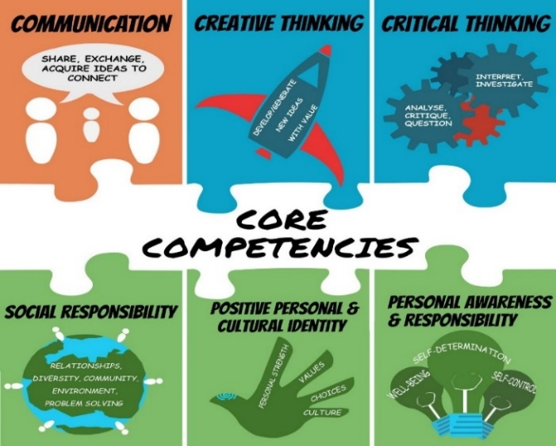
Learning Intentions:
- to reflect on semester one and set/tweak personal goals for semester two
- to identify two artefacts from semester one that represent your progress
- to continue caring for the environment through building awareness of single-use plastics
- to inspire you through the stories of others to use your unique talents for positive change and to take care of this land we work and play on

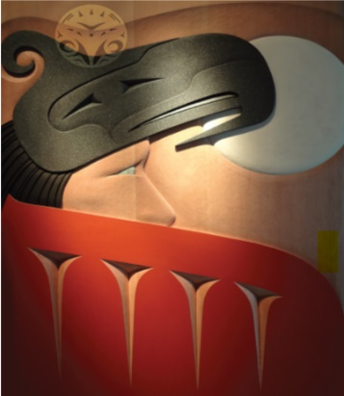
This activity rests within indigenous principles.
Specifically, we can enjoy nature and help take care of this land by reducing our dependence on single-use plastics.

1. “Learning is connected to land, culture, and spirit.”
2. “Learning is a journey that takes courage, patience and humility.”

Carl Stromquist “Carving and Raven moon”
Aboriginal Ways of Knowing and Being (bctf)

TIMELINE: Core Competency Schoolwide Activities 2021/2022
Tues Nov 23 | Tues Feb 08 | Thurs May 26 | Tues June 07
Sem 1 half-way reflection/goal setting – personal & social responsibility focus: spending more time in nature & single-use plastic awareness | Sem 1 reflection/ measure progress/adjust goals/select artefacts from Sem 1; continue plastics discussion | Sem 2 reflection/ artefact selection from semesters 1 & 2/ /peer presentation script preparation | Year-End small group  Mini Presentations/ Core Competency growth document shared with home
INSTRUCTIONS: Your block 2 teacher will facilitate this lesson through PowerPoint slides and discussion. During the slide presentation, you will have opportunities to talk to your peers and write on this handout.
Important: SAVE this document in a folder called Core Competency Documents in OneDrive as a “time capsule”. Save all CC handouts in this folder. This collection will be helpful for year-end reflections and eventually, for your CAPSTONE project at the end of grade 12.

PART A: PERSONAL AWARENESS & RESPONSIBILITY REFLECTION & ACTION
Think about Semester 1. You recently received your report card. Think about your courses, your social activities, your extracurricular responsibilities, your personal challenges.
- What are two things that went well for you in semester 1 – in school and/or out of school?
a)

b)

- What are one or two artefacts that represent your progress? (examples -- a project; a performance or presentation mark; a basketball, swimming goggles, etc. to represent playing on a team; an assignment; a test score, an art or woodworking piece; a pay stub from a new job; a photo of an activity … Describe why you chose this artefact and how it shows your strengths, struggles or stretches.
ARTEFACT | WHY YOU CHOSE IT—This artefact shows how…
1.  -------------------------------------------------------  2. | -------------------------------------------------------

- What are two things you would like to improve, in or out of school during semester two or by end of the school year?
a)

b)

What are two specific actions that will get you closer to your goals? (Without action, your goals are just wishes.) For example, start homework at a specific time each day--- take a 30 minute break-- and then resume homework; or, walk Coquitlam crunch 3x per week; or, limit week day video game playing to one hour etc.
a)

b)

PART B: SOCIAL AWARENESS & RESPONSIBILITY & ACTION
- READ & RESPOND//TAKING CARE OF THIS LAND WE WORK & PLAY ON
13 year-old, Langley student, Sophia Schultz’ article, “Reducing Plastic Pollution.” Art by Delta’s Seaquam Secondary students Abhayjeet Sachal Singh and Faith Carswell.
- Read the article below. (Select & right-click to open link or place link in browser.)
- Respond to the questions.

https://www.sd43.bc.ca/school/gleneagle/StaffInfo/departments/english/Mr%20F%20Shared%20Docs/Core-Competencies/Reducing%20Plastic%20Pollution.pdf

- What combined factors make plastics such a problem?

- How does creating a plastic journal help Sophia reduce her plastic usage?

- What does Sophia learn from surveying 124 people?

- Look carefully at the image at the top Sophia’ article. How does the image, created by Delta students Abhayjeet Sachal Singh and Faith Carswell, reinforce key ideas in the article?

- ACTION: What’s a plastic habit that you can change?

- SHARE & DISCUSS: share your responses in small groups. What habits can we collectively change for the greatest impact?

- WATCH & DISCUSS// Zero Waste Solutions are Good for Business featuring NADA, a Vancouver based, zero waste grocery store

https://www.youtube.com/watch?v=vmeoVyV8jmg

Discuss in small groups: We are all familiar with the three R’s (reduce, reuse, recycle). Brianna suggests there is a fourth--R: REFUSE. What plastics can we “refuse” in our daily lives that could help make a difference?

- READ & DISCUSS: Zero-Waste Groceries
UBC student, Alison Carr, turns inspiration from a class assignment to a business opportunity that helps to reduce plastic and waste.
- Read the article below

https://trekmagazine.alumni.ubc.ca/2020/fall-2020/changemakers/zero-waste-groceries

- After reading, in a group, brainstorm how you might turn a passion into a career that can make a positive difference for this land we all share.
***
Thank you! You have completed the written portion of this activity.
Save this document to your OneDrive. You will be accessing it again on May 26 when you start planning for your year-end mini presentations on June 7.
Remember to keep saving or taking pictures of artefacts as measures of your progress—stretches & struggles—throughout semester 2.
Next Schoolwide Core Competency Activity: May 26, 2022
***

