Completing GT (Grad Transitions) & Exit Interviews

Grade 12s are required to complete all sections of Graduation Transitions in order to earn 4 credits to graduate. GT must also be completed to buy Grad Dinner & Dance tickets.
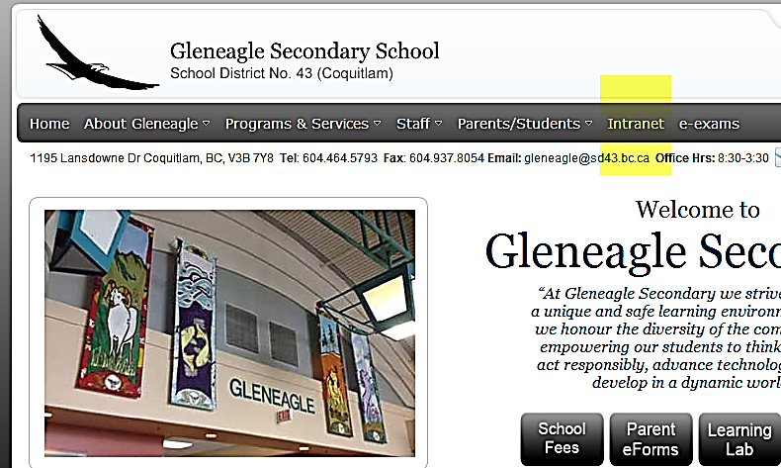

Follow these steps to complete GT:

- Go to: www.gleneagle.org

- Click on Intranet and enter your school
username and password if you’re logging in from home.
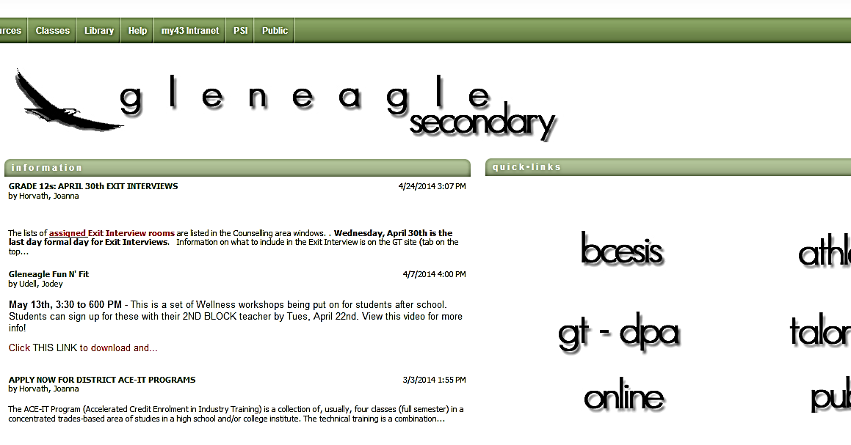

- then click on “gt-dpa”.

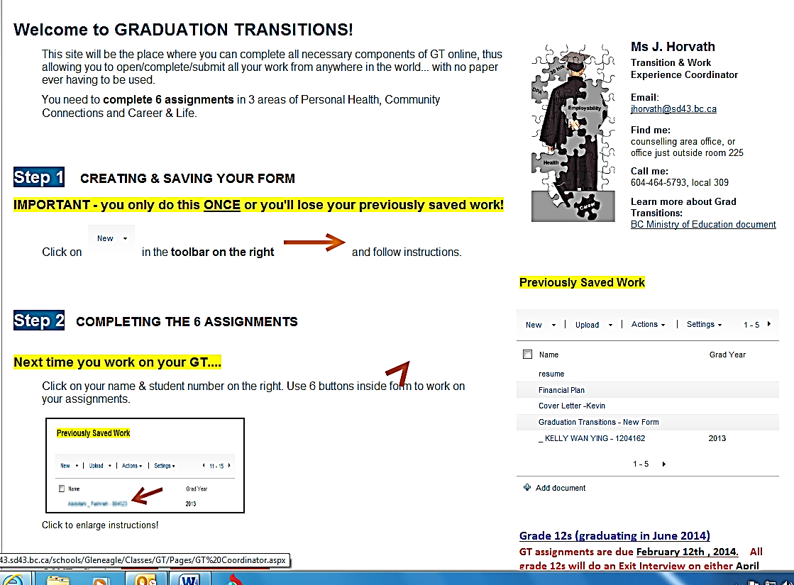
- If you already have a folder, click on it. If you
don’t, follow the instructions. Steps 1 & 2 are very
important. Only create ONE folder for yourself.
after you have completed Step 1, select
“SAVE & CLOSE”.

- Click on your folder and complete all 6 sections
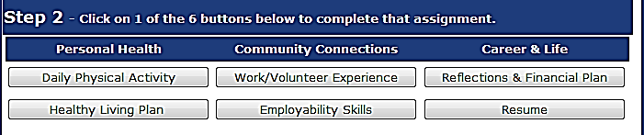

- Always test your connection and SAVE OFTEN! You may want to copy and save your work into a Word file as back up.

*** The FINAL due date for GT assignments is February 13th, 2016. Email Ms. Horvath (jhorvath@sd43.bc.ca) when you think you are done the assignments. You must check your email for a response and for feedback on your assignments.

E
Exit Interviews

- This is the culminating activity for GT
- Your GT assignments must be complete before you do your Exit Interview as they will help you prepare for it.
- All info can be found on the GT site. Click on the “Exit Interviews” tab at the top of the opening page
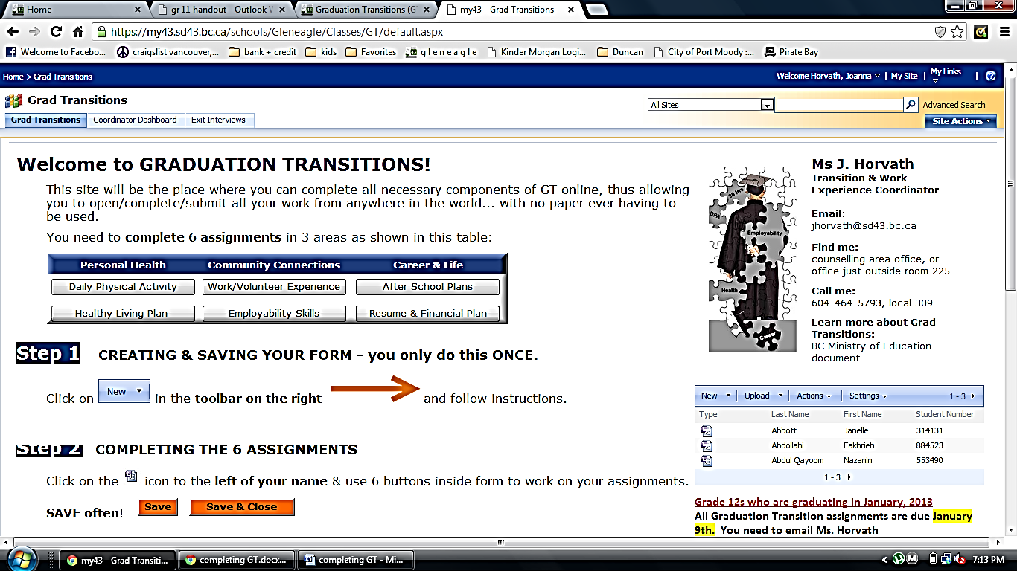

The Exit Interview date for all grade 12s will be April 13th, 2016. You must follow the instructions on the Exit Interview page. You must thoroughly prepare your presentation

You CAN and SHOULD aim to complete your GT assignments earlier than the due date. You may be then be able to book an earlier Exit Interview date. Email Ms. Horvath.

