How to Complete DPA ( D a i l y P h y s i c a l A c t i v it y )

All students must complete 150 minutes per week of physical activity for grades 9, 10, 11 and 12 and report out on it. Each year you will record your DPA on the blank template for your grade level.
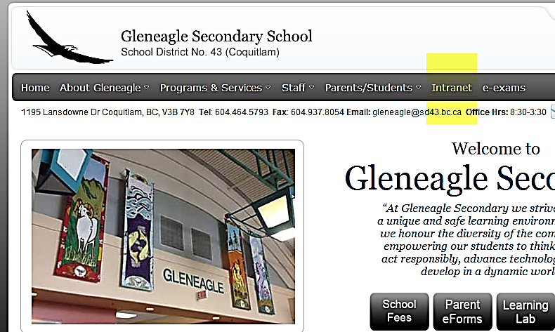

Follow these steps to complete DPA:

- Go to: www.gleneagle.org

- Click on Intranet and enter your school
username and password if you’re logging in from home.
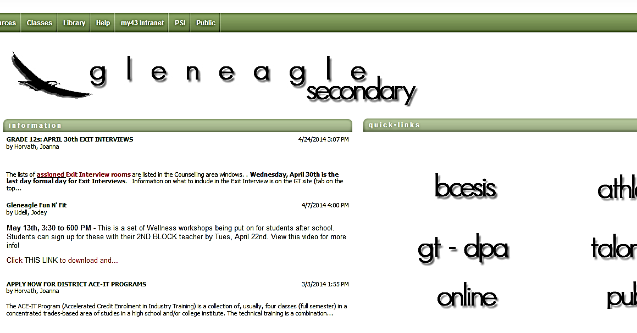

- then click on “gt-dpa”.

- The Graduation Transitions site is where all grades will complete DPA every year, and grade 12s will complete the rest of the GT assignments.

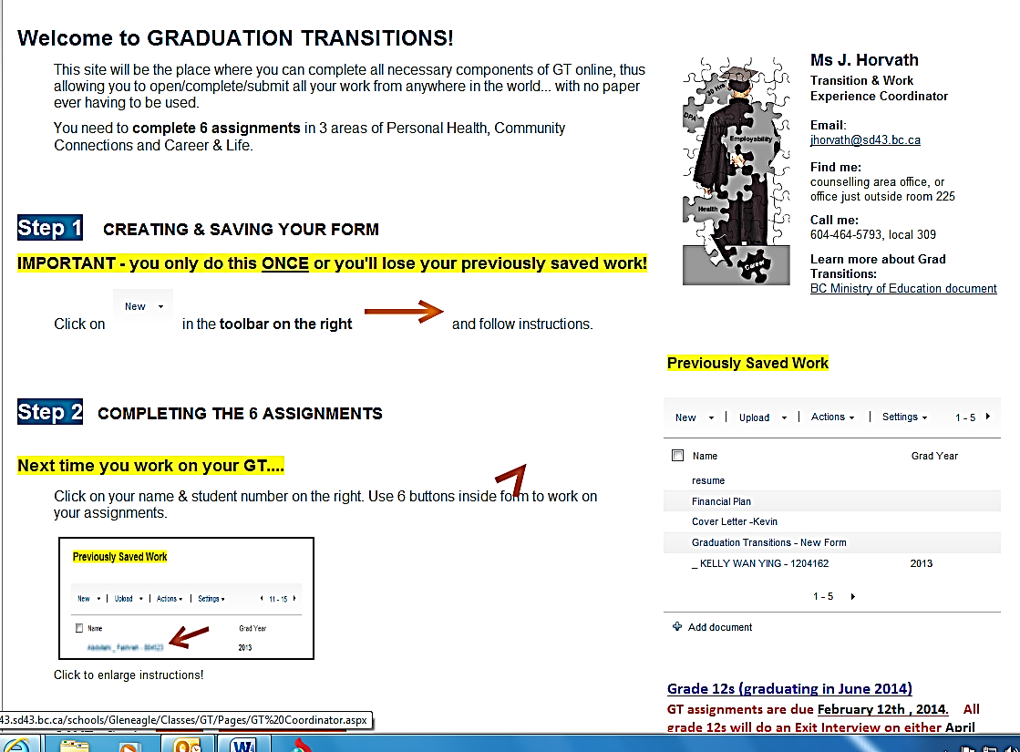
- Follow the instructions. Steps 1 & 2 are very
important. Only create ONE folder for yourself.
you will use this folder until graduation. After
you have completed Step 1, select “SAVE & CLOSE”

- Click on your folder and then “Daily Physical Activity”. Follow the instructions carefully and fill in all of the boxes.
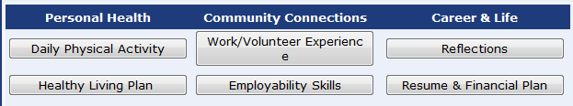

- Always test your connection and SAVE OFTEN!
Email Ms. Horvath (jhorvath@sd43.bc.ca) if you have any questions

