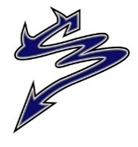
Dr. Charles Best Secondary Newsletter
Issue 8 – November 10, 2022
2525 Como Lake Avenue, Coquitlam, BC V3J 3R8 604-461-5581
Website: http://www.sd43.bc.ca/school/charlesbest/Pages/default.aspx
Principal – Heather Murphy
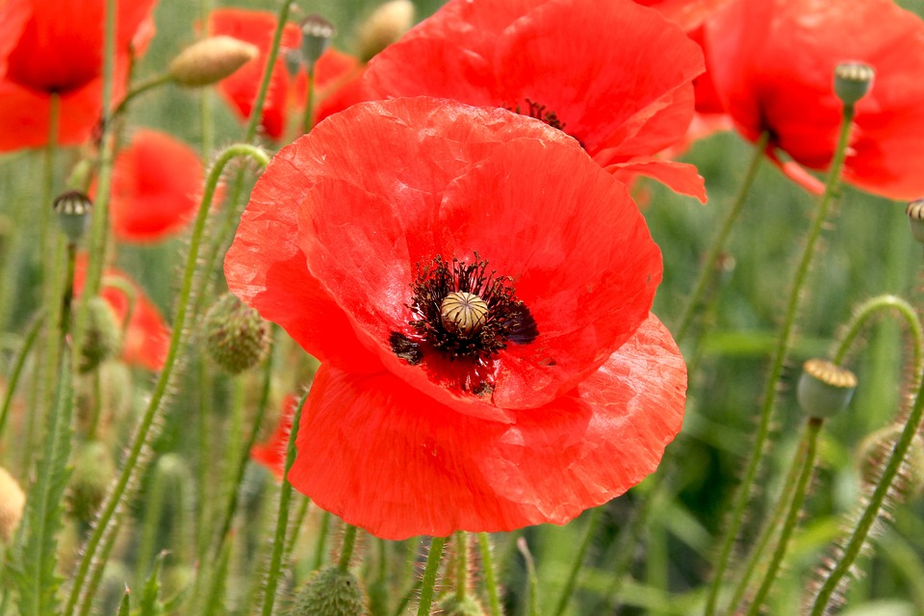
Vice-Principals – Michelle Ciolfitto, Kelly Fridge, and Joel Nelson
Our school goal is to develop a culture of connectedness and belonging within the school, among school staff, students, and our parent community, in order to enhance opportunities for collaborative partnerships.

UPCOMING EVENTS
Thursday, November 10 ***Save the Date – Senior Winter Ball***
Midterm Report Cards Thursday, December 8th, 2022, 6:00-9:00pm
Friday, November 25 Grad Photos @ Lifetouch
Appointments required
REMIMDER: WINTER WEATHER AHEAD!
Schools are not routinely closed due to snow or other inclement weather conditions. All schools in School District 43 (Coquitlam) will remain OPEN, if possible, during winter weather, including snowfall.

However, on occasion, a district-wide or partial-district closure is required due to extreme weather. Partial-district closures affecting individual schools may occur due to the very different geography within our school district. If there is a partial-district closure affected schools will be identified.

The decision on schools remaining open or needing to be closed, because of extreme weather, occurs before 6:30 a.m. so that families can plan and make alternate arrangements.

Any district-wide or partial-district closure will be decided and communicated by 6:30 a.m. via the School District 43 website www.sd43.bc.ca and CKNW AM 980 radio, CKWX 1130 radio and CBC (690) radio.

Extreme weather can also impact transit. Transit schedules may face significant changes or cancellations due to the weather conditions. Parents seeking information on transit schedules need to consult the Translink website: http://www.translink.ca/ We encourage families to continuously check the School District 43 website for updates and changes: www.sd43.bc.ca Learn more about SD43’s process for emergency and inclement weather status updates at: http://www.sd43.bc.ca/NewsEvents/Pages/EmergencyInformation.aspx

While the District tries to make the best decision with the information available, the weather does change quickly. Therefore, when schools remain open, decisions to stay at home during challenging weather conditions should be made by each family.

Learn more about SD43’s process for emergency and inclement weather status updates at: http://www.sd43.bc.ca/NewsEvents/Pages/EmergencyInformation.aspx
MIDTERM REPORT CARDS
Midterm report cards will be published to the Family Portal this afternoon after 4pm.
Please check the school website for more information.

GRADE 12 YEARBOOK DEADLINES
Grade 12’s, we want to see you and your contributions in the 2022-2023 yearbook. The deadline is TOMORROW to submit your baby picture, submit your grad write-up and vote.
Click on the QR codes below for each category.

GRADE 12 DELF EXAM
Just a reminder to students who have signed up for the DELF exams, they are taking place at the end of November
(21st-25th).

GRADE 12 DELTA/CHALLENGE EXAM
Please mark your calendar for the Grade 12 DELTA/CHALLENGE – if you applied, the exam will be held on either
January 28th or January 29th depending on which day they host the specific test.
If you have any questions, please contact Mr. Papillo.

GRAD FRIENDSHIP PHOTOS AFTER GRAD FUNDRAISER
Lifetouch will be here on Monday, November 28th from 3:30-8pm to offer Friendship Photos to those grads who wish to have a group photo taken. To sign up, have 1 person in your group, your group Captain, use the QR code in the flyer provided to book your groups sitting time. At the time of your booking each person in the group must bring a toonie for payment. Each grad in the photo will receive a 4X6 photo. When photos arrive the group captain will be called to the office to receive their groups photos and then distribute to group members. Lifetouch will donate all money collected to our After Grad!
GRAD PHOTOS
If your child did not have their Grad photo taken when Lifetouch was here, there are two additional opportunities to have photos taken:

- Nov. 25th Studio Day – Photo sittings will take place in the Lifetouch Burnaby studio. To book a sitting date please contact Adrian at:
Adrian.prasad01@lifetouch.com or call him directly at 236-700-6449

- Retakes January 6 & 7 – Any grads who did not have their photo taken or require a retake will have an opportunity to book a sitting on Jan. 6 & 7. Photos will be taken at Charles Best in the cafeteria. In early December a link will be made available from Lifetouch for grads to book a sitting date/time.

We want all our graduating students to be identified in our yearbook and in the Graduation Class Composite. If you are not interested in purchasing grad photos, we ask that you make an appointment for your child to have their photo taken and when they arrive let the photographer know that they are only having their photo taken for the yearbook and composite. Those who are not purchasing grad photos are not required to pay the $35 sitting fee.

Photo Delivery – If you purchase a photo package you can expect to receive it in the mail approximately 3 weeks after the order was placed. You should also receive an email from Lifetouch where you can view your child’s proofs. If after three weeks you have not received either please contact Lifetouch directly at:
qvarea@lifetouch.com or call 604-294-1005 when prompted dial “1” to speak to Customer Service Team.

LOST AND FOUND TABLE
There are many items currently in our lost and found bin. We will have a table setup in the main hallway every Friday. If your child is missing something, please tell them to stop by the table to take a look.

MOVEMBER CAMPAIGN

Support the Movember campaign at Dr Charles Best benefitting the Marc Lalonde Memorial Foundation (this foundation supports men's mental health in the Tri Cities) and the Canadian Legion (in support of initiatives to support veterans with PTSD).
Donations can be made by going to your child's School Cash online account. The link to School Cash online can be found on our website under Quick Links - Student Fees.
MET FEST 2022
The Best Players are proud to present Mix Up – Six Up: Six evenings of one act comedies.
Opening November 22nd, 23rd, 24th, 25th and 26th, tickets are $10.00 for students and seniors, and $12.00 for adults. Purchase tickets online now through the school’s cash online system or at the door.
Ticket dates and their specific links:
November 22nd: https://sd43.schoolcashonline.com/Fee/Details/88002/108/False/True
November 23rd: https://sd43.schoolcashonline.com/Fee/Details/88011/108/False/True
November 24th: https://sd43.schoolcashonline.com/Fee/Details/88018/108/False/True
November 25th: https://sd43.schoolcashonline.com/Fee/Details/88019/108/False/True
November 26th: https://sd43.schoolcashonline.com/Fee/Details/88021/108/False/True

Box office opens at 7:00 PM and curtain is at 7:30 PM. Join us for The Safety Match, by Norman Ginsbury, adapted from a short story by Anton Chekov, Come Live in My House, by Mae Howley Barry, Bridal Terrorism, by Bill Rosenfield, All in Disguise, by Gene Traylor and James Michael Elrod, Personal Effects by John McNamara, and Carry me Over the Threshold Super Hunk by Dina Del Bucchia, Marina Simpson, Patti Berukoff and Lisa Venturini.
Bring a friend, bring the kids, bring the whole family, and support the wonderful work we all do at here at Dr. Charles Best. See you at the festival.

POST SECONDARY RECRUITER VISITS

University of Waterloo | Tue, Nov. 15th 3.20 pm | School library
McGill University | Wed, Nov. 16th 3.20 pm | School library
University of Calgary | Thu, Nov. 17th 3-4 pm | Booth, main foyer
Fraser Health – Health Careers Access Program | Tue, November 22nd, 6 pm | Virtual session for SD43. Sign up.
University of Alberta | Wed, Nov. 23rd 3.20 pm | School library
UBC Sauder School of Business | Wed, Nov. 23rd, 6 pm | Virtual session for SD43. Zoom link
POST SECONDARY EVENTS
DOUGLAS COLLEGE INFO SESSIONS
Learn more about any specific Douglas program you are interested in. Virtual sessions take place
Tue and Thu, November 15th and 17th, starting at 5 pm. Different faculties are participating each day.
Check details and sign up here.

SFU ENGINEERING SCIENCE, MECHATRONICS & SUSTAINABLE ENERGY ENGINEERING
Technology is integrated into every aspect of our daily lives; from the moment your alarm wakes you up in the morning to your smart phone tracking every step that you take. Are you interested in understanding how this technology works? Do you see yourself advancing existing technologies to create a long-lasting societal impact? Register here to learn more on Wed, November 16, 4.30-5.30 pm.

McGILL RECRUITER VISIT AT BEST
Mark your calendar! McGill will be visiting us on Wed, November 16. Everyone interested in learning more about studying at Canada’s top university is welcome (open to all grade levels). Main language of instruction at McGill is English. Understand the application process and get your questions answered!
See you on Nov 16 after school in the library.

RETIREMENT HOME VOLUNTEERS
​Rideau Residence in Burnaby is looking for Bingo Volunteers (Wednesday evenings, 6.30-9 pm OR Saturdays, 2-4.30 pm) and for musicians/ performers/ entertainers. If you are someone with a musical talent and/ or want to perform in front of a (small) crowd of seniors, the scheduling is very flexible. More info here.

AFTER GRAD FUNDRAISING
RETURN IT BOTTLE DEPOT INFORMATION
Clear bags, up to six at a time
MUST be EXPRESS locations at Return It
At kiosk print out label/s and place on bag/s, then place in designated area.
CODE for label at the kiosk for Grad account is 6044182023

GROWING SMILES WINTER PLANT FUNDRAISER
Order in time for the holidays.
Order deadline is November 18th.
https://charlesbestsecondaryaftergrad2023.growingsmilesfundraising.com/

PURDY’S CHOCOLATE FUNDRAISER
The Purdy's Christmas Chocolates Fundraiser is back!!! Funds raised will go towards reducing the cost of producing the After Grad for our 2023 Grads. Sales Deadline: November 27, 2022
Exact Delivery Date: TDB - The week of December 12th, 2022
Click on the link to view the brochure and to order: https://fundraising.purdys.com/join.aspx/473828-99972
Campaign #: 59854 Thank you for your support of our Fundraiser….the Grads appreciate your support!
For more info contact: bestgrad2023@gmail.com
DR CHARLES BEST WINTER MARKET
Join us for our ‘Gala Shopping Event’! All proceeds are for the 2023 Dry Grad
Friday, November 18th
5:30 – 9:00pm
By donation at the door
Info: bestgrad2023@gmail.com
Please use the front entrance- FUN, FOOD AND AMAZING VENDORS!

CALLING ALL ARTISTS
Be sure to book your painting spot for our upcoming ‘Winter Market’ night at Charles Best on Friday, November 18th from 5:30pm-9:00pm. Many designs to choose from. Click on the link for more info and to book.
https://backpac.parentcouncil.net/admin

AFTER GRAD DONATIONS
• The 2023 Grad Committee is looking for donations of wine and silent auction items. The money raised will go towards reducing the ticket cost for After Grad and providing a fun and safe environment for the Grads on Grad night. Thank you in advance for your generous donation. If you're interested in donating, please contact the committee at bestgrad2023@gmail.com

PAC CORNER
Upcoming PAC meeting: Monday, January 9, 2023 at 7:00 pm in the school library. All parents are welcome!

After Grad 2023:
• The 2023 Grad Committee is looking for donations of wine and silent auction items. The money raised will go towards reducing the ticket cost for After Grad and providing a fun and safe environment for the Grads on Grad night. Thank you in advance for your generous donation. If you're interested in donating, please contact the committee at bestgrad2023@gmail.com
