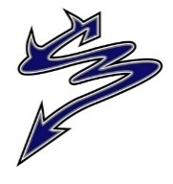
Dr. Charles Best Secondary Newsletter
Issue 6 – October 28, 2022
2525 Como Lake Avenue, Coquitlam, BC V3J 3R8 604-461-5581
Website: http://www.sd43.bc.ca/school/charlesbest/Pages/default.aspx
Principal – Heather Murphy
Vice-Principals – Michelle Ciolfitto, Kelly Fridge, and Joel Nelson
Our school goal is to develop a culture of connectedness and belonging within the school, among school staff, students, and our parent community, in order to enhance opportunities for collaborative partnerships.
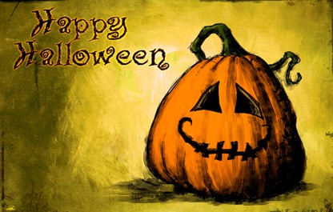
UPCOMING EVENTS
Monday, October 31
Miracle Movement – Halloween Bake Sale
Drama Department – Haunted House on Halloween
2nd Annual Scavenger Hunt
Tuesday, November 1- Wednesday, November 2
Provincial Assessments
Wednesday, November 2
Take Your Kid to Work – Grade 9’s only
Thursday, November 3
Soccer District Playoffs – Best Field – Jr. Boys 1pm, Sr. Boys 3pm
Friday, November 4 @ 8:40am - 11:00am
Post Secondary Institution Day
Monday, November 7 @ 7:00pm Library
PAC Meeting
Tuesday, November 8 @ 6:00pm Library
Grade 11 Dinner-Dance Meeting

MONDAY, OCTOBER 31st HALLOWEEN!
We realize this can be a fun day with so many students and staff dressing up in costumes but please be aware your costumes must be appropriate and not offensive. Our Superintendent sent out a message last week – please see below:
The following message is sent on behalf of Superintendent of Schools Patricia Gartland:

Halloween across all schools in SD43 is a fun and festive day which brings the school community together. Typically, the time around Halloween is incident-free and very respectful.
From time to time, a few students “in character” push the boundaries of what is socially acceptable, or what is appropriate behavior in schools, sometimes at the expense of others. With that in mind, for student safety and school climate reasons, and to ensure that every student and adult in our community enjoys the time around Halloween, we would like your assistance in reinforcing these guidelines with your children:
- Students in costume should be easily recognizable and/or identify themselves to any staff member when queried. Also, students “in character” are to conduct themselves appropriately. Behaviors which intimidate, harass, or humiliate members of the community do not contribute to a fun, festive, and safe environment.
- Replica weapons (guns, knives, etc.) are inappropriate, as are costumes which are hyper-sexualized, or costumes which depict elements of sexual exploitation.
- It is also important to note that costumes which portray negative stereotypes or that demean or make fun of any group of people are inappropriate. Costumes should not make light of anyone’s religious, cultural, ethnic or racial group.
As a reminder, by law and School District expectations, the use and possession of firecrackers or fireworks at school is strictly prohibited. This pertains to students before, during or after school, on or offsite.
With respect for each other, we can avoid any disruption to school communities in the form of vandalism and/or disrespectful, potentially dangerous behaviour. Students and parents need to be mindful that inappropriate behaviour will be addressed by school administration under the authority granted by the BC School Act and with the involvement of police where appropriate.

HALLOWEEN BAKE SALE OCTOBER 31ST
Miracle Movement is hosting a Halloween bake sale! We will be in the foyer and beside the Devil’s Den on October 31st for the whole day. Come by to get some spooky treats!

HAUNTED HOUSE MONDAY, OCTOBER 31ST
On Monday October 31st, the drama department is holding a haunted house! In the spirit of Fright Night we will have some special effects and a group of actors performing as scary things. Make sure to check it out-it’s going to be ghoulishly great. Bring your Twoonie

HALLOWEEN SCAVENGER HUNT MONDAY, OCTOBER 31ST
Get ready for our second annual Halloween Scavenger Hunt! Track down all the elements to win a treat!
Pick up a Scavenger Hunt list in the DL/Tech Room (located between rooms 202 and 203) in blocks 1, 2, 3 or 4. Find the teachers who are the elements on your list, write the symbol, and get the teacher to initial it once you find them (offices and classrooms are off limits). Once you have all the teachers’ initials, collect your prize in the DL/Tech Room in blocks 2, 3 or 4. Hunt ends at the end of block 4.

MYED PARENT PORTAL ACCESS FOR GRADE 9’S
***If you have not received an email to set up your Parent Portal account through MyEd, please click on the following link: https://forms.office.com/r/9uhkHjJ9mU
An account will be created for you and an email will follow early next week.

GRADE 11 PARENTS
A reminder to the Grade 11 Parents! Dr. Charles Best Secondary has a great tradition of holding a themed dance at the school (in the small gym) hosted by the Grade 11 parents! This popular party is back from a 3-year pause due to the pandemic. Established in 1999, the date has traditionally been in March.
Money raised will help offset the cost (ahem, big cost) for our 2024 Grads fancy grad dinner downtown.
We would like to invite you to meet other Grade 11 parents and learn more about how you can help pull off a great community event to support our GRAD 2024!
Grade 11 Dinner-Dance meeting
When: 6:00pm November 8
Where: Charles Best Library
Please contact Will Davis with any questions or for more information - willdavisvancouver@gmail.com

LITERACY 10/NUMERACY 10 ASSESSMENTS NOV. 1 & 2
If you are in Gr 11 or 12 and missed writing the Literacy 10 or Numeracy 10 Provincial Assessments, you should have received two emails telling you when and where to write them. This information will also be available in the main foyer.
If you are in Gr 11 or 12 and missed these assessments and haven’t received this information, please see Ms. Thibault in the main office asap to make sure you get registered to write these graduation requirements.

GRADE 12 FL DELF EXAM
Students who are taking FRAL12 this semester can sign up to take the DELF exam using the following link prior to October 31st 2022: https://forms.office.com/r/VxpahDgcT6.
The DELF (Diplôme d'études en langue française - beginner and intermediate level) is a diploma that is internationally recognized and valid for life. The exam is used to assess and certify the French language proficiency of candidates whose first language is not French.
Students taking FRAL12 in semester two will sign up at a later date.
After October 31st 2022, a list of the students who signed up will be able to pay the registration fee via School Cash Online/KEV portal..
The exams are taking place at the end of November (21st-25th).

GRADE 12 DELTA/CHALLENGE EXAM
School District 43 offers an opportunity for all grade 11 and grade 12 students to complete a one-day Language Challenge Exam through the Delta School District that will account for credits and meet the language 11 post-secondary entry requirements for UBC and SFU (this exam will test students on their ability to read, write and speak in this language).
Many students who have taken this challenge exams in the past are students who are in the French Immersion Program and wish to use this opportunity to possibly obtain a high grade for one of their grade 12 classes for the purpose of post-secondary entry requirements.
We also have students who take this exam for the sole purpose of meeting the grade 11 language requirement for post-secondary entry into UBC and SFU, but students must be proficient in the language if they wish to pursue this challenge exam, as these tests are rigorous and proof of how they obtained the knowledge will be required.
Below is a list of languages that students can challenge and please remember, that the due date to hand in this application to Mr. Papillo is November 1st. A link to the challenge exam application will be listed below as well and please make sure the instructions are followed quite carefully, as application in the past have been declined due to not following their instructions (a portion of the application must be typed out, refundable cheques need to be written to the Delta School District (with a few other important details) and a photo must be a passport like photo).
The language challenge exam is only offered once a year and the exam will be held on either January 28th or January 29th depending on which day the host the specific test.

January 28th, 2023: January 29th, 2023:
Farsi 11/12 (New addition this year) French 11
French 12 Korean 11
Japanese 11/12 Mandarin 12 (simplified)
Korean 12 Mandarin 12 (traditional)
Mandarin 11 (simplified) Punjabi 11/12
Mandarin 11 (traditional) Spanish 11/12
Link to the application page:
https://www.deltasd.bc.ca/wp-content/uploads/sites/2/2022/09/Challenge-Exam-Application-Package-2023.pdf
TAKE OUR KIDS TO WORK (TOKTW) DAY
Wednesday, November 2 is take your Grade 9 to Work Day! TOKTW 2022 Website
TOKTW day is a national program to promote career awareness and skill building for all Grade 9 students. Start planning now where your child will “work”; it might be with you, your neighbour, uncle, cousin, friend, or other contact. Some companies even offer special programming for multiple participants on this day. Check with your employer and begin planning how your Grade 9 will participate in this one-day work experience.
Note that Grade 9 classes will be canceled Nov 2 as we expect ALL Grade 9’s will find a work placement and will complete a related Applications of Digital Literacy course assignment.

POST SECONDARY CAREER FAIR NOVEMBER 4, 2022
All grade 11 and 12’s students are required to attend this important presentation during blocks 1 & 2.
You will be dismissed from your block 1 class. If you DO NOT have a block 1 and/or 2 class, you are still required to attend this important visit from 17 post secondary institutions. If you have any questions, please contact Mr. Chang.

MET FEST 2022
The Best Players are proud to present Mix Up – Six Up: Six evenings of one act comedies.
Opening November 22nd, 23rd, 24th, 25th and 26th, tickets are $10.00 for students and seniors, and $12.00 for adults. Purchase tickets online through the school’s cash online system or at the door. School cash online links will be available November 7th.

Box office opens at 7:00 PM and curtain is at 7:30 PM. Join us for The Safety Match, by Norman Ginsbury, adapted from a short story by Anton Chekov, Come Live in My House, by Mae Howley Barry, Bridal Terrorism, by Bill Rosenfield, All in Disguise, by Gene Traylor and James Michael Elrod, Personal Effects by John McNamara, and Carry me Over the Threshold Super Hunk by Dina Del Bucchia, Marina Simpson, Patti Berukoff and Lisa Venturini.
Bring a friend, bring the kids, bring the whole family, and support the wonderful work we all do at here at Dr. Charles Best. See you at the festival.

FALL CONCERT
Very Entertaining Night of Music on October 26th! Mr. Hughes and his talented musicians presented a variety of songs and musical pieces – it was excellent as usual. After only a few short weeks of rehearsals those students were quite amazing. Please mark on your calendars Dec 14th Winter Concert --- another wonderful concert as well.
Thank you Mr. Hughes for all that you do.

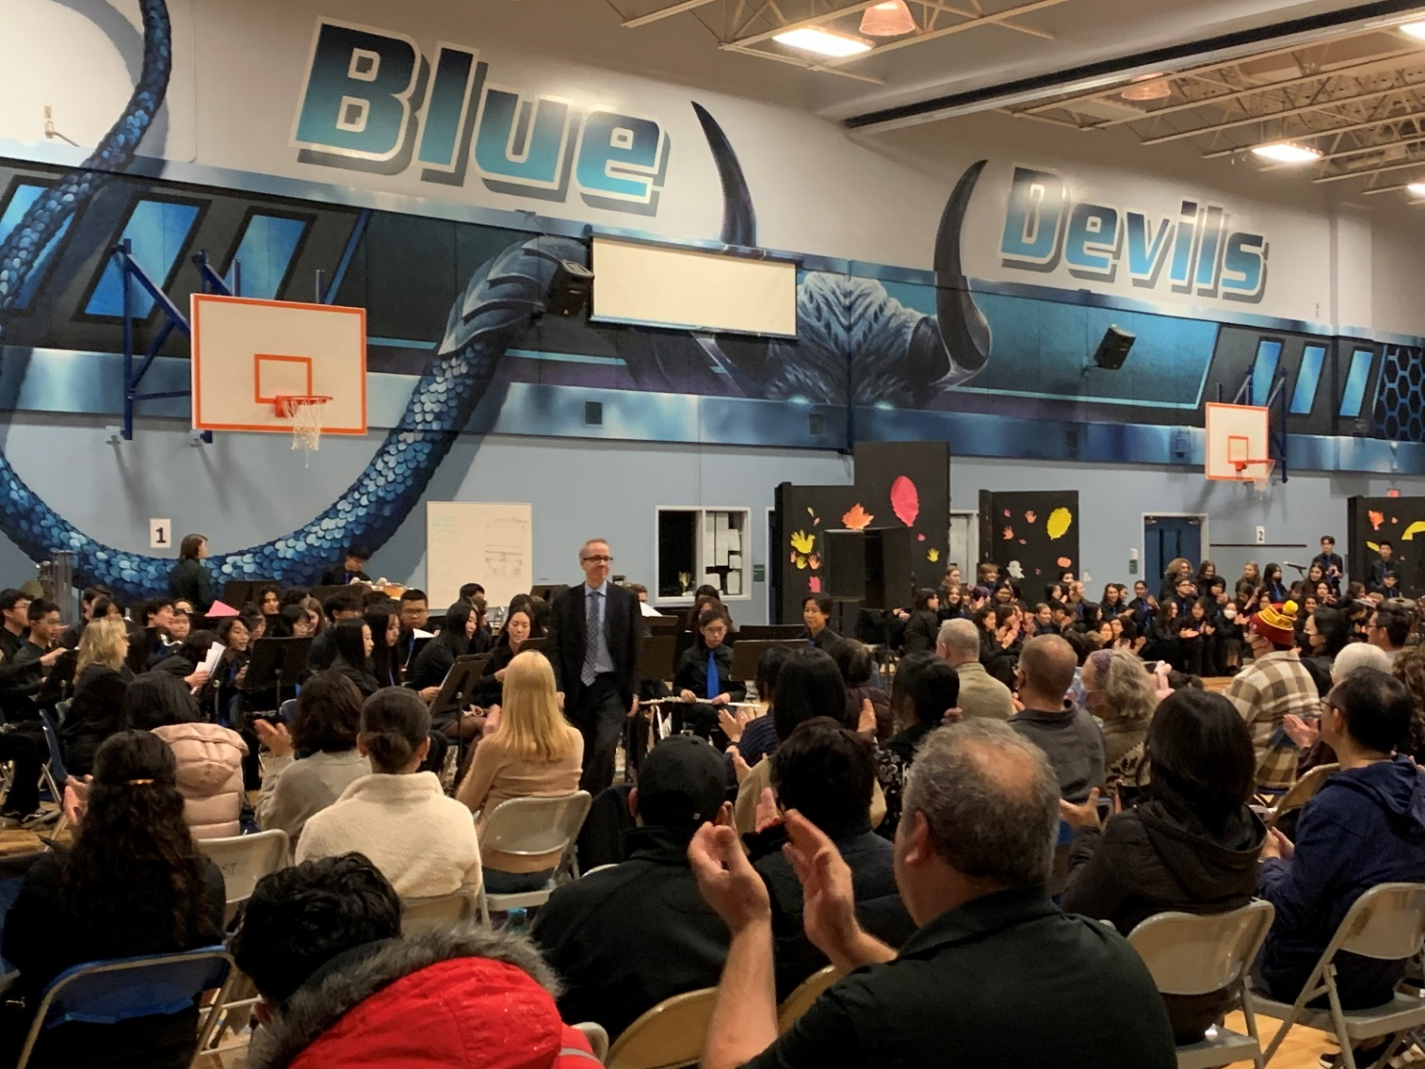

SPORTS RESULTS ARE IN!!!!
FRASER NORTH SWIM RESULTS
Great results for the swim team from Wednesday, October 26th!
7 swimmers qualified for Provincials in various individual events. 6 of 7 relays qualified for Provincials!
17 swimmers will be attending Provincials on Nov 18-19 at Watermania in Richmond. Overall, 5th place in the Zone

CROSS COUNTRY FRASER NORTH CHAMPIONSHIP RESULTS
The kids all ran well in windy and (eventually) rainy conditions, but unfortunately none of our teams qualified for Provincials. Our Junior Boys placed 5th and were only 6 points behind 4th (top 4 teams qualified). Senior Boys were 7th, and just 7 points behind 5th (top 5 teams qualified). Our Junior Girls also ran well, placing 7th overall.
We did have some individual qualifiers and wish them all the best at Provincials.

SENIOR BOYS’ SOCCER RESULTS
After a hard-fought victory in the pouring rain against first place Heritage Woods (3-1), the senior boys' soccer qualified for the Fraser Valley North Zone championships next week.
CONGRATULATIONS TEAM!

JUNIOR BOYS’ SOCCER RESULTS
Junior boys also had a victorious week!! They beat Riverside to make it into the district finals next week. Thursday, November 3rd we host (at Best) the Jr. & Sr. Boys Soccer playoffs, Jr – 1pm, Sr – 3pm.

POST SECONDARY RECRUITER VISITS

UBC Sauder School of Business | Wed, November 2nd, 3.20 pm | CANCELLED
Western University | Thu, November 3rd 3-4 pm | Booth, main foyer
Post-Secondary BC Fair (Recruiters from all BC universities & colleges will be at Best!) | Fri, November 4th 8.35-11 am | Varies rooms around the school.
Langara College | Tue, November 8th, 6 pm | Virtual session for SD43. Zoom link
University of Waterloo | Tue, Nov. 15th 3.20 pm | School library
McGill University | Wed, Nov. 16th 3.20 pm | School library
University of Calgary | Thu, Nov. 17th 3-4 pm | Booth, main foyer
Fraser Health – Health Careers Access Program | Tue, November 22nd, 6 pm | Virtual session for SD43. Sign up.
University of Alberta | Wed, Nov. 23rd 3.20 pm | School library
UBC Sauder School of Business | Wed, Nov. 23rd, 6 pm | Virtual session for SD43. Zoom link
POST SECONDARY EVENTS
University of Toronto Prospective Students event in Vancouver
U of T will have representatives from all undergraduate divisions available to answer students' questions about programs, student life, and applying. Tue, November 1, 7-9 pm, Westin Bayshore Hotel, Vancouver.
Register here.

SFU Computing Science & Software Systems
Learn more about the undergraduate programs in SFU’s Faculty of Applied Sciences. Do you want to be a problem solver in this digital age? Sign up to attend on Wed, Nov 2, 4.30 pm.

UBC SAUDER FALL OPEN HOUSE
Prospective students and their parents are invited to UBC’s biggest info session this year. Learn about applying to the BCom program, meet the dean and the admissions team, get your questions answered and tour the Sauder facilities. On campus visit includes free lunch, but you can also attend virtually.
Sat, November 5th, 9 am – 12.30 pm. Sign up here.

UBC ENGINEERING OPEN HOUSE
Explore all UBC Engineering has to offer through in-person booths and demonstrations. Learn about the 14 engineering programs by chatting with professors, students and advisors, co-op, student life, etc.
UBC Vancouver campus, Sat, November 5th, 10 am – 2 pm. Register here.

U OF T APPLICATION WORKSHOP
Applying to UofT? Make sure that you fully understand the application process by signing up for an application workshop. UofT recommends that BC students should submit their OUAC-105 by November 7th, but that doesn’t include any supplemental applications. Register here for Tuesday, November 8 at 5 pm PST.

PAC CORNER
Upcoming PAC meeting: Monday, November 7 at 7:00 pm in the school library. All parents are welcome!
After Grad 2023:
- The 2023 Grad Committee is looking for donations for a silent auction. The money raised will go towards reducing the ticket cost for After Grad and providing a fun and safe environment for the Grads on Grad night. Thank you in advance for your generous donation. If you're interested in donating, please contact the committee at bestgrad2023@gmail.com
- Check out the attached flyers for other ways to support After Grad 2023.

Did you know? You can DONATE TO THE PAC ONLINE!
- Parent donations to the Charles Best PAC help to support various aspects of your student’s educational experience. Each year, the PAC provides much-needed funds to support activities such as extracurricular clubs, AfterGrad, teacher appreciation, and student scholarships.
- Login to your student’s portal on the SchoolCash Online system to make your PAC donation today!

AFTER GRAD FUNDRAISING

GROWING SMILES WINTER PLANT FUNDRAISER SIP AND SHOP EVENT

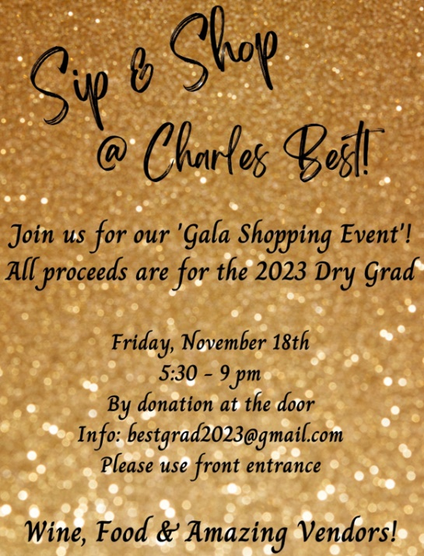
Order in time for from. Order deadline is November 18th.
Click on the link for more info:
https://charlesbestsecondaryaftergrad2023.growingsmilesfundraising.com
