Baker Drive Elementary

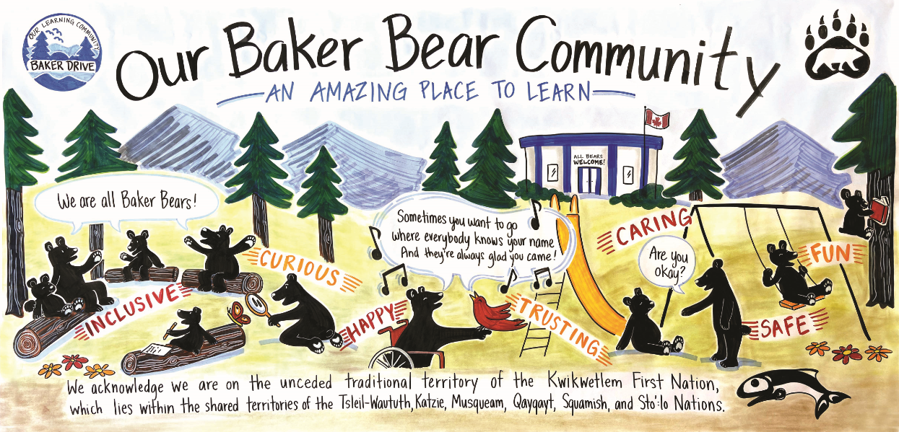

School Code of Conduct
2023 - 2024

School Code Of Conduct

A) Introduction

School boards and schools are entrusted through the School Act with authority to establish codes of conduct. While recognizing the autonomy of these bodies and acknowledging the efforts they have already undertaken to ensure school climates are as positive as possible, the provincial standards described below are provided to assist them in developing consistent and coherent policies and practices in their communities. Although most schools have codes of conduct in place, it is expected that all British Columbia schools will revisit existing codes and/or develop new codes of conduct reflecting the provincial standards. (Safe, Caring and Orderly Guide, page 15)

B) Code of Conduct: Key Elements

1) Process
Baker Drive’s Code of Conduct was developed through a collaborative effort involving school staff, learners, parents, and our community of schools. The process involved school administration from our Community of Schools meeting to discuss a common approach and theme to promote consistency throughout our extended community. A first draft was then formed by our School PAC Executive. That draft was reviewed and edited by school staff, the Parent Advisory Council, and learners. The revised draft was then compared with those from our Community of Schools and edited to promote consistency and is reviewed and updated yearly.

2) Communication
The Code of Conduct is printed in our learners’ agenda and each learner and parent is required to annually sign a form demonstrating they have read and agree to it. New learners throughout the school year have the same requirement upon registration. Kindergarten parents are introduced to the code at the New Parent Orientation along with our Baker Drive Community Commitment Graphic. The Code is placed in our staff handbook and reviewed at the beginning of the year or at the beginning of an employment contract for any new staff. For public viewing, a copy of the Code is placed on our website and posted on the parent board in the main hallway.

3) Implementation
In addition to being read and signed by parents at the beginning of the year the expectations and “spirit” of the Code are taught and reinforced throughout the year through our commitment to directly growing self-regulation and using restorative practices to maintain our critically important culture of attachment. These approaches include themes from the core competency curriculum taught school wide, and frequently reinforced and celebrated at school-wide gatherings.

4) Monitoring and Review

The behaviour, attitude and culture of attachment and connectedness are reflected upon as necessary through Student Services School-based Team meetings. As well, individual learner behaviour that is contrary to this CODE is documented through incident reports that are reviewed regularly to identify trends and concerns. Parents review the Code annually at the School PAC meetings and at the PAC AGM. Learners also are given opportunities to revisit the Code throughout the year through Classroom Agreements, and directly reinforced through self-regulation and executive function instruction.

5) Alignment
School codes are shared between our Community of Schools to promote consistency and common themes for learners as they transition through their school career. As well, our code is reviewed by district staff to ensure that it aligns with district standards and expectations.

6) Standards
Baker Drive Elementary School promotes the values expressed in the BC Human Rights Code respecting the rights of all individuals in accordance with the law – prohibiting discriminatory publication and discrimination in accommodation, service, and facility in the school environment.

a) Statement of Purpose

The purpose of our Code of Conduct is:
- To establish and maintain safe, caring and orderly environments for purposeful learning.
- To establish and maintain appropriate balances amongst individual and collective rights, freedoms and responsibilities.
- To provide a structure through which learners can learn the expectations and skills necessary to be responsible community members.

b) Conduct Expectations

These expectations apply to behaviour at school, during school-organized or sponsored activities, and behaviour beyond these times (including on-line behaviour) that negatively impacts the safe, caring, or orderly environment of the school, and/or learner learning.

1) Acceptable Conduct
As a community we expect all our members including staff, learners and parents to behave in a spirit of RESPECT toward one another and understanding of our personal RESPONSIBILITY. This requires that everyone:

Respect Themselves by:
-being prepared to learn
-not tolerating disrespectful behaviour toward themselves
-taking pride in their identity
-engaging in purposeful learning activities
-using the Three Steps:
- Giving Explicit Feedback process to solve problems in peaceful ways
- requesting help from a staff member to help solve a problem in a peaceful way using a restorative approach
- reporting ongoing incidents of bullying, harassment, or intimidation

Respect Others by:
-being safe and respectful toward others – treating others as they wish to be treated
-being cooperative and including others
-helping to make the school a safe, caring, and orderly place

Respect the Environment by:
-treating our natural world – plants and all other living things with
kindness and care
-cleaning up after themselves
-recycling and conserving resources
-caring for school resources and property

2) Unacceptable conduct
The school will treat seriously behaviour or communication that discriminates. As per Section 8 of The Human Rights Code of British Columbia; discriminate against a person or class of persons regarding any accommodation, service or facility customarily available to the public because of the Indigenous identity, race, colour, ancestry, place of origin, religion, marital status, family status, physical or mental disability, sex, sexual orientation, gender identity or expression, or age of that person or class of persons. Furthermore, as per Section 7 of The Human Rights Code of British Columbia, no learner shall publish or display anything that would indicate an intention to discriminate against another, or expose them to contempt or ridicule, on the aforementioned basis.

Unacceptable conduct is behaviour that:
- Interferes with the learning of others
- Physically or verbally harms or threatens people
- Creates unsafe conditions
- Includes theft or damage to property
- Bullying (physical, verbal, relational), including cyber bullying
- Illegal acts, such as:
  - Possession, use or distribution of illegal or restricted substances
  - Possession or use of weapons
  - Theft or damage to property (Dist. Pol. 17)

The above list depicts examples and is not inclusive of all unacceptable behaviours.

3) Rising expectations
As learners mature, it is expected they:
- Take increasing responsibility for their own actions
- Exhibit more socially responsible behaviours
- Understand that consequences for irresponsible or unsafe behaviour also escalate accordingly.

c) Consequences

Consequences for Inappropriate Behaviour:

When a learner does not act in a respectful or responsible manner, it is necessary for the school to respond to the behavior in a way that will help the learner re-establish positive behavior and to repair relationships within the community.

The goal of any intervention is to have a learner return to the group strengthened by repairing the damage and mending/building relationships. Whenever possible, the focus of the consequence(s) will be restorative in nature.

- Responses to learner behaviour are appropriate to the age of the learner, as well as to the nature and frequency of the misbehaviour.

- Special considerations may apply to learners with special needs if the learner is unable to comply with a code of conduct due to an intellectual, physical, sensory, emotional, or behavioural disability. Such instances will be handled on a case-by-case basis.

- If challenging behaviour is on-going and more serious, the School-Based Team (including the parents) may be consulted to create a support plan that gives the child strategies to better monitor his or her own behaviour with the assistance of guiding adults.

- Reasonable steps are taken to prevent retaliation by a person against a learner who has notified the school of a breach of conduct

- Every effort is made to support all learners. When there are ongoing conduct issues, after having implemented restorative interventions, District policies will be followed in conjunction with restorative interventions.

- A search by school officials of an individual under their authority or a search of the learner’s property may be undertaken if the school has reasonable grounds to believe a school rule has been or will be violated, and that the evidence of that violation will be found in the location or on the person of the learner being searched. Learners know that their teachers and other school authorities are responsible for providing a safe learning environment and maintaining order and discipline at school. As a result, they must know that, where reasonable grounds exist, this may require searches of learners, their lockers and their personal effects and the seizure of prohibited items.

- Learners should also be aware that the schools may collect, use, and disclose personal information about learners for the purposes of investigating and addressing learner misconduct, safety, and maintaining order in a school community. Such collection and use of learner information may include information that is obtained from witnesses or collected from other secondary information sources (e.g. social media). All personal information of learners collected by the school will be collected in compliance with and under the authority of the Freedom of Information and Protection of Privacy Act (ss. 26(a), (b), and(c)) and the School Act. Questions about the collection, use or disclosure of learner personal information should be directed to the Director of Instruction and Chief Information Officer Stephen Whiffin, at swhiffin@sd43.bc.ca.

- All disciplinary decisions will be made with respect to the individual and context, and responses to conduct issues will take into consideration the learner’s age, maturity, and past conduct.

- Notification

Depending on the seriousness of the learner’s transgressions against an individual and/or the community and taking into account their age/developmental maturity and number of previous incidents notification can vary.
  - Classroom based intervention notification. Parents/guardians will be notified of serious or repeat concerns and their assistance sought in resolving the situation.
  - School based intervention notification. If breeches in the Code of Conduct continue to be a concern, then parents/guardians, principal, teacher, and relevant others are involved in problem solving and determining an appropriate process and resolution in line with this Code of Conduct and the School Act.
  - District based intervention notification. If breeches continue, or behaviours are wilfully destructive, dangerous or defiant, the principal, parents/guardians, relevant school and district staff are to be involved in problem solving and determining and appropriate process and resolution.

  - Note: The goal of any intervention is to have a learner re-establish positive connection to the school community, repair relationships, and engage in purposeful learning.

The victim, as well as their parents/guardians are notified, and involved in the resolution process though not necessarily notified of consequences.

In extreme circumstances, police and other agencies will be contacted as required by law.

There may be times when the entire school community is informed of an incident and/or the outcome of an incident. (Safe, Caring and Orderly Schools Guide)

If concerns are unresolved, School District personnel are notified as required by District Policy I-D-12.

