WORKING TO ENHANCE STUDENT SAFETY AT ASPENWOOD

Thank you to the City of Port Moody, the Port Moody Police and the school district for continuing to work with our school community to find and to implement strategies to manage traffic around Aspenwood Elementary, making this a safer place for students and their families. These signs are intended to calm the traffic and to encourage traffic flow through our drive thru while preventing traffic gridlock along Panorama Drive.

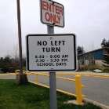NO LEFT TURN

During the peak traffic times of arrival and dismissal, drivers are not able to turn left from Panorama Drive into the Aspenwood drive thru. Drivers can only access the drive thru by making a right turn from Panorama Drive eastbound. As families and caregivers plan for this traffic pattern, they should consider the direction they will be approaching the school.

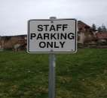LIMITED ACCESS
Some of our parking lots have limited access and are intended for
school staff only. These spots must be left open during school hours
as we have itinerant district staff needing to access the school for
short periods of time throughout the school day.

NO STOPPING / NO PARKING
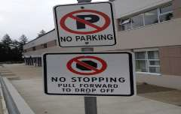Once in the drive thru, drivers will not be allowed to stop or park in the lanes in
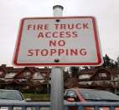the drive thru other than for immediate pick up. Currently cars are parked in the drive thru for 15 to 40 minutes before student dismissal. This results in traffic gridlock westbound on Panorama Drive and drivers
making unsafe decisions to pass through this traffic congestion –
including veering into the oncoming lane.
As well as being a drive thru for the pick-up and drop off of students, this is a fire lane and needs to be available for emergency vehicles to easily access the building in unexpected situations when there is a need for immediate response and
support for an child or adult who is in extreme circumstances.

Daycare providers with buses or vans will have a specific parking space allotted to them. Signs and traffic cones will mark that area off.

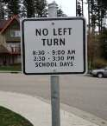Cars exiting the drive thru during peak traffic can not turn left on to Panorama. All traffic exiting the drive thru must proceed eastbound on Panorama Drive.
NO LEFT TURN

Safety in school zones is a high priority for all members of the community. The Bylaw Enforcement Section of the City of Port Moody will be conducting strict enforcement of street and traffic regulations near our schools throughout the school year. Please be reminded to obey all traffic laws and signage, drive cautiously, and yield to pedestrians. Congestion around school zones can be alleviated by walking to school, parking one or two blocks away from the school when picking up and dropping off children; remember to always give yourself extra time to
arrive safely.

The most commonly ticketed offences in school areas are: parked on left side of street (facing wrong direction/crossing centerline), parked obstructing traffic (includes vehicles stopped in travelled portion of street even if letting off passengers), and parked/stopped where prohibited by traffic control device (includes vehicles stopped to let off passengers).

Questions and concerns regarding street and traffic violations in school zones can be forwarded to the Bylaw
Enforcement Section at 604-469-4697 or bylaw@cityofportmoody.com . Moving violations such as speeding and aggressive driving should be reported to the Port Moody Police non-emergency
at 604-461-3456

Please be sure this information is shared with all members of your family or child care providers who may be responsible for picking up your children at the school.

MORE INFORMATION ABOUT STUDENT PICK UP
After school, students are supervised until 3:00 pm. Any student who has not been picked up at that time will be asked to
come back into the school and wait in the foyer for their ride. We ask that parents remind their children that if they have not been picked up they should come back into the school and report to the office. They should not walk home by themselves -
unless parents or guardians have arranged that ahead of time.

Thank you for your cooperation and your patience as we work to improve student safety for our community. Please feel free to contact me should you have any comments, questions or concerns.

Laurie Birnie, Principal
On behalf of our Health and Safety Committee

