BECOME A CAMP IGNITE PARTICIPANT

CALLING ALL GRADE 11 & 12 GIRLS IN B.C.!
Do you have an interest in exploring the limits of your potential?
You are invited to share this unique experience while working with a team of like-minded friends who share your passion for challenge and adventure.
Applications CLOSE May 1st, 2024

PARTICIPANT GOOGLE FORM: https://docs.google.com/forms/d/e/1FAIpQLSdgU2bJhWYF71YNwaW3DFs8SPMbNiMsNLJY-AWCnDz1GIWGfw/formResponse

ASPIRING FIREFIGHTER GOOGLE FORM:
https://docs.google.com/forms/d/e/1FAIpQLSePy0hAxyKAVuidgVongRJYyZ_xIW3K7QLF9IEtrrImWhVKSw/formResponse
To be considered for participation please complete the Camp Ignite Participant Application Google Form by May 1st, 2024​

August 8-11, 2024
Participants arrive on the 8th in the evening for team building and icebreakers, followed by three days of camp. In 2023 we were grateful to be hosted by Maple Ridge Fire & Rescue, Vancouver Fire Rescue Services, and Township of Langley Fire Department.

Ignite your passion. Ignite the possibilities.
Ignite tomorrow’s opportunities!​
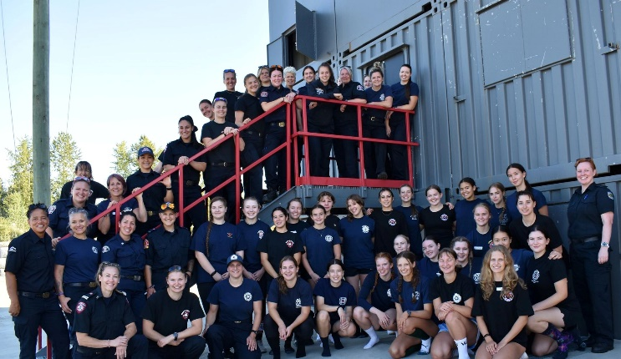

WHAT TO EXPECT
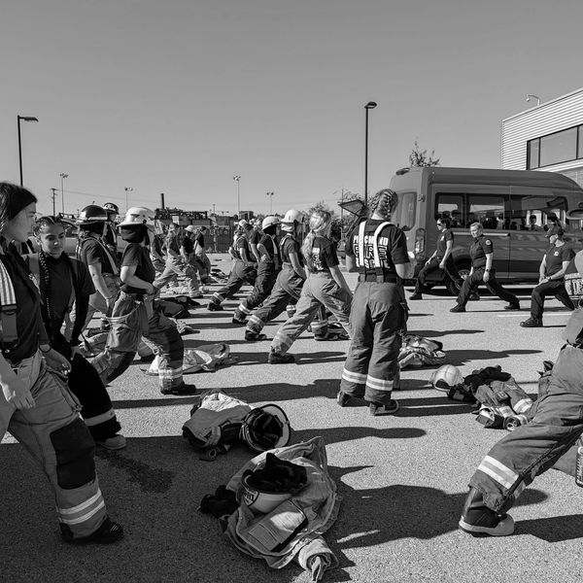

Camp Details
Camp Ignite is a three-night, three-day camp that educates and inspires young women to follow their dreams. We aim to show our campers a future of limitless opportunities and demonstrate that anything is possible.

The camp is open to girls in grades 11-12 (ages 15-18 ) living in British Columbia. Our camp offers an introduction to the exciting world of firefighting, along with fitness, nutrition, health and teamwork.

We are a not-for-profit society and strive to keep the camp affordable and accessible to those interested.
APPLY BY MAY 1, 2024

