Changing your SD43 Network Password

There are two easy ways to change your password:
- At School using Windows 10 or Windows 7, or
- At School using a Mac or At Home using Windows or a Mac

See the instructions below and use the one that works best for you.

At School using Windows 10 or Windows 7

- Log on to any School District computer that is connected to the school network (e.g. Lab computers, your TLI Laptops).

- Once logged on, press CTRL-ALT-DEL all together at once. You should see this screen:

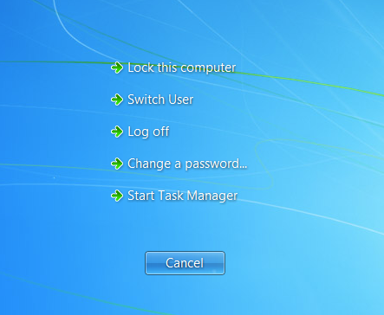
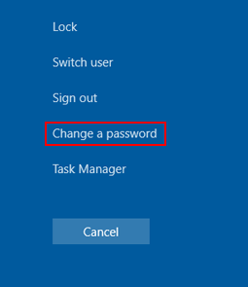
Windows 10
Windows 7

- Click on “Change a Password” and follow the prompts on the screen.

At School using a Mac or At Home using Windows or a Mac

- Open your web browser (e.g. Safari, Edge, Firefox or Chrome) and log onto your District email. To log onto your District email, go to www.sd43.bc.ca and click on Staff Email near the top of the screen.

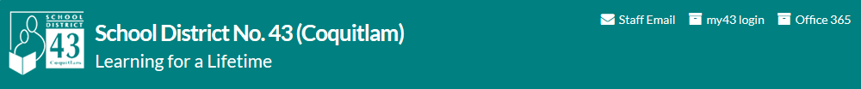

- Once logged into your email, click on the “Gear” icon located top right of the menu bar (next to your name). Then click on Change password.

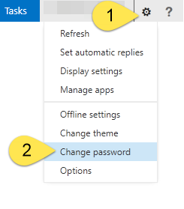

- Follow the prompts on the screen and click Save to save your new password.

-------------------------------------------
If you have a mobile device or iPad connecting to the WIFI and/or email using your network ID, then you will also have to enter your new password for these devices.

Your phone or iPad will eventually let you know your password has changed and you will need to enter the new password, but you may not get mail until you update your password.

If you use a District iPhone, see Updating your SD43 Password on iPhone for Wi-Fi and Email.

